The RYA Day Skipper Course, Dominic Lloyd at Largs August 2017.
Introduction.
I am the Sailing Captain at Dundee University Sailing Club which involves organizing events and running training for sailing dinghies and providing support for yachting activities through the club. As the club membership changes on a year to year basis, there is a need to maintain a certain number of people with appropriate sailing qualifications in order to allow it to run properly and offer sailing training and activities to members, some of whom have little or no experience. One of these qualifications is the RYA Day Skipper certificate, for which I was given financial support by the The Neil Mackenzie Trust. The cost of the course is £450 and I was given a contribution of £200 which made it affordable for me as a full time student.
The Day Skipper Course.
The course began on a Sunday evening at Largs Yacht Haven through Scotsail, with introductions and a boat familiarization and safety briefing while still in the marina. This was an opportunity to get to know the other four people on the boat for the week and the instructor. The boat was a Bavaria 36 foot yacht which was large enough for us all to sleep each night and be fully self-sufficient for the week ahead.
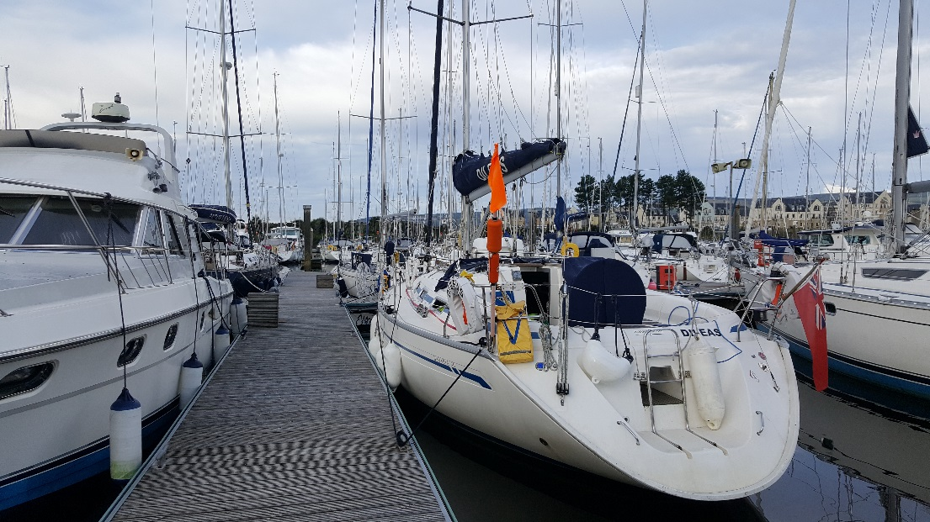 Dileas – our yacht !
We had a mixture of weather, as is usual in Scotland ! This varied from Force 6 and lashing rain, trying to keep the yacht on a straight course (without inducing too much sea sickness !) to a flat calm sea with beautiful blue sky as a magnificent backdrop to the Scottish Loch scenery. The course required a good degree of boat handling as a prerequisite in addition to good knowledge of how to sail and an understanding of the theory, which we were tested on frequently throughout the week. The objective of the course was to learn how to put these elements into practice together and be a ‘Skipper’ in charge of boat and crew safety. We each had to take turns to be the ‘Skipper’ for a day; my turn involved planning and executing a passage from Portavadie (Loch Fyne) around the Kyles of Bute and up the Clyde to Kip Marina.
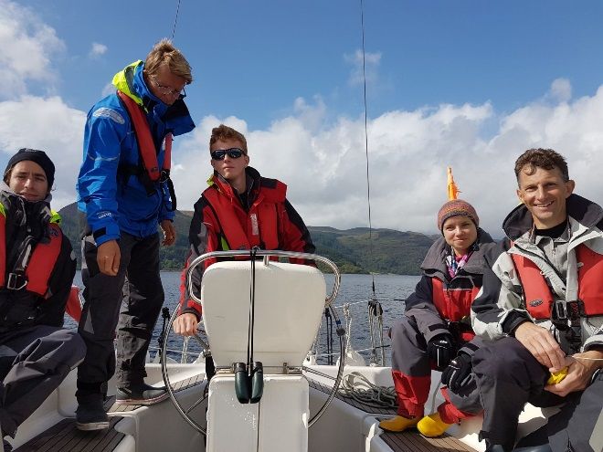 Me under instruction on how to ‘park’ the boat !
After Kip marina, I had to take the helm for the night passage up to Rhu marina in Gare Loch. Having to navigate and identify features in the dark took on a new perspective and provided the whole crew with many challenges remembering the sequence and colour of lights for different buoys, with very little logic !
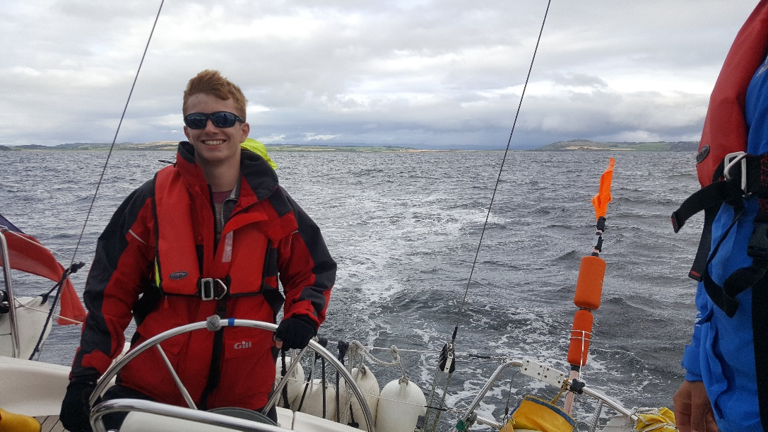 Sailing north of Arran
The following days involved some fantastic sailing into many sea lochs around the stunning south west coast of Scotland, finishing back at Largs on Friday 1st September with a Day Skipper certificate !
Conclusion.
The week ended with the people on our yacht achieving two Competent Crew and three Day Skipper certificates. There were some people who failed on other boats, so a good level of competence is expected and I’m pleased I managed to meet the required standard. This will allow me to support our sailing club as a Skipper on yachts for people who do not have this level of experience and continue the many activities we run. I feel confident that I can create an enjoyable and safe experience for all people who are learning to sail and wish to join or are already members of the university club. Thank you to the The Neil Mackenzie Trust for helping me achieve this !

