Mountain Bike Leader Level 2 – April 2017
It started when a teacher at the primary school my children go to asked me if I had a mountain bike qualification. He then explained that he takes a group of primary 6’s and 7’s out on their mountain bikes after school in the summer and it would be helpful to have a parent helper who is qualified as a mountain bike leader. Knowing I am a keen mountain biker and my children are quite young (P2 and P4) he thought I would be a good candidate who would be able to help out for many years to come.
I was grateful of the opportunity and booked myself onto the 2 day British Cycling Level 2 Mountain Bike Leader award at Glenmore Lodge near Aviemore.
I arrived at Glenmore lodge on Wednesday the 19th of April at about 9pm and signed myself in at the desk. My first impressions were great as the staff were very friendly and helpful. I found my room, which I had all to myself, and organised my bike clothes and gear for the next day. Breakfast was at 7.45am and the course started at 8.30am.
There were five of us on the course and our instructor, Alex, made as all feel very welcome and relaxed as we introduced ourselves and briefly explained why we were on the course.
The first bit of the day was spent in the classroom discussing the role and remit of a level 2 MTB leader. It was emphasized that this is a British Cycling course which is taught all over the UK and not specific to Glenmore Lodge.
Later in the morning we moved into the workshop where we spent a few hours working on trailside repairs. I was slightly nervous of this part of the course having always been happy to let my brother deal with most of my bike maintenance. The first thing we were shown was how to change an inner tube from the rear wheel and we were then asked to do it on our own bikes. I wasn’t quick but I was pleased to manage without too much difficulty. We then looked at various other trailside repairs including gears and brakes. I was much more confident after this short session as I had always felt nervous doing bike repairs but having been shown what to do it was much more straight forward than I had imagined.
After lunch we had a practical session on our bikes and were given lots to think about for leading and managing a group ride. We were then back into the classroom to discuss preparation and route planning followed by an introduction to risk assessment.
The next day we were to go on a 30km ride from Glenmore lodge to Carrbridge with each of us taking a turn at leading the group. We were given a map with our section of the ride highlighted and our homework for the night was to use the skills we had learnt to plan our ride and also complete a risk assessment.
Unfortunately the weather deteriorated during the night and we woke up to heavy rain. It turned out to be typical Scottish April showers so one minute we were wet and cold and the next the sun would be out and we were all stopping to remove extra layers. This helped to reinforce the need to be prepared with appropriate clothing. Before we set off we discussed the need for a quick but thorough bike check as this can save a lot of issues during the ride if potential issues can be spotted and fixed before the ride starts.
Once we returned to Glenmore Lodge we reviewed our ride and our risk assessment before a final debrief and individual feedback from Alex.
The course was really enjoyable with a great deal of information and practical sessions packed into two days. I came away feeling much more confident in my ability to be a successful mountain bike leader and with a plan to concentrate on developing my trail side repair skills before my assessment.
Thank you to the Neil Mackenzie Trust for contributing towards this course and I look forward to putting my skills into practice.

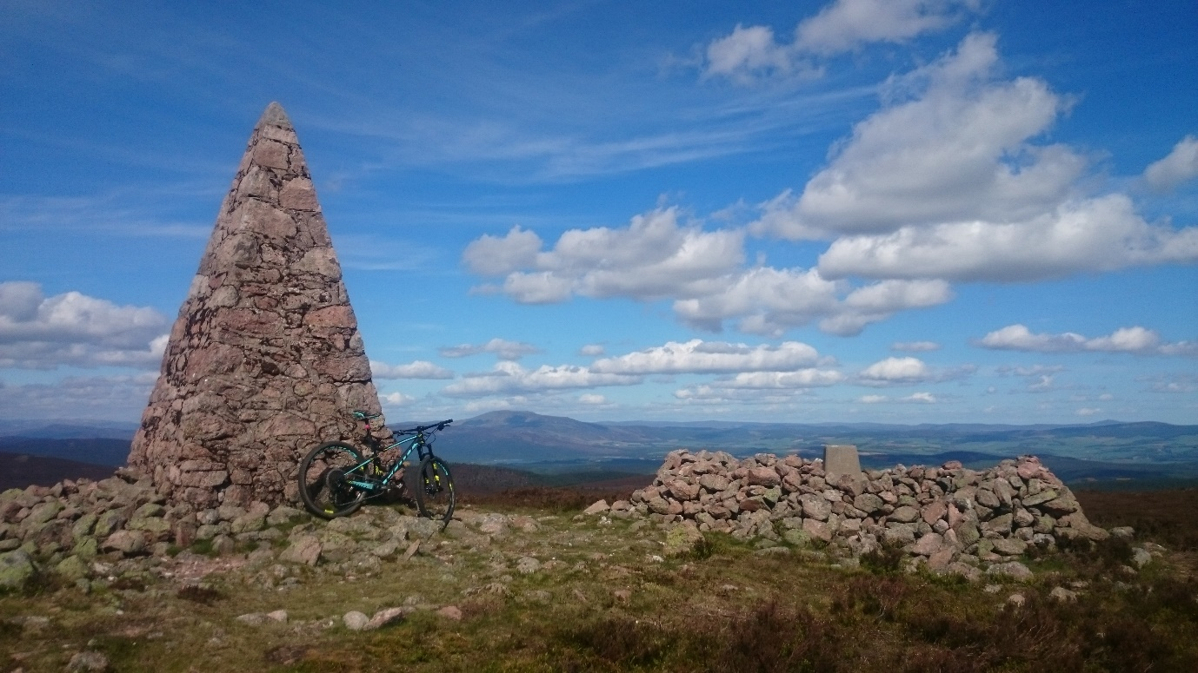
It’s not been too hard motivating myself to get out and practice my skills!

