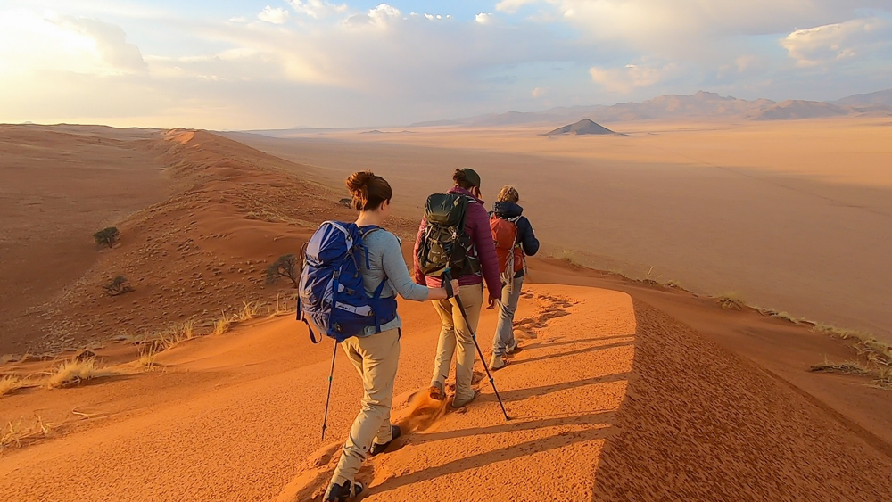

EXPEDITION REPORT
NamibRand Nature Reserve Fence Survey
Harriet Barr, Sarah Becker, Megan Gray, Rosie Forsyth, Fiona Mackay, Amy Savage

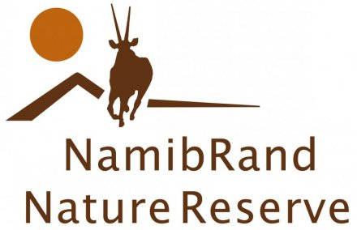 |  | 

Acknowledgement
A great part of the expedition has involved the planning, logistics and financing of our aims. We would therefore like to use this space to thank our sponsors, The Neil Mackenzie Trust and Quest Solutions, without whom we would have not been able to commence on this expedition.

Thank you for all your kind support and help, you have enabled us to contribute to the improvement and development of the Namib Rand Nature Reserve in Namibia.

Aim & Supporting Objectives
Describe your expedition Aim in a single attention-catching statement. Supporting Objectives should follow the SMART mode. The Aim is expressed as a statement of intention, whereas the Objectives should be measurable outcomes that provide a mechanism for achieving your Aim.

The aim of this expedition is to trek and survey the Southern 50km of the boundary fence (Appendix 1) between Namib Rand Nature Reserve and Namib-Naukluft National Park in Namibia.
The fence was built in the 1970’s to protect wildlife from accessing Namib-Naukluft Park where there was severe poaching. Today the poaching threat has decreased, making the fence irrelevant. In search for water and food wildlife tries to cross the fence, often getting fatally entangled. An appeal to the government to have the fence removed is being established; this will enlarge the animals’ habitat and protect their populations. By surveying the fence, any gaps, possible wildlife traps and mortality rates, the appeal for the fence removal will be verified.
The project is an excellent opportunity to practice purposeful surveying skills whilst travelling through the Namib deserts unique landscape none of the team members have visited before.
Our supporting objectives are to:
- Survey wildlife and plants along the route
- Produce an audio podcast and video of the expedition
- Promote fieldwork expeditions
- Learn about local culture, people and history by involving local communities
- Empower other young females to adventure and explore
- Experience a Dark Sky Reserve

Team members and experience
½ page per team member maximum. Highlight experience and motivation for undertaking the expedition. Include a photograph of each team member – creative approaches are acceptable within reason!

  - Sarah Becker
Official Role: Financial Officer
Subsequent Role: Day 1 Leader (collaborative leadership)
Academic background: 3rd Year Adventure Performance and Coaching
Growing up in a multinational family, Sarah has always been on the go and lived in different regions and cultures. After discovering her enjoyment in outdoor sports such as hillwalking, skiing and wild swimming, she joined UHI to deepen her knowledge and understanding in this field.
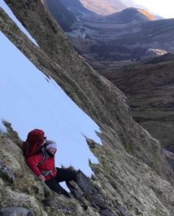
Over the last 18 months her passion has developed towards scientific research and survey work within conservation, areas in which she was able to broaden her experience via several work and volunteer placements across the UK. By carrying out survey work on this expedition, she hopes to engage her peers in fieldwork and promote the concept of travel with purpose.

  - Harriet Barr
Role: Medical Officer
Subsequent Role: Day 2 Leader (collaborative leadership)
Academic Background: 3rd Year Adventure Tourism Management
Harriet has worked as a Duke of Edinburgh leader assisting on expeditions for 5 consecutive years. As part of her leadership role on DofE expeditions Harriet is often tasked with responsibilities as a first aider and therefore has sufficient experience to be the team’s medical officer. Besides leading expeditions, she also has a lot of personal mountaineering experience and in the summer of 2017 completed her mountain leader training.
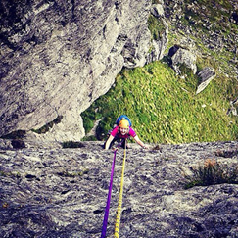
Apart from spending a winter season in France she has little travelling experience, no experience of international expeditions and very little experience of hot weather. She is hoping to learn a lot from the planning and participation of this expedition which will help to expand both her knowledge and experience.

  - Megan Gray
Role: Scientific Project Consultant
Subsequent Role: Day 3 Leader (collaborative leadership)
Academic Background: 3rd Year Adventure Tourism Management.
Megan gained her passion for the outdoors from her parents. Raised in the hills, she enjoyed many outdoor activities from a young age including hill walking, mountain biking, rock climbing and kayaking.
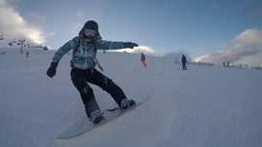
Megan has a passion for challenges and new experiences. Though she has experienced a similar climate she has never been challenged with this type of terrain before or an expedition for this length of time. Megan has many strengths that can be brought to the team some include emergency outdoor first aid training, an ability to adapt to new circumstances, high quality teamwork, determination and positive thinking.
Rosie Forsyth
Role: Communications Liaison
Subsequent Role: Day 4 Leader (collaborative leadership)
Academic Background: 3rd year Adventure Tourism Management
Rosie has always been a keen adventure enthusiast from a young age. From growing up in the countryside and exploring her surroundings she established a love for the outdoors that continues with her participation in outdoor pursuits such as skiing, kayaking, biking and climbing.
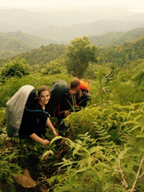
By progressing through the Girl Guides and achieving her Gold Duke of Edinburgh Award, Rosie has developed an array of skills such as teamwork, leadership and communication, vital to any expedition project. She has gathered previous expedition experience by trekking through Borneo jungle for a month. This was a challenging but rewarding experience for Rosie and gained her a sense of accomplishment. This experience will enable her to motivate the team whilst on expedition.

  - Fiona Mackay
Role: Expedition Photographer
Subsequent Role: Day 5 Leader (collaborative leadership)
Academic Background: 3rd year Adventure Tourism Management

Since Fiona was little, she had a passion for outdoor life, whether it was kayaking, biking or hill-walking. When she turned ten, she joined the local sailing club and began learning a brand-new sport. Four years later and she was helping the instructors, teaching the beginner groups the basics and she began learning about instructing.
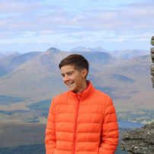
During school she took part in Duke of Edinburgh expeditions and since then she has completed several other overnight walking expeditions. After school she went to West Highland College to study Adventure Tourism Management with a view to establishing a career in the adventure industry. Since then she has worked in Menorca teaching sailing for two seasons to groups of different ages and different abilities.

Amy Savage
Role: Logistics Officer
Subsequent Role: Day 6 Leader (collaborative leadership)
Academic Background: 3rd year Adventure Tourism Management
Amy’s hiking experience started in Scotland, nearly five years ago.
Since then, she has climbed many mountains in many different conditions. She undertook a training course with the Glenmore Lodge, as well as a navigation specific course during her 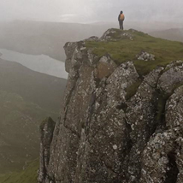
Outdoor Adventure college course. Three years ago, she travelled to Tanzania and hiked up Kilimanjaro in five days.
Also, since May 2018, she has been training with a personal trainer in order to make sure she is physically ready for the Namibia expedition.
Finally, she has been working with a guiding company guiding people in the hills and organizing the client’s trips.

Expedition details
Expedition schedule, route, logistics, permits, brief destination typology that includes historical weather, routine communications, etc.
  - Expedition Schedule
Date | Description | Additional Info
21st May | Travel to Glasgow, departure time from Fort William 11:00 at the latest. Arrive at GLA 14:00 and check in luggage at least 2 hrs prior to flight. Departure from GLA at 16:55 on flight to Amsterdam. Arrive in AMS 19:30. Departure from AMS 22:55 on flight to Windhoek. Arrive in WHK at 11:05 on 22nd. | Flights operated by KLM
22nd May | Arrival in WHK 22nd at 11:05. Day in Windhoek - final expedition preparations, get food & fuel, etc. | Before the end of April: Find B&B
23rd May | Windhoek – final expedition preparations, get food & fuel, confirm arrangements with transfer company, etc. | Harriet’s Birthday Before the end of April: Find B&B
24th May | 24th – travel to NaDEET. Stay at NaDEET and preparations for the trek/survey. Game Count.
25th May | Stay at NaDEET and preparations for the trek/survey. Game Count
26th May | Day 1: fence trek/survey (starting at the far southern corner so that we get gradually closer to NaDEET as we progress) 9.20km | Fiona’s Birthday
27th May | Day 2: fence trek/survey 8.29km
28th May | Day 3: fence trek/survey 10.7km
29th May | Day 4: fence trek/survey 11.4km
30th May | Day 5: fence trek/survey 14km
31st May | Day 6: fence trek/survey evening return to NaDEET (finishing late afternoon and back to NaDEET) 13.9km
1st June | Travel to Winhoek, departure time from NaDEET at 9am latest. Arrive at WHK at 15:00 and check in luggage at least 2 hrs prior to flight. Departure from WHK at 17:35 on flight to AMS. Arrive in AMS at 06:05 on the 2nd June. | Flights operated by KLM
2nd June | Arrive in AMS at 06:05. Departure from AMS at 09:30 on flight to GLA. Arrive in GLA at 10:00. Travel to Fort William and arrive at 13:00.

  - Logistics

Pre-Arranged Transfers
We have pre-arranged minibus transfers from Fort William to Glasgow, Windhoek International Airport to Tamboti Guesthouse in the city centre, the guesthouse to NaDEET, from NaDEET to the airport and from Glasgow back to Fort William.

Flights
The flight connections we have booked will depart from Glasgow International Airport and continue via Amsterdam Airport to arrive at Windhoek International Airport. The return route is a replica flight plan in reverse.

Supply Vehicle
A supply vehicle has been arranged to transport us while we are on the nature reserve, this vehicle will also be used to drop supplies off at various camps while we are trekking.

Food and Water
During the journey from the UK to the NaDEET centre we will be buying food and water as we go. Due to dietary requirements we have agreed to bring individualized boil in the bag meals from the UK for our dinners while trekking. For breakfasts we will be buying porridge oats in Windhoek to share as a group and for lunch we will be buying plenty of snacks (i.e. nuts, energy bars, fruit). Water will be available to us from the NaDEET centre during our expedition. To cook food and water we will require gas; this we will buy at CYMOT in Namibia.
CYMOT | +264 61 295 6000
Newcastle Street, Northern Industrial Area, Namibia | Info@cymot.com

Accommodation
We have booked to stay at Tamboti Guesthouse for two nights upon arrival in Windhoek. After arriving at the Namib Rand Nature Reserve we will stay at the NaDEET centre for two nights until we begin our 6-day camping trek. We will return to the NaDEET centre for one night before traveling back to the airport the following day.

Camp Set Up
We plan to set up a camp with a fire at its centre: tents will be based around the fire and food will be consumed around the fire.
Guidelines for toilet arrangements in semi-permanent camps for small to large groups recommend that the toilet is situated 30 to 50 meters away from camp. This is to reduce the risk of pathogens, man-made contaminants affecting water supply, and the potential of attracting unwanted animals. As our water supply will be mobile (jerry can) the risk of pathogen transference is lowered; thus, our toilets will be situated closer to camp, 10 meters away is deemed appropriate for hygiene purposes and to avoid attracting animals.

Expedition Destination
Namibia is an African country inhabited by 2.5 million people and an extensive range of wildlife. It is located on the South Atlantic Coast of Africa, comprising 824,292 square kilometres.
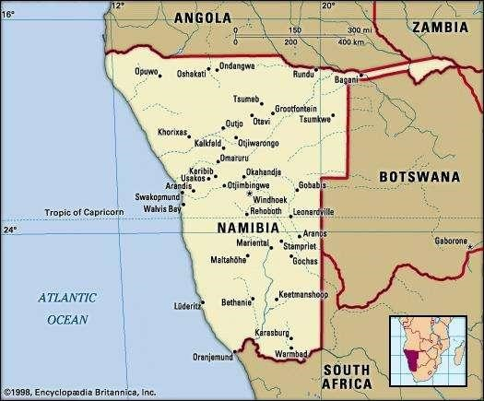
Figure 1. Namibia on the World Map. from: Green (2018)
Three main topographic zones are found within Namibia: The Namib Desert, Central Plateau and Kalahari Desert. Appendix 2 details geological information in addition to plant and animal life found in each.

The Namib Rand Reserve: General
The reserve is located in the South East of Namibia, within the Coastal Namib Desert region (See Figures 2 and 3). It is not a registered private park or reserve, but instead, a not-for-profit organization operating on 172,000 hectares of former farming land.
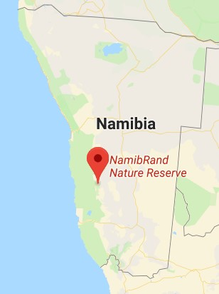
Figure 2. Pinpoint of the Namib Rand Nature Reserve Location. From: Google Earth (2018)
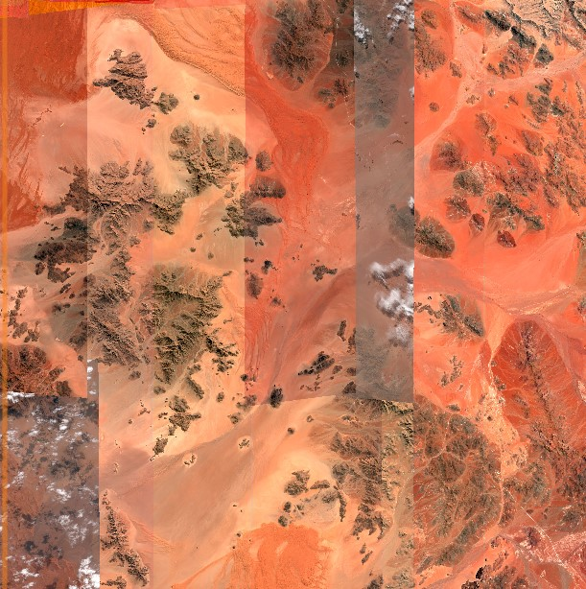
Figure 3. Namib Rand Area. From: Digital Global
On the reserve, there are four distinct habitats with varying flora and fauna:
Habitats
- Dunes and sandy plains
- Inselbergs and mountains
- Gravel plains
- Sand and gravel plain interface
Flora and Fauna
- A variety of herbs, succulents and trees
- Large mammals including Oryx, Springbok, Zebra, Giraffe, Klipspringer and Baboon
- Birds (150 different species) and rodents

Expedition Area
The expedition’s destination (Figure 4) is located in a ‘critical’ area of the reserve (Figure 5), bordering with the Namib-Naukluft National Park for around 100 km.
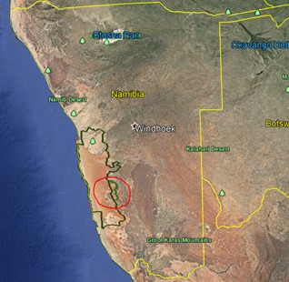
Figure 4. Satellite Picture of Namib Rand Reserve. Dark Green = Namib-Naukluft Park. Light Green = Namib Rand. Red Circle = Where the team is going on Expedition in relation to the lines. From: Google Earth (2018)
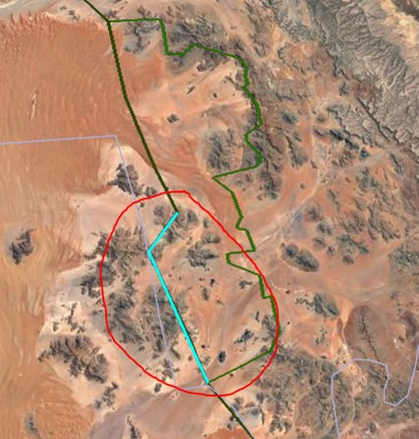
Figure 5. Satellite image of specific expedition location. Blue = Southern Boundary Fence (50km). From: Google Earth (2018)

  - Route
Routes on the expedition include the route to the Nature Reserve from the airport (Appendix 4), a support vehicle route within the reserve and the walking route along the fence.
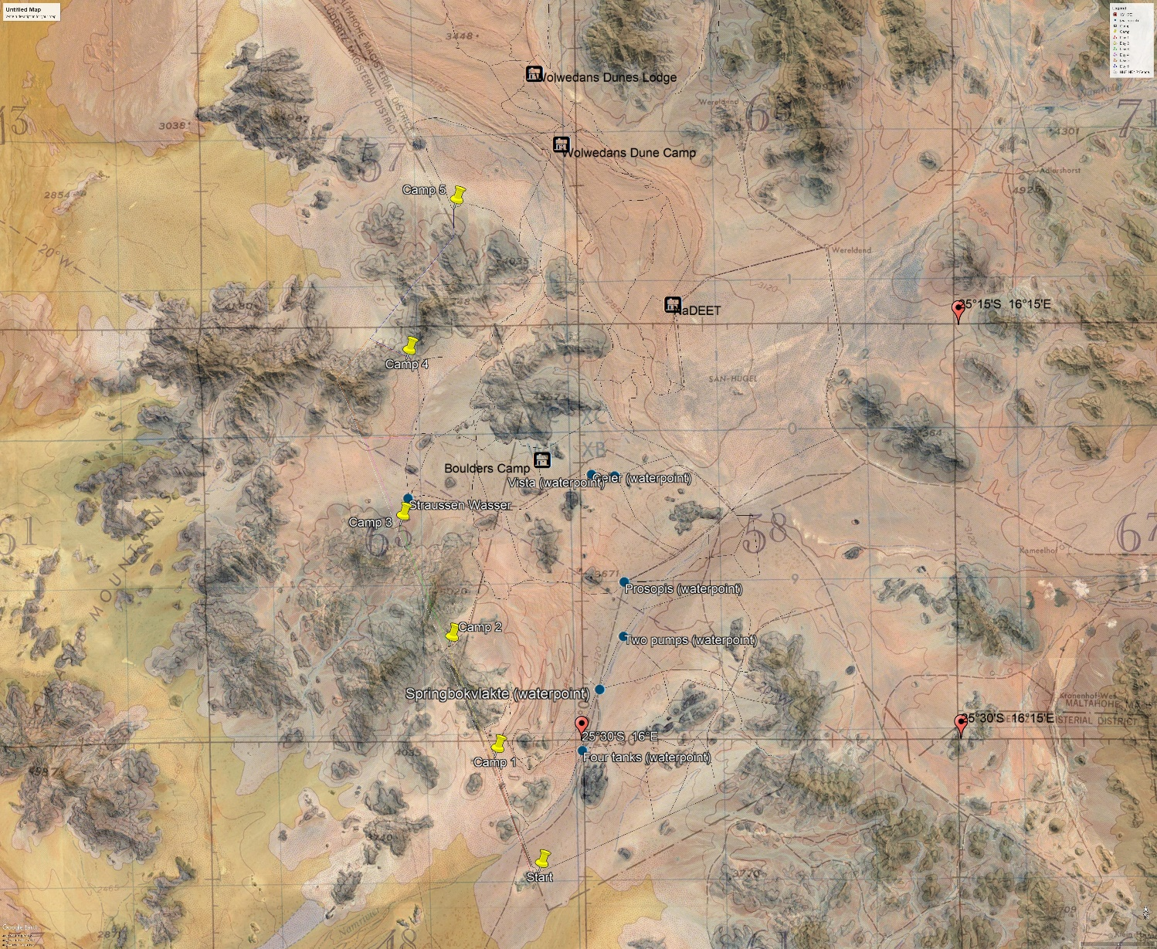

Group Name: Namibia Team |  |  |  |  |  |  |  |  |  |  |  |  |  | Aim of expedition: The aim of this expedition is to trek and survey the Southern 50km of the boundary fence between Namib Rand Nature Reserve and Namib-Naukluft National Park in Namibia.
Expedition Dates: 26th May to 31st May 2019 |  |  |  |  |  | Names of team members: |  |  | Amy Savage |  |  | Megan Gray
 |  |  |  |  |  | Sarah Becker |  |  | Fiona Mackay |  |  | Rosie Forsyth
 |  |  |  |  |  | Harriet Barr |  |  | Jose Navarro |  |  | Amy Exeter
Day (see image below) |  | General direction  or bearing |  |  | Distance  in km  (30 mins per km) | Height climbed in m  (1 min per 5 meters) | Time allowed for journeying | Time allowed for surveying, rests or meals |  | Total time  for leg
Day (see image below) | Latitude/ Longitude |  |  |  |  |  |  |  |  |  | Brief details of route to be followed or planned activity. |  |  |  | Escape/Notes
(a) | (b) | (c) |  |  | (d) | (e) | (f) | (g) |  | (h) | (j) |  |  |  | (k)
- Red Route | 25°34’52.83”S/ 15°58’7.40”E | NW |  |  | 9.20km  (4hrs 35mins) | 40m  (4 mins) | 4hrs 39mins | 2hrs |  | 6hrs 39mins | Handrail fence: veer right to meet path after 9.10km (camp) |  |  |  | 25°30’41.35”S/ 15°58’23.51”E Emergency water source: Four tanks 25°33’18.18”S/ 16°00’03.99”E
- Yellow Route | 25°30’41.35”S/ 15°58’23.51”E | W |  |  | 8.29km  (4hrs 5mins) | 672m  (2hrs 14mins) | 6hrs 19mins | 1hr |  | 7hrs 19mins | Veer left to meet fence, handrail fence: meet path after 8.29km (camp) |  |  |  | 25°26’35.82”S/ 15°54’36.52”E Emergency water source: Four tanks 25°33’18.18”S/ 16°00’03.99”E
- Green Route | 25°26’35.82”S/ 15°54’36.52”E | NW |  |  | 10.7km  (5hrs) | 427m  (1 hr 35mins | 6hrs 35mins | 1hr |  | 7hrs 35mins | Handrail fence: veer right to meet path after 10km (camp) |  |  |  | 25°21’09.59”S/ 15°53’01.10”E Emergency water source: Straussen Wasser 25°21’12.14”S/ 15°53’01.68”E
- Pink Route | 25°21’09.59”S/ 15°53’01.10”E | SW |  |  | 11.4km  (5hrs 30mins) | 47m  (9mins) | 5hrs 39mins | 1hr |  | 6hrs 39mins | Veer left to meet fence, handrail fence: veer right to meet path after 9.06k (camp) |  |  |  | 25°18’57.93”S/ 15°53’17.27”E Emergency water source: Straussen Wasser 25°21’12.14”S/ 15°53’01.68”E
- Orange Route | 25°18’57.93”S/ 15°53’17.27”E | W |  |  | 14km  (7hrs) | 551m  (1hr 50mins) | 8hrs 50mins | 1hr |  | 9hrs 50mins | Veer left to meet fence, handrail fence: veer right to meet path 8.34k (camp) |  |  |  | 25°16’11.81”S/ 15°53’18.45”E Emergency water source: Straussen Wasser 25°21’12.14”S/ 15°53’01.68”E
- Blue Route | 25°16’11.81”S/ 15°53’18.45”E | NW |  |  | 13.9km  (6hrs 30mins) | 195m  (39mins) | 7hrs 9mins | 1hr |  | 8hrs 9mins | Handrail fence: meet track after the fence veers off to the left :) |  |  |  | 25°10’40.90”S/ 15°54’54.65”E Emergency water source: Schafberg 25°12’10.82”S/ 15°57’12.71”E
 | Totals: |  |  |  | 67.49km  (32h40) | 1932m  (6h31) | 39hrs 11mins | 7hrs |  | 46hrs 11mins

Maps and Navigation
The main maps we are using to plan our route are taken from a Google Earth file provided by the Namib Rand Nature Reserve. We have also purchased several maps of the region:
Name of Map | Scale | Features
JOG maps Wereldend and Witwater (Omnimap) | 1:1.250.000 | Topography  Road network  Points of special interest (i.e. World Heritage sites, camping sites)

Topographic maps of Namibia are available for sale
in the new building of the Directorate of Survey and Mapping in Windhoek
Address : Robert Mugabe Avenue, N° 49 (see city plan)
Opening hours : 8:00-13:00 & 14:00-1700

Geology and Climate

Climate
Namibia is partially covered by the Namib, one of the world’s driest deserts with an extreme and arid subtropical climate (see Appendix 7). It experiences less than 70mm rainfall per year.
Throughout the year there are significant differences between daytime and night-time temperatures (38 degrees days in summer, below 0 degrees nights in winter). Radiation of the sun tends to be very high due to the clear air conditions of this region.
In general, the high season for the Namib area is between the winter months (July and November). The temperatures are more bearable and there is almost no rainfall. The best times of the year to hike are between March and June, and between mid-August and December.
We will be traveling at the end of May beginning of June (turnover low to high season). The temperatures are far milder (daytime: 23 degrees average) during these months. However, it is important to consider in the potential risk of flash floods.
A collection of historical climate data for the Namib Rand NR with regards to rainfall, solar radiation, temperature and wind patterns for the months of May and June can be found in Appendix 8.

Geology
The environment of the Namib Rand NR, seated at the edge of the Namib, shows characteristics of desert and xeric shrublands as well as Namibian savanna woodlands.
For the section of the fence that will be covered during the expedition, the geology comprises smooth and gravel plains and gravel plains interface. For these environments, appropriate risk management will need to be implemented for the safety of the group. This is further discussed in the Risk Management section of the report.
As the expedition will cover rocky areas, it is expected that potential wildlife that could be encountered are kudus, klipspringers, baboons and leopards. Again, for this, risk management should be considered for the team’s safety.

Rules and Regulations
Likewise, to any other country Namibia has rules to be adhered to, that may differ slightly from rules in other countries:
- Drug taking, and smuggling is an offense (punishments are severe)
- Buying, selling, killing, capturing, trading protected wild animals or parts requires a specific licence
- LGBT topics and relationships can be a taboo topic, awareness of this is vital
- Photography of state houses and properties may be prohibited (if in doubt don’t)
- Parts of Namibia require a permit to enter
  - Visa and permits

Visa
For holidays or private visits of up to 90 days, as British nationals we will not require a visa.
For foreign workers on short term assignments of up to 6 months, a working visa is usually required. However, as agreed with Namib Rand, due to our volunteering work with them this visa will not be necessary.
Travel documents
We must ensure that our passports are valid for a minimum of 6 months from the entry date into Namibia and that they have enough blank pages for Namibian and potentially South African Immigration to use. Should a passport get lost before or during the trip, it is possible to apply for UK emergency travel documents. These can be used to travel to Namibia through a maximum of 5 other countries and can also be used to return to the UK.

Permits
The Namib Rand NR is on privately owned commercial land and requires visitors to pay an entrance fee for sustaining the conservation efforts of the reserve. However, we have permission from Namib Rand to pursue the fence survey for them. Therefore, this may involve an agreement with the reserve regarding costs of staying on the reserve for one week.

Documentation of Expedition
To document the expedition, we will:
- Record the surveys of the fence for Namib Rand
- Create a ‘diary-log’ style podcast
- Take high quality photographs.
This will allow the team to share any content they create with their family, sponsors and social media followers as to their progression.
Equipment
Having experience of walking expeditions, the team will have acquired most of the required kit (Appendix 20). Having not experienced a desert, kit such as lighter clothing with neutral colours and wide brimmed hats would need to be purchased for the daytime. In terms of the climate at night, warm clothing and warm sleeping bags will be required.
Group Training
All team members have prior experience working as part of a group. In March we took part in a group training walk together which was the first time we had all been walking as part of the existing team. The primary focus of the walk was to build rapport as a team. We got to know each other's capabilities on a long-distance walk, and we learned how to best work cohesively over extended periods of time.
We also completed scientific field research training and In Reach satellite communicator device training while on our practice walk. This training gave the entire team valuable instruction on how to use surveying equipment specific to our fence survey, and an understanding of how to appropriately record the information. The training will allow us to efficiently complete the necessary surveys for the boundary fence. Training for the In-Reach device was completed during a lecture at the start of semester two and the device was then taken with us on the walk for training purposes (Appendix 21).
Both Sarah and Fiona will take part in the REC First Aid course before we leave for Namibia to ensure that we have a sufficient and relatable understanding of what to do in a remote medical emergency.
In addition to this, each member has taken part in their own training programmes leading up to the expedition. As the programmes are both individual and therefore varied, they have not been featured in the report.

Budget and expedition finances
Please use the Excel budget template on Blackboard; adapt it as you see fit.

Budgeting and Fundraising
Expeditions are a costly matter, and this venture does not differ from that trend. However, the team created a careful budget, applied to grant giving organisations and developed a fundraising plan to combat the monetary obstacle. As part of their fundraising campaign the team set up a GoFundMe webpage, organised events such as a raffle, a pub quiz, a car wash, a tombola and a movie night. Due to their early initiative on fundraising, the team was able to raise an amount of just under £3000 across a time period of three months (Appendix 26).

Expedition Budget
Budgeting is the “cornerstone” of expedition planning. Hence, a document has been created detailing the proposed budget for the Namibia expedition (Appendix 12). The team have carefully considered the cost of the expedition, from which, they have concluded five main areas to help cover the cost:
Individual team member contributions
Monetary assistance from West Highland College (Appendix 26)
Grant giving bodies
Fundraising events
Seizing sponsorship opportunities
Each area has been developed further in the budget appendix.

Individual Contributions
It is expected that each team member will contribute to the overall cost evenly, thus making it fair. Furthermore, an additional budget consideration, specifically for individual members, is the currency used in the destination country, for this expedition it is Namibian Dollars (NAD). As of 18/12/18, the exchange rate was £1 = 18.24 NAD. The team should bring a sum of NAD on expedition with them to cover any unexpected costs and pay for in country meals and transport (classed as in country spending money in Appendix 12).

Grant Giving Bodies
An application was made to the Neil Mackenzie Trust: Expedition Grant. The team believe the grant to be appropriate as the expeditions aims and objectives meet the charity’s ambitions of developing new skills and enabling young people to engage in adventurous projects. The Trust offered to support the expedition team’s mission with a grant of £1000. This grant (Appendix 25) enabled the expedition to accomplish a milestone on the planning timeline, that of booking flights.

Fundraising Plan
The team have created a strategy to raise both awareness and funds for the expedition. The fundraising plan has included:
- Submitting applications to grant giving organisations
- Creating a social page (Facebook)
- Planning and delivering fundraising events (2 days car wash, movie night, tombola, raffle)
- Opening an online funding account for family, friends, or members of the public to donate to (Go Fund Me)
- Contacting corporate brands with similar values and philosophies and enquiring if they will sponsor our effort in any way – be it monetary or equipment for example.

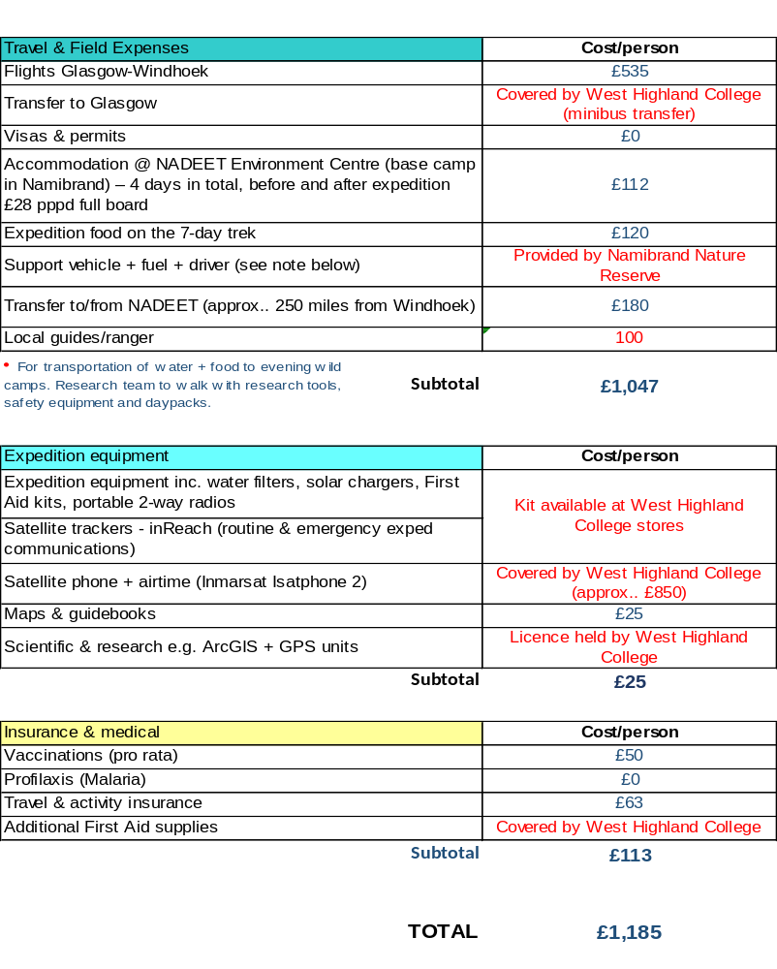

Contingency Plans
Plan B’s in the context of the BS8848. Please note these are NOT emergency plans, although they may have to be deployed as a knock-on effect in case of emergency. The Emergency Response Plan is a separate section in the Expedition Plan – please see below.

Apart from potential difficulties in using GPS mapping tools, the main threat to the expedition is being unable to conduct the fence survey due to heat related illnesses of team members. In case of heat related illnesses in only some of the team members, a healthy sub-team to continue sequences of the survey, will be determined. Should the entire team be affected, they may be required to finish their expedition early.
An issue that may arise in regard to the GPS device is that it may, for some specific reason, stop working. The team would be required to find their way with a compass and map. The team will be taking at least two compasses and maps covering the area of the Namib Rand Nature Reserve as a back-up, should the GPS display any faults.
The main issue that could occur during fieldwork will be support vehicle based. Should the vehicle break down, it is likely the team will not receive required food and water sources. It is essential the team carries enough additional supplies such as an extra 2 litres of water and an extra meal each and has knowledge of in-desert water sources (Appendix 10). This will reduce some of the pressure on support vehicle drivers in case of a break down. The vehicle will be fully insured with breakdown cover.
The team will be walking along the fence line, never further away from vehicle tracks than 5.5km. In emergency or rescue situations it should therefore work quickly to get back to the support vehicle tracks or for in-land help to reach the team.
The tracks present an important safety feature along this route, as movement in emergencies will likely be via these tracks. Should the team get lost or separated, they will backtrack to the last point of contact. However, the risk of getting lost is very low as the team will be following an obvious man-made structure.
Finally, it must be stated that the route itinerary (Appendix 6) is merely a plan and will likely change in the field. By having an outline of objectives each day, the team has a rough structure of their trek that can be changed and adapted flexibly and based on the team’s needs and circumstances.
Travel and transport
Booking and organising requires travel, transport and accommodation to get to the expedition destination. This is considered in the expedition itinerary and the overall budget. Setting dates for these will present a milestone in the planning process as the start of the expedition relies on getting to the Namib Rand Nature Reserve. the dates are listed in the expedition schedule (refer to 3 Expedition Schedule).
Water and food supply
Due to the vehicle dependence of this expedition, the team will be required to carry daypacks that are replenished at each camp. They will organise their daily meals and water according to the trip itinerary before departure and have them in place for the support vehicle to dispatch accordingly. Each member of the team will organize their own food for the day; however the breakfast will be communal (e.g. porridge) and will be bought in Windhoek.

Risk Assessment & Expedition Health
Please use the IEL Risk Assessment template on Blackboard. In this section you also need to include information connected with expedition health e.g. vaccinations, sanitation, water purification

“Expeditions should be about total reliability, about planning the risks and problems out of the project at the planning and training stage. Nowhere is this more important than in the desert where the consequences of getting it wrong are unlikely to be cushioned by living off the land or getting assistance from local people”.
An extensive evaluation and assessment of risk (Appendix 13, 14) has been collated and will be taken along on the expedition. It will enable the expedition team to refer to potential hazards and remind themselves of appropriate behaviour in the field.

Venomous Animals
Antivenom can be very dangerous and needs to be given by someone who can deal with full-blown anaphylaxis (including drips, adrenaline, IV Piriton, hydrocortisone and fluids). The team will thus not be carrying any and will instead make sure a reliable evacuation plan is in place (Appendix 17, 19). The team will be referring to the WHO guidelines on snake bites as well as the Namibian government’s standard treatment guidelines, which involves the appropriate treatment procedures of venomous scorpions, spiders and snakes in Namibia.
Emergency Communications
Communication with home and in country support will be vital in an emergency, having ways of communication will provide the team with the ability to contact help and can also be used to reassure in-country and home country contacts. This expedition will require daily information exchange to allow for a daily delivery of food and water. The college will hire and provide the expedition team with an Iridium Extreme satellite phone, the features of this satellite phone are applicable to a desert environment:
- Dust proof (helpful in desert environments)
- Global coverage (covers expedition location)
- Daylight readable LCD (useful in strong sun radiation)
- Has the ability to send and receive SMS messages
- Share its location via SMS
- Online tracking via SBD
The team will also carry with them a mobile phone on the MTC mobile network, this network is the first and biggest network provider in Namibia and reaches the remote Namib Rand area (Appendix 15).
The team’s list of important and emergency contacts (Appendix 16) is listed as a component of their emergency response plan. first point of emergency contact is the Namib Rand reserve office. However, if this contact fails, the team will contact the Walvis Bay Port Control search and rescue (Appendix 16).

 |  | Likelihood of Harm
UIAA Injury and Illness Classification | Severity of Harm | 1 Remote  e.g. <1 in 1000 chance | 2. Unlikely  e.g. 1 in 200 chance | 3. Possible  e.g. 1 in 50 chance | 4. Likely  e.g. 1 in 10 chance | 5. Probable  e.g. >1 in 3 chance
---- | 1. Negligible | 1 | 2 | 3 | 4 | 5
- Slight injury or illness, no medical intervention necessary, self therapy (e.g. bruises, contusions, strains) | 2. Slight | 2 | 4 | 6 | 8 | 10
- Middle severe injury or illness, not life threatening, prolonged conservative or surgical therapy, outpatient therapy, doctors attendance within a short time frame (days), injury related work absence, heals without permanent damage (e.g. undisplaced fractures, tendon ruptures, pulley ruptures, dislocations) | 3. Moderate | 3 | 6 | 9 | 12 | 15
- Major injury or illness, not life threatening, residential hospital therapy, surgical intervention necessary, immediate doctors attendance necessary, injury related work absence, heals with or without permanent damage e.g. dislocated joint, fractures, vertebral fractures, cerebral injuries | 4. Severe | 4 | 8 | 12 | 16 | 20
- Acute mortal danger, polytrauma, immediate prehospital doctors or experienced trauma paramedics attendance if possible, acute surgical intervention, outcome alive, permanent damage  - Acute mortal danger, polytrauma, immediate prehospital doctors or experienced trauma paramedics attendance if possible, acute surgical intervention, outcome dead  - Immediate death | 5. Very Severe | 5 | 10 | 15 | 20 | 25
- The correlation between the Severity of Harm and the UIAA Injury Classification is not an official match by the UIAA. Please use the above matches to inform your assessment of the severity of hazards in your risk assessment.

RISK LEVELS KEY
1 - 3 | VERY LOW | No specific measures necessary. Awareness and information followed by a sensible approach will suffice
4 -6 | LOW | Consider how you would reduce risk further and bring it down to a negligible level
8 - 10 | MEDIUM | Design and implement effective practical measures to reduce the risk level to LOW or VERY LOW
12 - 16 | HIGH | Unacceptable level of risk. The activity must not take place without comprehensive and effective risk reduction measures that bring the risk level to a maximum of MEDIUM
>16 | EXTREMELY HIGH | Avoidance strategy absolutely necessary. Critically reflect on whether engaging in the extremely high-risk activity is avoidable. If it isn’t, you might need specialist safety training in order to produce realistic and professional-level risk-mitigating strategies.

Hazard | Hazard details  (please provide further details e.g. mechanism of injury) | Risk Factor | Risk control measures | Residual Risk
Wildlife | Injury from predators | 2x5 | Educate team on precaution measures, awareness of dangerous locations, dangerous parts of the day and signs of dangerous wildlife nearby. Ensure food is stored away and disposed of correctly | 1x5
Snake / insect / spider bites | Pain, swelling, inflammation, anaphylactoid symptoms, hypotension | 2x5 | Education on precaution measures and first aid procedures, caution when collecting firewood, beds above floor level, mosquito nets, insecticide, appropriate footwear, correct storage and disposal of food an waste, antivenom | 1x5
Hot Temperate | Lack of water leading to dehydration and sunburn | 4x5 | Require team to drink at least seven litres of water per day. Wear appropriate clothing in the sun, apply sun cream and take breaks in shade when needed | 2x5
Adjusting to climate and surroundings | Inability to breathe properly due to alterations in humidity. Unfamiliar surrounding could create stress for some team members | 3x3 | Prepare the team for this change in climate and temperate. Educating team on what should be expected, have a rest day when team arrives in host country | 1x3
Mountain and cliffs | Fall, injury or death | 3x5 | sure, all team members are aware of risks associated with getting to close to edge, educate team on trip hazards and loose rock. | 1x5
Insect and mosquito bites | Infection, allergic reaction and illness such as malaria and yellow fever | 4x4 | Ensure the team takes precautions, these include malaria tablets, yellow fever injections and antihistamine for allergic reaction. Apply anti-bite spray and wear clothes that cover the body in high risk areas | 1x4
Poor visibility due to darkness at night | Team left with in inability to set up tents or see where they are going | 4x3 | Plan when sun will rise and set each day. All team members should carry a personal head torch and spare | 1x3
Sand in boots | Irritation to feet resulting in blisters and infection, could result in inability to finish proposed route | 4x3 | Team should make sure they remove sand from boots as soon as they feel discomfort to prevent further injury. Blister plasters should be applied, feet should be aired out when possible | 2x3
Heavy bags | Strain injury | 4x2 | Ensure weight is distributed evenly and bag weight is to a minimum | 2x2
Equipment failure, such as broken bag straps or broken boots | Inability to carry equipment or continue expedition | 3x3 | Equipment should be tested before, bring spares where possible | 1x3
Lack of water | Dehydration | 5x5 | Team should consume at least seven litres of water per day | 1x5
Getting lost | Running out of resources, fail of field work mission | 3x5 | GPS and mapping, correct training, all team member should carry a compass and maps, team aware of teach days route | 1x5
Trips, falls and hazard | Injury or infection | 4x3 | Correct footwear, good route choice and high-risk areas highlighted | 2x3
Unsafe state of fence being surveyed | Cuts or injury from the fence leading to infection | 3x2 | Make sure team does not touch the fence particularly at hazardous looking sections | 1x2
Tent breakage or loss | No shelter for team members resulting in hyperthermia or increased risk of attack from predators | 2x5 | All teams’ members should contribute to the assembly of the tent particularly in bag weather conditions. Ensure tent is stored correctly, and check all equipment before expedition execution | 1x5
Sun cream loss, damaged or run out | Sunburn resulting in skin blisters and infection. Highly possibility of sun stroke | 5x4 | Sun scream should be stored correctly. Enough should be brought to last all team member throughout the expedition. Spares should be brought | 2x4
Stove breakage | Inability to heat food or drink | 3x2 | Check equipment before expedition, store correctly and bring spares | 1x2
Gas canisters breakage | Inability to heat food or drink | 3x2 | Frequent checks of gas canisters condition | 1x2
Bugspray broken or lost | Increased risk of insect bites resulting in disease and infection | 4x5 | Make sure spray is stored safely and spares are taken | 2x5
Loss of luggage | Important items lost | 2x1 | Label luggage correctly, take back up necessities in carry-on luggage | 1x1
Traffic incident | Hold up in schedule, possible risk of injury | 3x4 | Check roads before travel to check for any traffic incidents or hold ups on the roads. Check weather and road conditions before travel | 2x4
Damaged or bad quality roads | Damage to vehicle resulting in holed up in schedule. This could be costly to repair, increased risk of traffic accident | 2x3 | Chose a driving route with better quality roads where possible. always drive carefully and use an appropriate vehicle for the terrain | 1x3
Mugging/theft | Loss of valuables, including documents maps passports, monkey ect | 4x4 | Ensuring money and valuables are hidden. Use hotel safe where possible. Travel as a group. Do not enter townships at night without a local to guide you. Keep car doors and windows locked especially in heavy traffic. | 2x4
Bacteria in food | Food poisoning and illness | 3x4 | Make sure there is not cross food contamination. Do not eat dropped or out of date food. Develop water purification methods. Carry anti-bacteria gel for application before cooking | 1x4
Bad hygiene | Team members may become sick and disease will spread faster | 3x4 | Apply anti-bacteria gel. Ensure toilets are far enough away from the camp site and away from the team swatter supply | 1x4
Tent catching on fire | No shelter, possible severe burns and injury. Damage to equipment and supplies | 3x5 | Make sure stove is far enough away from the tent and other flammable material. Never use stoves inside of tents. Team should never leave fire unattended and should ensure fire has been put out before going to sleep | 1x5
Falling over tent guide ropes | Deep cuts or bruises, possible head injury | 2x3 | All team members should be aware where guide ropes have been placed. Everyone should wear a headtorch in the dark to increase visibility | 1x3
Bacteria in food | Food poisoning and illness | 3x4 | Make sure there is not cross food contamination. Do not eat dropped or out of date food. Develop water purification methods. Carry anti-bacteria gel for application before cooking | 1x4
Bad hygiene | Team members may become sick and disease will spread faster | 3x4 | Apply anti-bacteria gel. Ensure toilets are far enough away from the camp site and away from the team swatter supply | 1x4
Falling over tent guide ropes | Deep cuts or bruises, possible head injury | 2x3 | All team members should be aware where guide ropes have been placed. Everyone should wear a headtorch in the dark to increase visibility | 1x3

Emergency Response Plan (ERP)
Please use the ERP template on Blackboard. The ERP needs to contain a comprehensive medical evacuation (MEDEVAC) plan. The ERP plan will also need to include insurance details, compete with your insurance company’s emergency contact number

The team has created an emergency response plan (Appendix 17). This plan will allow the team to react to any crisis or emergency in the most efficient manner. An emergency response plan is situation dependent, however having a plan in place will support the team during any emergency replacing panic with structure and decreasing the level of risk.
In Appendix 18 the initial response steps are collected, that will be considered during an emergency. The British Standards Institute developed a guide for adventurous activities out with the UK. These standards discuss six critical elements that will be involved within the management of any emergency:
- Assign clear roles and responsibilities
- Appoint competent staff
- Plan and prepare
- Provide clear and accurate information
- Safety management
- Emergency plans
Besides having a well-structured and clear emergency response plan in place, the team will recruit the knowledge of a local guide to help them assess danger and risk during the trek.

External Medical Assistance within Namibia
The nearest hospital to the Namib Rand Reserve is in Windhoek, approximately five hours away. The hospital the team have chosen to be sent to in case of any emergency is Mediclinic. This is due to several factors:
- English speaking staff
- Private facility
- They have experience of representing British nationals
Namibia does not provide free health care unlike the UK; therefore, the team will require health care insurance on this expedition. This will not only cover the team financially in terms of health care but will also reduce waiting time, widen choices in terms of access to facilities and treatments and help with emergency situations.
Casualty Evacuation Plan
Significant thought and consideration are necessary when choosing the most appropriate way of evacuating a casualty. The following will be considered if an evacuation is required:
- Danger/difficulty of evacuating victim
- Severity of injury/illness
- Skills/ medical and psychological condition of the rescuers
- Availability of equipment/ rescuers
- Time, distance, terrain, weather
- Cost
A casualty evacuation checklist (Appendix 19) will be used in the event of an incident to ensure nothing is overlooked.
Extraction points have been established along the route, providing clear locations where extraction would be possible. A list of get out points with GPS coordinates and a visual map of the positions of the points is featured below:
Get out point | Latitude | Longitude
1 | 25°10'39.09"S | 15°54'46.56"E
2 | 25°16'5.33"S | 15°53'6.14"E
3 | 25°18'51.48"S | 15°53'20.83"E
4 | 25°21'14.77"S | 15°53'2.67"E
5 | 25°26'33.26"S | 15°54'41.02"E
6 | 25°29'35.01"S | 15°55'59.32"E
7 | 25°33'10.65"S | 15°57'44.34"E
8 | 25°34'52.07"S | 15°58'7.51"E

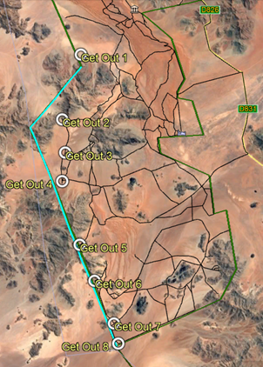
Figure 9. Location of Extraction Points. From: Google Earth (2018)

  - Medical Emergency Levels

Minor
Can be dealt with easily by group and expedition carries on
* Slight injury or illness, First Aid, no medical intervention necessary (e.g. bruises, contusions, strains, other minor ailments, etc.)
Priority 3
Significant
Outside treatment required but a stable casualty can be moved or help is very accessible.
* Not life-threatening but doctors assistance within a short timeframe required e.g. undisplaced fractures, minor dislocations.
Priority 2
Severe
Outside help (SOS call) required. Casualty is not fully stable and reaction timeframe is short. Situation is potentially critical.

* Major injury or illness, not immediately life threatening but with the potential of becoming so rapidly if appropriate action is not taken. Residential hospital therapy and surgical intervention are necessary, immediate doctor’s attendance necessary e.g. major joint dislocations, displaced or open fractures, vertebral fractures or cerebral injuries.
Priority 1
Very Severe/Critical
Outside help (SOS call) required immediately. Critical emergency where death of casualty is possible or likely.
* Acute mortal danger, polytrauma, trauma paramedics and acute surgical intervention necessary. Outcome is permanent damage/disability or death.
*As per UIAA Medical Commission Injury Classification
https://www.theuiaa.org/documents/mountainmedicine/UIAA_MedCom_Rec_No_17_Injury_Classification_2010_V1-4(1).pdf

Incident Handling

 | Incident Handling
Priority 3  Significant  Outside treatment required but a stable casualty can be moved or help is very accessible.  * Not life-threatening but doctors assistance within a short timeframe required e.g. undisplaced fractures, minor dislocations. | Immediate Actions  - Assess scene and ensure team is safe  - First Aid  Secondary Actions  - Stabilise casualty  - Assess if a SOS call is necessary  - Establish communications with base camp or HQ  - Consider MEDEVAC options and timescales  Further Actions  - Discuss and implement Contingency Plan  - Confirm agreed course of action with HQ. Maintain communications.  - Plan and review next steps  - Keep a record of events – incident documentation  - Support / Manage team | Notes  Good judgement is fundamental at this level of emergency. Once the casualty is stabilised and the team are all safe the group needs to assess and discuss if a SOS call is necessary. A factor in this decision will be the feasibility of your reaching medical assistance independently within an acceptable time. You will need to refer to the MEDEVAC plan to such effect.  HQ communications are managed by the team’s Communications Officer. Main points of contact are the HQ Main Emergency Contact or, if unavailable, the HQ Backup Emergency Contacts.  If SOS is not necessary then MEDEVAC options need to be discussed and agreed with HQ. Communications need to be established and maintained throughout the process. If communications break down or are not possible then the team needs to exercise initiative and decide on the best course of action.  The expedition will continue, in all probability, but might end early. A Contingency Plan will need to be put in place and casualty care will need to be arranged - on location, in hospital and after being discharged while in the country.
 | Incident Handling
Minor  Can be dealt with easily by group and expedition carries on  * Slight injury or illness, First Aid, no medical intervention necessary (e.g. bruises, contusions, strains, other minor ailments, etc.) | Immediate Actions  - First Aid  - Plan next steps  Secondary Actions  - Monitor casualty  - Establish communications with base camp or HQ – for information purposes | Notes  No further actions necessary. The expedition will continue after the next steps have been discussed. These may include a change of schedule or the implementation of a Contingency Plan.

 | Incident Handling
Priority 2  Severe  Outside help (SOS call) required. Casualty is not fully stable and reaction timeframe is short. Situation is potentially critical.  * Major injury or illness, not immediately life threatening but with the potential of becoming so rapidly if appropriate action is not taken. Residential hospital therapy and surgical intervention are necessary, immediate doctor’s attendance necessary e.g. major joint dislocations, displaced or open fractures, vertebral fractures or cerebral injuries.  SOS call | Immediate Actions  - Assess scene and ensure team is safe  - First Aid  - SOS call  Secondary Actions  - Stabilise casualty  - Liaise with emergency services on casualty extraction point.  - Establish and maintain communications with base camp or HQ  - Monitor casualty until rescue services arrive  Further Actions  - Support / Manage team  - Keep a record of events – incident documentation  - Plan and discuss next steps with HQ. | Notes  This level of priority is characterised by an immediate SOS call as soon as the team is safe and First Aid is being administered effectively.  Communications need to be established and maintained with HQ, as soon as possible and throughout the process. If communications break down or are not possible then the team needs to exercise initiative and decide on the best course of action.  HQ communications are managed by the team’s Communications Officer. Main points of contact are the HQ Main Emergency Contact or, if unavailable, the HQ Backup Emergency Contacts.  The expedition will end, in all probability. This is a time-critical emergency level on a situation that could become life-threatening. The priority is to take the casualty to a medical facility by the fastest possible method. The casualty is not fully stable hence the SOS call. A team member needs to accompany the casualty, if possible.  The team may need to be extracted to minimise the potential traumatic impact of events. If extraction is not possible then the team needs to head for the nearest extraction point as per MEDEVAC chart.  Do not contact next of kin, even if they are known to you personally.

 | Incident Handling
Priority 1  Very Severe/Critical  Outside help (SOS call) required immediately. Critical emergency where death of casualty is possible or likely.  * Acute mortal danger, polytrauma, trauma paramedics and acute surgical intervention necessary. Outcome is permanent damage/disability or death.  SOS call | Immediate Actions  - Assess scene and ensure team is safe  - First Aid  - SOS call  Secondary Actions  - Stabilise casualty  - Liaise with emergency services on casualty extraction point.  - Establish and maintain communications with base camp or HQ  - Monitor casualty until rescue services arrive  Further Actions  - Expedition is cancelled  - Discuss escape routes and extraction points for the rest of the team  - Support / Manage team  - Keep a record of events – incident documentation  - Discuss escape plan and end of exped with HQ. | Notes  This level of priority automatically demands a SOS call and triggers the end of the expedition.  Additionally, the rest of the team will need to be extracted to minimise the potential traumatic impact of events. If extraction is not possible then the team needs to head for the nearest extraction point as per MEDEVAC chart.  Communications need to be established and maintained with HQ, as soon as possible and throughout the process. If communications break down or are not possible then the team needs to exercise initiative and decide on the best course of action.  HQ communications are managed by the team’s Communications Officer. Main points of contact are the HQ Main Emergency Contact or, if unavailable, the HQ Backup Emergency Contacts.  This is a time-critical emergency level on a situation that is seriously life-threatening. The priority is to take the casualty to a medical facility by the fastest possible method. The casualty is very unstable hence the SOS call. A team member needs to accompany the casualty, if possible.  Do not contact next of kin, even if they are known to you personally.

  - Key contacts / communications

West Highland College
Name | Role | Mobile no. & email address
Jose Navarro | Expedition Coordinator | +44 7731 899876  jose.navarro.whc@uhi.ac.uk
Carl Haberl | Operations Manager  HQ Main Emergency Contact | +44 7765 774830  carl.haberl.whc@uhi.ac.uk
Alex Williams | Programme Leader  HQ Backup Emergency Contact | +44 7713 040094  alex.williams.whc@uhi.ac.uk
WHC Front Desk | +44 1397 874000
Claire Knifton | Expedition Supervisor & Assessor
Matt Groves | Expedition Supervisor & Assessor
Amy Exeter | Expedition Supervisor & Assessor
Lee Woodward | Expedition Supervisor & Assessor
Deb Pinniger | Expedition Supervisor & Assessor
Annabel Lawrence | Expedition Supervisor & Assessor

Expedition team
Name | Role | Mobile no.
Harriet | Medical Officer, Incident Manager
Rosie | Communications Officer
Fiona | Expedition Photographer, First Aider
Sarah | Financial Officer, First Aider
Amy | Logistics Officer
Megan | Scientific Project Officer

In-country support & emergency contacts
Name | Address & contact details | UTM or Lat/Long grid reference (if applicable)
 | +263 (62) 52-3811
  Ambulance
Fire Brigade | +264 (62) 52- 2091
Hospital | +264 (62) 52-2006
Police | +264 (62) 1-0111
Namib Rand Nature Reserve | +264-61-224882
NaDEET Centre Namib Rand | +264 63-693012
MRCC  Walvis Bay Port Control | +264 64 208 2265
Namibia Search & Rescue  NAMSAR | +264 61 2088025/6/7
British Embassy | British High Commission  116 Robert Mugabe Avenue  Windhoek  Namibia  Local Number: (061) 274.800  International Number:  +264 61 274 800
EMed Rescue 24 | +264 61 411 600
International SOS | Johannesburg Assistance Centre +27 (0) 11 541 1300
City Cab Airport Transfer  Jason Tembo | 0812 572 188  0852 572 188
Horizon Transfer | +264 81 257 4243
Tamboti Guesthouse | +264 61 235 515  +264 61 259 855
 | +264811291655
  Nils Odendaal (mobile)
Murray Tyndall (Control Warden) - landline | +26463683026
* Information on the above table are only examples. Please amend as required and include: main hospitals, local health centres, ground agents if applicable and SAR contacts.
Extraction points/Escape routes (in yellow)
Group Name: Namibia Team |  |  |  |  |  |  |  |  |  |  |  |  | Aim of expedition: The aim of this expedition is to trek and survey the Southern 50km of the boundary fence between Namib Rand Nature Reserve and Namib-Naukluft National Park in Namibia.
Expedition Dates: 26th May to 31st May 2019 |  |  |  |  | Names of team members: |  |  | Amy Savage |  |  | Megan Gray
 |  |  |  |  | Sarah Becker |  |  | Fiona Mackay |  |  | Rosie Forsyth
 |  |  |  |  | Harriet Barr |  |  | Jose Navarro |  |  | Amy Exeter
Day (see image below) |  |  | General direction  or bearing | Distance  in km  (30 mins per km) | Height climbed in m  (1 min per 5 meters) | Time allowed for journeying | Time allowed for surveying, rests or meals |  | Total time  for leg
Day (see image below) | Latitude/ Longitude |  |  |  |  |  |  |  |  | Brief details of route to be followed or planned activity.  (Enter full details of activity on reverse) |  |  |  | Escape/Notes
(a) | (b) |  | (c) | (d) | (e) | (f) | (g) |  | (h) | (j) |  |  |  | (k)
- Red Route | 25°34’52.83”S/ 15°58’7.40”E |  | NW | 9.20km  (4hrs 35mins) | 40m  (4 mins) | 4hrs 39mins | 2hrs |  | 6hrs 39mins | Handrail fence: veer right to meet path after 9.10km (camp) |  |  |  | 25°30’41.35”S/ 15°58’23.51”E Emergency water source: Four tanks 25°33’18.18”S/ 16°00’03.99”E
- Yellow Route | 25°30’41.35”S/ 15°58’23.51”E |  | W | 8.29km  (4hrs 5mins) | 672m  (2hrs 14mins) | 6hrs 19mins | 1hr |  | 7hrs 19mins | Veer left to meet fence, handrail fence: meet path after 8.29km (camp) |  |  |  | 25°26’35.82”S/ 15°54’36.52”E Emergency water source: Four tanks 25°33’18.18”S/ 16°00’03.99”E
- Green Route | 25°26’35.82”S/ 15°54’36.52”E |  | NW | 10.7km  (5hrs) | 427m  (1 hr 35mins | 6hrs 35mins | 1hr |  | 7hrs 35mins | Handrail fence: veer right to meet path after 10km (camp) |  |  |  | 25°21’09.59”S/ 15°53’01.10”E Emergency water source: Straussen Wasser 25°21’12.14”S/ 15°53’01.68”E
- Pink Route | 25°21’09.59”S/ 15°53’01.10”E |  | SW | 11.4km  (5hrs 30mins) | 47m  (9mins) | 5hrs 39mins | 1hr |  | 6hrs 39mins | Veer left to meet fence, handrail fence: veer right to meet path after 9.06k (camp) |  |  |  | 25°18’57.93”S/ 15°53’17.27”E Emergency water source: Straussen Wasser 25°21’12.14”S/ 15°53’01.68”E
- Orange Route | 25°18’57.93”S/ 15°53’17.27”E |  | W | 14km  (7hrs) | 551m  (1hr 50mins) | 8hrs 50mins | 1hr |  | 9hrs 50mins | Veer left to meet fence, handrail fence: veer right to meet path 8.34k (camp) |  |  |  | 25°16’11.81”S/ 15°53’18.45”E Emergency water source: Straussen Wasser 25°21’12.14”S/ 15°53’01.68”E
- Blue Route | 25°16’11.81”S/ 15°53’18.45”E |  | NW | 13.9km  (6hrs 30mins) | 195m  (39mins) | 7hrs 9mins | 1hr |  | 8hrs 9mins | Handrail fence: meet track after the fence veers off to the left :) |  |  |  | 25°10’40.90”S/ 15°54’54.65”E Emergency water source: Schafberg 25°12’10.82”S/ 15°57’12.71”E
 | Totals: |  |  | 67.49km  (32h40) | 1932  (6h31 | 39hrs 11mins | 7hrs |  | 46hrs 11mins

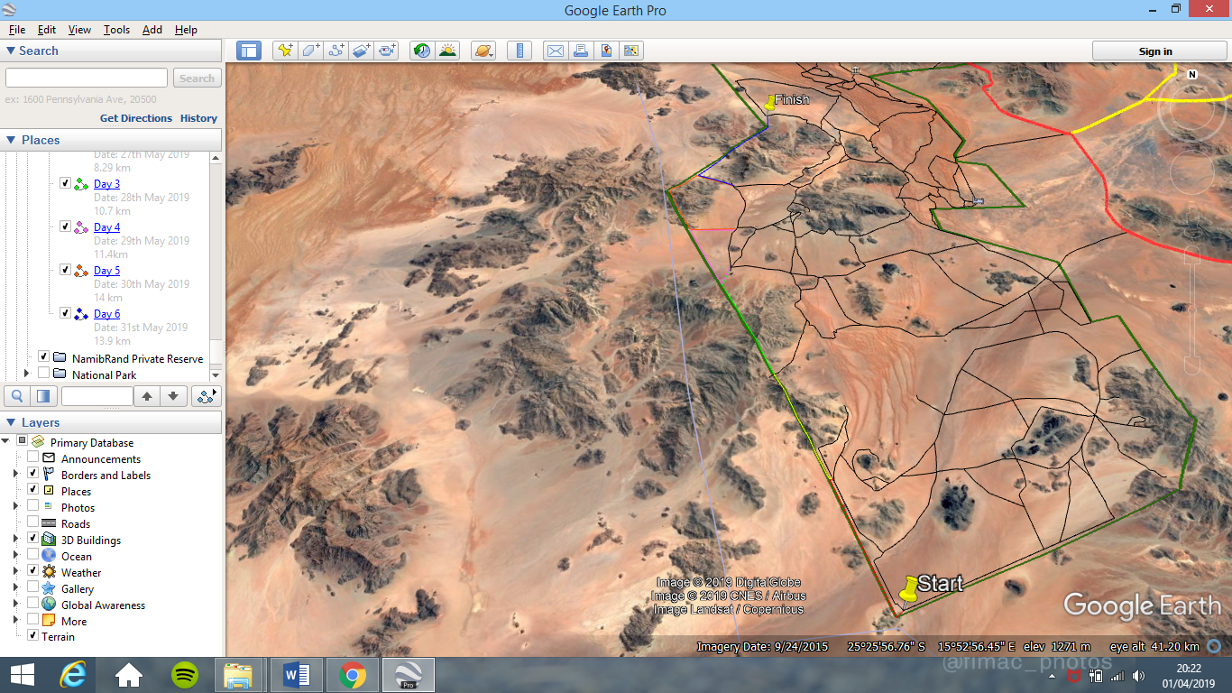

Hospital & Health CEntre locations
  - Maltahohe
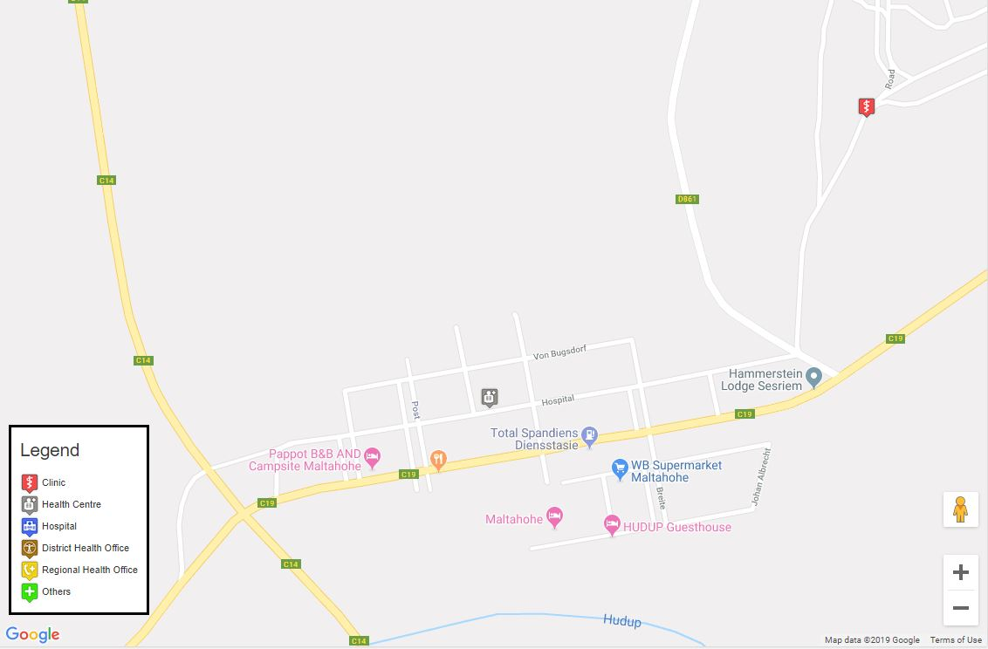
  - Windhoek
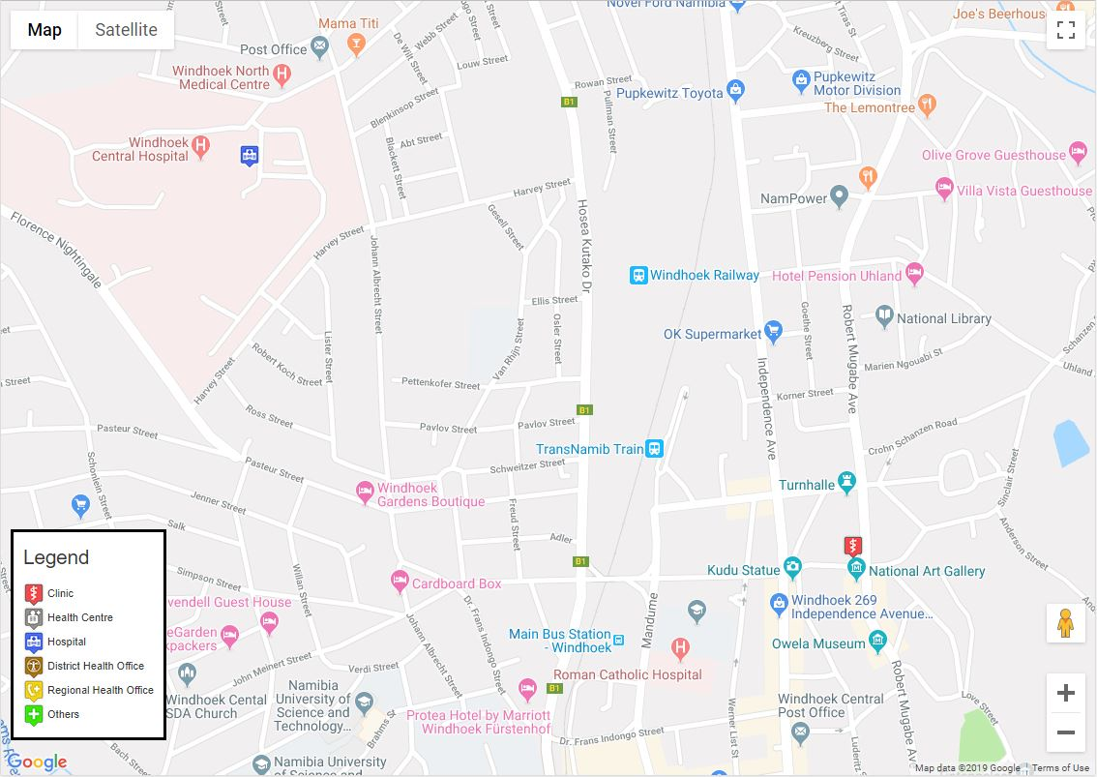

Environmental Strategy
Briefly explain your impact & minimum resource use approach. This should be a collection of pro-active strategies that aim to minimize your environmental and socio-economic impact in your expedition area.

Environmental Strategy
Namibia is one of the world leaders in pursuing conservation initiatives (Appendix 23). With this in mind we have developed a list of potential positive and negative environmental impacts we may encounter:
Positive | Negative
Improved management of sensitive habitats | Over development
Increased awareness of natural values and importance | Destruction of environment
Strengthening of natural heritage | Disturbance to wildlife
Stimulation of funding for natural heritage conservation | Overconsumption of natural resources
Increased understanding of possible positive impact of tourism and fieldwork | Pollution

We will follow an environmental strategy with six main principles to minimise our impact on the environment of the NamibRand area:
Plan ahead
- Assess environmental impact (see Appendix 24) and act accordingly (create subsequent Environmental management practical working plan)
- Use local resources sustainably
- Avoid waste and overconsumption
- Maintain and encourage natural diversity and respect wildlife
- Promote education and awareness for sustainable development (collaborating with NaDEET)
Things we will do to minimise our environmental effect:
- All rubbish will be disposed of appropriately or carried until it can be disposed
- Minimal signal use plastic will be taken to and from Namibia (shampoo bottles, boil in the bag food pouches, etc)
- Faeces to be buried at least six inches deep
- No plants or animals will be handled or removed from their environment
- Care will be taken when trekking to avoid disturbing the terrain
- “Leave no Trace” standards will be attired too

Endorsements and Stakeholders
Relevant contacts in UK and in-country, inc. links at institutional and official level, if applicable.

- The Neil Mackenzie Trust
- West Highland College
- Quest Solutions
- Mountain Warehouse
- School of Adventure Studies
- NaDEET
- Namib Rand Nature Reserve Namibia

Empowering and Reaching Out
Please reflect on who will benefit from your expedition, beyond yourselves that is. Think further about how you can use your expedition as a vehicle that also brings benefits to the host community and environment. This section also needs to include PR and post-exped arrangements.

To accomplish the expedition’s supporting objective of empowering other young females to explore, the team will endeavour to produce a video documentation of their expedition. On return, they will ‘tour’ the video in local schools with the hope of encouraging, motivating and ultimately empowering young women to dream big and adventure.

1. Expedition Log
Concise, day-by-day account of main events.

Date | Location | Breakdown of day
21/05/19 | Travel | - Meet at college 11.30am  - Transfer to Glasgow airport 12pm  - Arrival at Glasgow airport 3pm  - Flight to Amsterdam 5pm  - Arrival in Amsterdam 7.30pm  - Flight to Windhoek 11pm
22/05/19 | Windhoek | - Arrival at Windhoek airport 11am  - Transfer to Tamboti Guesthouse  - Introductory information from owner Sigrid  - Changing currency at bank (USD to ND)  - Buying food for Windhoek at supermarket  - Restaurant for dinner
23/05/19 | Windhoek | - Breakfast at guesthouse  - Shopping for gas, food, maps, souvenirs  - Rearranging Horizon transfer pick up to 3 hours earlier in order to arrive at NaDEET in time for the first day of the game count  - Talking through comms procedure  - Harriet’s birthday  - Fiona and Rosie demolish an entire Foufou (with sauce)  - Bar payment settlement at Tamboti  - Agreement on an early breakfast
24/05/19 | Travel and NaDEET | - Early breakfast at Tamboti  - Leaving guesthouse with Horizon Transfer at 7am  - Arrival at NaDEET 2.45pm  - Game count briefing  - Discussing first aid and packing distribution  - Message sent to support team in Britain  - Dinner at NaDEET  - Meeting student form Nebraska  - Night not as cold as expected
25/05/19 | NaDEET | - 6.45am leave for game count  - Group divided into 2 – separate routes checked  - Seeing different indigenous animals (I.e. zebra, oryx, hyena, springbok0  - Lunch 1pm  - Dune surfing  - Group meeting at 3pm to discuss maps, comms and survey method  - Introduction to NaDEET 4pm  - Dinner 6.30pm  - Testing sun shield tarp  - Message to support team in Britain requesting information on weather and wind
26/05/19 | NaDEET and Desert | - Fiona’s birthday, cake for breakfast  - Briefing with Murray  - Leave NaDEET 9am  - Travel to south west corner of the fence via pick-up truck  - Begin survey 11am (2 groups: 3 surveying, 3 on break, rotating every hour)  - Set up tarp for shade  - Lunch 1.30pm  - Resume survey 3pm  - Walking speed 2km/h  - Cooler weather in afternoon due to wind and cloud  - Reaching camp 15.30 pm  - Setting up camp, tents, stove, toilet area  - Dinner 6pm  - Team debrief, comms 7pm  - Deciding that the survey group would walk at the front to upkeep group togetherness
27/05/19 | Desert | - Waking 6.45am  - Clear up camp and leave by 8am  - Trekking day, walking around mountain range, no fence to survey until 4pm (200m stretch)  - Half of team walk up to saddle point to check for more fence  - Dinner and camp set up by 6pm  - Trying Oryx meat  - Fire set up by guides  - Group debrief and making plans for next day 6.45pm  - Socializing around fire 7pm onwards
28/05/19 | Desert | - Wake up 7am  - Pack up camp by 8am  - Drive around mountain range to next section of fence  - 10km fence survey  - Lunch break during hottest part of day (12.15pm - 2.15pm)  - Group looking at map and discussing plans for following days  - Drive form end of survey point to camp in plain  - Set up camp by 5.15pm  - Dinner 6pm  - Group debrief and comms 6.30pm  - Bedtime 7.15pm
30/05/19 | Desert | - Wake up 7am  - Pack camp by 8am  - Walking along and surveying fence by 8.30am  - Encountering 3 snakes along the way (Fiona and Amy E. both almost step on a horned adder, third snake Namibian sand snake)  - Break for approx. 3 hours under tarp (11.30am - 2.30pm)  - Continue survey until the end of the fence  - Set up camp near kraals  - Dinner 5.30pm  - Socializing around fire  - Thanking guides for their help and support, handing them the agreed tips and useful gifts  - Sand storm interrupting cooking of dinner  - Murray checking up on us 7pm to see if we are alright  - Rain and thunder during the night  - Outer layers spread over tents 2.40am
31/05/19 | Desert and NaDEET | - Wake up 6.30am  - Walk up dunes behind camp for sunrise  - Walk down to pack up camp 8am  - Drive to Wolwedans (2hrs)  - Brunch at Wolwedans (very fancy and surreal after spending a week in the sand)  - Short tour around Wolwedans  - Drive to NaDEET (1hour from Wolwedans)  - Packing, showering  - Tea and cake  - Interviews and sound collecting with Jose, recapping our experiences  - Dinner at NaDEET 6.30pm  - Socializing in café before bed
01/06/19 | Travel | - Wake up 6am  - Breakfast at NaDEET 6.30am  - Horizon transfer to Windhoek airport 7am  - Flight to Amsterdam 5pm
02/06/19 | Travel | - Arrival in Amsterdam 6am  - Flight to Glasgow 9.30 am  - Arrival in Glasgow 10am  - Transfer to UHI WHC  - Arrival in Fort William 1.30pm

2. Findings and Recommendations
With reference to the Aim & Objectives. Think about information that would be useful for expeditions following in your footsteps – information that you only obtained in the field, while doing the expedition.

Recommendations
- Order Foufou with a sauce
- When changing currency, take your flight ticket and passport with you
- Windhoek Pick and Pay supermarket in shopping center has all necessary items
- Tamboti Guesthouse is excellent for travel groups
- Horizon transfer Windhoek is a very reliable transfer company
- Be aware of the speed of sunset and the risk of walking in town at night
- Traffic lights in Windhoek speak their own language
- Windhoek office for maps was excellent
- Ensure you are getting the right fitting gas bottle for the stove (screw-top not click-top)
- Bargain with people on stalls
- Bring more than 2 firelighters
- Less animals in proximity and visible than expected
- Tarp for shade is an unmissable necessity
- Don’t touch random bugs (especially colorful centipedes as they may be highly venomous)

3. Individual self-reflective commentary
Please be as open and candid as you can; these are confidential and will need to be submitted individually.

Appendices

Appendix 1; Boundary Fence
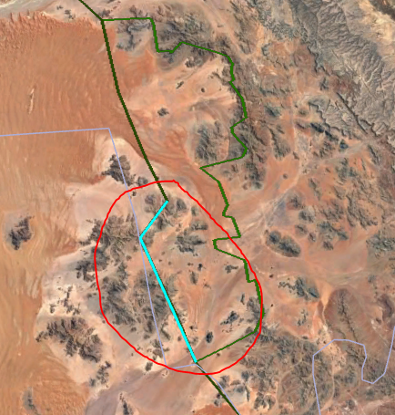
Figure 10: NRNR Boundary Fence. From: Google Earth (2018)

Appendix 2: Namibia Topographic Zones Information

 | Namib Desert | Central Plateau | Kalahari Desert
General | - Central desert covering 1,200 miles  - Excluding a number of scattered towns, remains almost entirely unpopulated by humans | - Largest landscape formation in Namibia  - Windhoek (Namibia’s Capital) located here | - Largest desert in South Africa, occupies eastern third of Namibia (estimated having a 360,000 square miles)
Landscapes | - Isolated steep mountains  - Steep walled gorges  - Smooth desert  - Rivers  - Dunes | • Mountains, ravines, salt pans  • Namibia’s highest mountain is here | - Contains sand sheets, longitudinal dunes and vleis  - Sand is red in many areas from iron oxide coating sand grains
Temperatures | - Coastal area temperatures range from 10-16 degree Celsius during day and night, through all seasons | • Average lowest temperature (in Windhoek) 13 degree Celsius. Highest is 24 | - In summer, shade temperatures reach 46 degree Celsius.
Rainfall | - Average annual rainfall ranges from 13mm in the coastal regions to 51mm further inland. | - Average annual rainfall is 370mm | - Receives no rainfall for 6-8 months
Plant life | - Succulent vegetation (Coastal region)  - Barren lands (outer Namib)  - Bushes and tall grasses (inner Namib)  - Native Namib plant, the tumboa | - Shrubs, trees and grasses | - Difficult for plants to grow due to deep sand covered areas, however some shrubs and short grasses do exist there
Animal life | - Antelope, Ostriches and Zebra (Inner Namib)  - Beetles, geckos and snakes (Dunes of Outer Namib) | - Main human population | - Northern area: elephants, lions, hyenas and snakes  - Southern animals: Oryx, steenbox and eland

Table adapted from: Rafferty 2017; Green 2018; Logan 2018 and Silberbauer 2017

Appendix 3: General Route
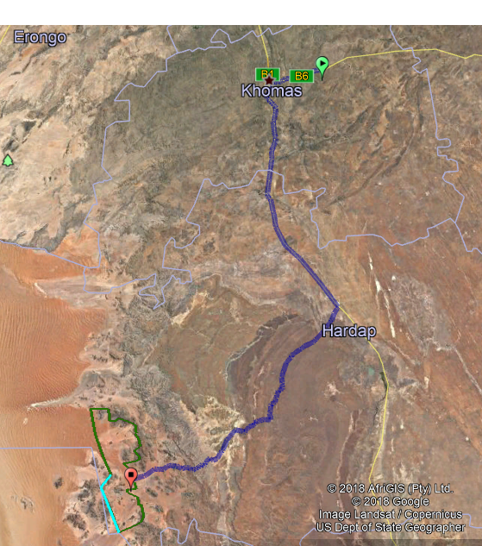
Figure 11. Route Airport to NamibRand NR. From: Google Earth (2018)

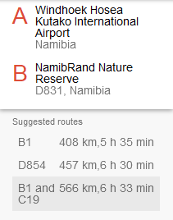
Figure 12. Airport to NRNR suggested Routes. From: Google Earth (2018)
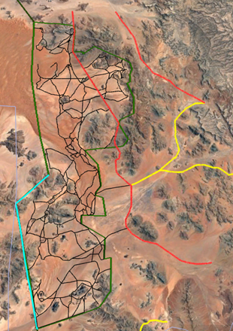
Figure 13. Namib Rand Roads and Tracks. From: Google Earth (2018)

Appendix 4: In-reserve route
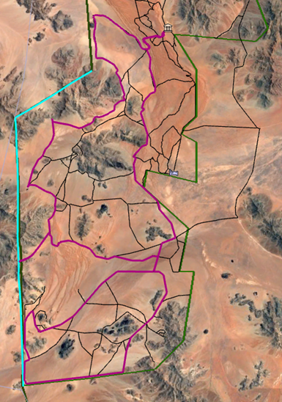
Figure 14. Namib Rand Support Vehicle Route. From: Google Earth (2018)
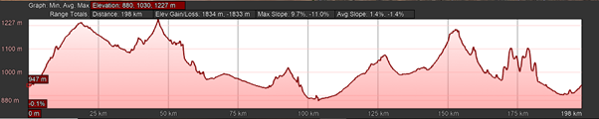
Figure 15. Vehicle Route Elevation Profile. From: Google Earth (2018)

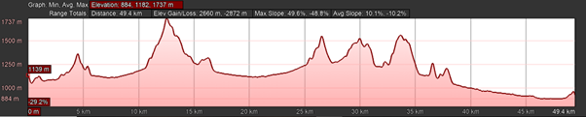
Figure 16. Fence Elevation Profile. From: Google Earth (2018)
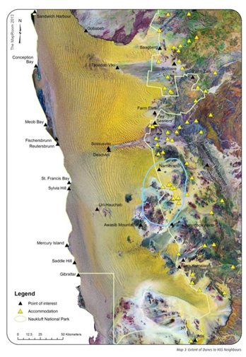
Figure 17. Extent of Dunes. From: Inked MET (2013)
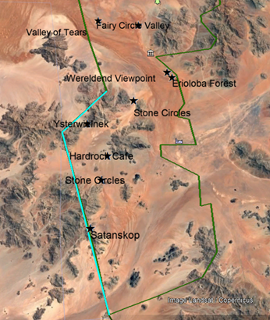
Figure 18. Points of Interest. From: Google Earth (2018)

Appendix 5: Climate Namib Area
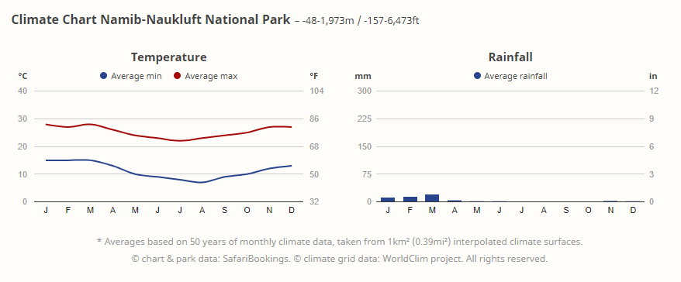
Figure 19. Climate Namib-Naukluft.

Appendix 6: Climate History
14.8.1 Wolwedans 2016
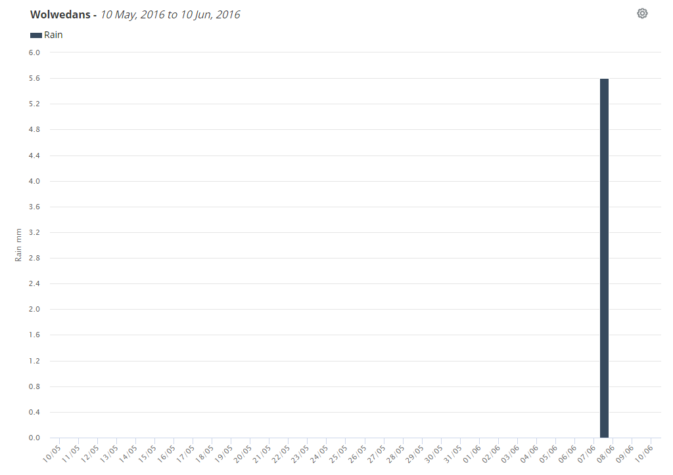
Figure 20. Rainfall 2016. From: Weather Link (2018)

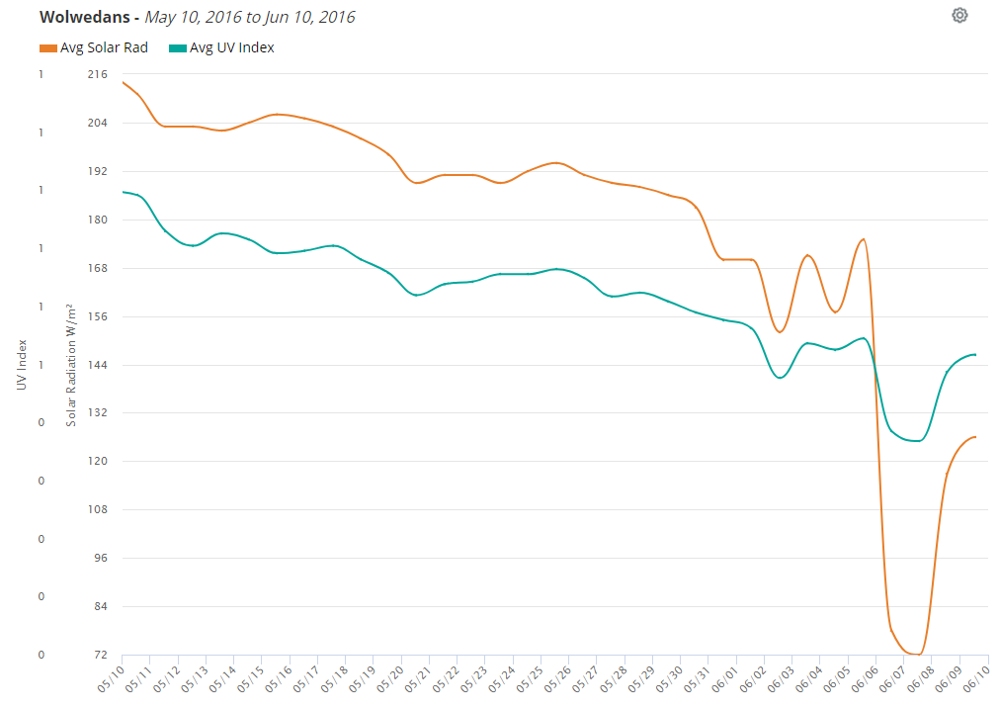

Appendix 7: Water Supply
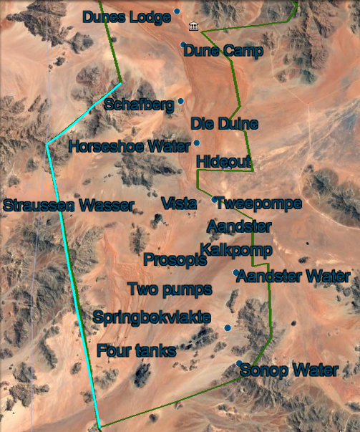
Figure 37. Water Supply Points. From: Google Earth (2018)

Appendix 8: Vaccinations
 | All Travelers | Some Travelers | Course | Team members vaccinated
Diphtheria | ✓ |  | Any time before travel 1 dose | all
Hepatitis A | ✓ |  | 2 weeks before travel 1 dose | all
Tetanus | ✓ |  | Any time before travel 1 dose | all
Hepatitis B |  |  | 3 weeks before travel 3 doses | Harriet, Rosie, Fiona, Amy
MMR | ✓ |  | 1 month before travel 2 doses | all
Rabies |  | ✓ | 4 weeks before travel 3 doses | Amy, Harriet, Fiona, Sarah
Typhoid | ✓ |  | 2 weeks before travel 1 dose | all

Appendix 9: Proposed Budget
This budget gives a rough estimate with the thought process being ‘worst case scenario’. We hope to make this trip as cost effective as possible.
Category | Description | Cost (Per team member £) | Cost (Entire Team £)
Travel
- Scotland travelling to and from airport | Fuel – 1 car for entire Team | 7.50 | 30
- Glasgow to Windhoek | 18.5-hour flight, 2 layovers | 608 | 2,432
- Windhoek to the Guest House | 5-minute journey through town | 2.75 | 12.45
- Windhoek to Namib Rand | Hire of vehicle to Namib Rand and from Namib Rand to the airport | 31 | 124
Accommodation
- Tamboti Guest House | 2 nights’ accommodation at Guest House | 55 | 320
- At the Namib Rand | 4-5 nights’ accommodation at Namib Rand | TBC – estimated 100-200 | TBC- estimated 400-800
Food
- For expedition | 7 days expedition food:  -Breakfast  -Lunch  -Dinner  -Snacks | Budgeting for 10-15 a day  = 150-225 | 600-900
Equipment
- Additional equipment needed | Will vary depending on what equipment team members already own | Up to 100 | Up to 400
Insurance and medical
Vaccinations | For any not included on the NHS | 482 | 1,928
Training
- Petrol | For getting to training locations (one car for whole team) | 15 | 60
- Food | For practice expedition:  -Breakfast  -Lunch  -Dinner  -Snacks | 10-15 per day = 50-75 | 100-300
Additional
Spending Money | Money to use in Namibia in case of emergency | 200 | 800
Total

Appendix 10: Network Coverage
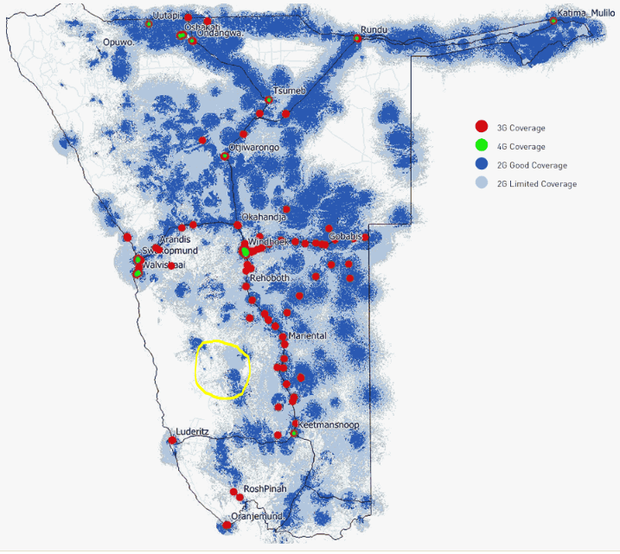

Appendix 10: Steps taken in an emergency
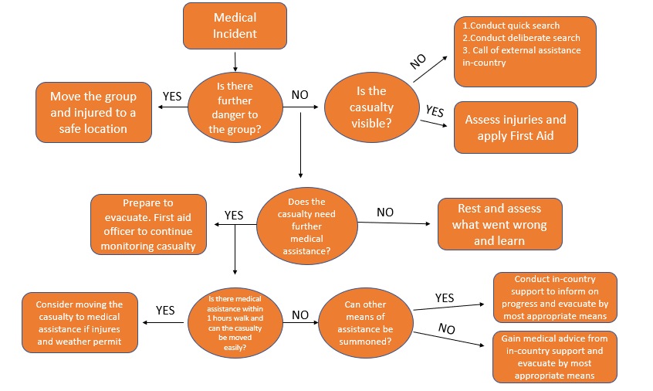

Appendix 11: Casualty Evacuation Checklist

Casualty Evacuation Checklist
- The priority is the assessment and treatment of the casualty
- All team members (including the casualty if possible) are included in the decision-making
- Contact is established with the support vehicle and in-country contact
- Reporting of casualty and critical incident (useful for medical personnel receiving the evacuee):
  - Information on location
  - Type of incident
  - Hazards
  - Access to and egress from the incident scene
  - Illness/injury
  - Personnel and equipment present and required One team member must stay with casualty
- Required resources will be kept with the casualty:
  - Money
  - Credit card
  - Passport
  - Travel insurance details
  - Prescription medications
  - Casualty and critical incident report forms
  - Sleeping bag
  - Warm layers
  - Food and water

Appendix 12: Equipment Kit List
Personal Kit | Priority | Optional
Passport | ✓
Small Personal First Aid Kit x1 (paracetamol, blister plasters, insect repellent) | ✓
Daypack (25L to 35L) | ✓
Duffle or large rucksack (60L to 65L) | ✓
Medication (if applicable) |  | ✓
Head torch with spare batteries | ✓
Battery pack | ✓
Compass | ✓
Toiletries (deodorant, toothbrush, wipes, sanitary products) | ✓
Lip balm with sunscreen | ✓
Walking Poles |  | ✓
Sun hat | ✓
Sunglasses (polarized) | ✓
Camping mat | ✓
Sleeping bag (3 season) | ✓
Sleeping bag liner |  | ✓
Walking Boots and walking shoes (no open toes) | ✓
Gaiters |  | ✓
Trousers (polycotton) x3 | ✓
T-shirt/base layer/long sleeve x 7  (light colours, no camouflage, it is illegal) | ✓
Sweatshirt/fleece x 2 | ✓
Underwear x 14 | ✓
Socks x 14 | ✓
Pyjama’s x 2 | ✓
Warm hat | ✓
Gloves | ✓
Food (day snacks and dinners) | ✓
Plate/bowl/cutlery/mug x 1 | ✓
Dry bags | ✓
Small notepad/pen |  | ✓
Watch | ✓
Travel towel |  | ✓
Water Bottle 1L x 2 and water bladder (2L to 3L) | ✓
Headnet |  | ✓
Insect repellent (with deet) | ✓
Book |  | ✓
Phone | ✓
Money | ✓
Group Kit List | Priority | Optional
Tents (3-man tent x2) | ✓
Stoves x 3 | ✓
Sunscreen x 3 (High factor) | ✓
Group First Aid Kit x 1 (emergency shelter, survival bag, bandages, scissors, tick twister, dressings, plasters, ice pack, gloves, wipes, tape, tube grip, immodeme, sodo crème, duct tape) | ✓
Group shelter or bivvy bags | ✓
Sat phone | ✓
Garmin GPS tracker with spare batteries AA | ✓
Water tablets x 100 | ✓
Water filter | ✓
Matches x 2 boxes | ✓
Fuel x 4 | ✓
Map x 2 | ✓
Map case x 2 |  | ✓
Solar powered battery pack x 2 | ✓
Drone x 1 |  | ✓
Camera x 2(waterproof) | ✓
Gopro x 2 |  | ✓
Trowel | ✓
Binoculars |  | ✓
Tarp |  | ✓
Wash kit (toothpaste, conditioner, shampoo) | ✓
Food | ✓
Surveying equipment (notepad, clipboard, pen) | ✓
Day Pack | Priority | Optional
Water bladder (2.5 L to 3L) | ✓
Spare water (1 L) | ✓
Down/synthetic jacket | ✓
Bivvy bag each or group shelter | ✓
Emergency food (rations) | ✓
Personal first aid kit | ✓
Snacks | ✓
Survey equipment (notepad, pen and clipboard) | ✓
Cameras | ✓
Sun cream/lip balm | ✓
Insect repellent | ✓
Drone |  | ✓
Map | ✓
Compass | ✓
Sat phone x 1 | ✓
Garmin GPS tracker x 2 | ✓
Water tablets | ✓
Sunglasses | ✓
Sun hat | ✓
Walking poles |  | ✓
Spare socks |  | ✓
Head torch with spare batteries | ✓
Face buff (for sand) | ✓
Small fire starting kit (group) | ✓
Power bank | ✓
Tarp for shade |  | ✓

Appendix 13: Training – Entire Team

Ballachulish forestry walk – Group Practice Expedition
Pre-Planning: As with their expedition to Namibia, the team will plan and consider similar factors to ensure a successful walking expedition. For example:
- Route planning, including emergency escape routes.
- Creating a day to day itinerary
- Looking at past weather history and the geological formation of the location to decide upon appropriate equipment to bring
- Risk assessments
- Contingency planning
During Expedition:
- Use teamwork to complete the expedition as an organised and cohesive unit
- Practice surveying skills
- Practice using recording equipment (video camera and voice recorder for podcast)
Aftercare:
Review the walk and what could be improved (e.g. team work, equipment use)

Appendix 14: Namibia Conservation Areas
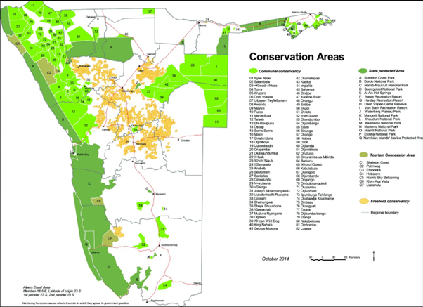
Figure 41. Conservation Areas in Namibia. From: MET (2018)

Appendix 15: EIA Practice
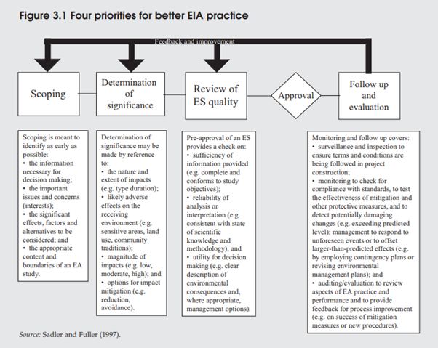
Figure 42. Four priorities for better EIA practice. from: UNEP (2004)

Appendix 16: NMT Grant Offer
The Neil Mackenzie Trust Expedition Grant 2019 Offer
Grants are available for expeditions in Scotland, UK and anywhere in the world. The value of the awards made will be limited to a percentage of the total budget and awards will not be made towards the purchase of clothes or equipment or to cover the whole cost of any proposed expedition. Some funding must be provided from your own resources or from other grants. The amount of grant is determined by The Neil Mackenzie Trust. Please note that this offer may be withdrawn if not accepted within 30 days of date of offer.
The applicants are responsible for their own insurance and The Neil Mackenzie Trust can take no responsibility for any claims or incidents arising out of the expedition.
A written report to the Trust must be submitted within four weeks of completing the expedition. As a guide, only, and depending on the nature of the expedition, we would consider a report of 1500 – 3000 words with photographs to be appropriate. We would also appreciate, if it is possible, for a video to be made of the trip which could be used as promotional material both for the Trust and UHI.
Name: Sarah Becker Age: 21
Email: sming.becker@gmail.com Phone: 07931557187
Mailing address: 21 Banff Crescent, Fort William, PH336TT
Number in group: 6
The Neil Mackenzie Trust would like to offer a grant of £1000 for the planned expedition to Namibia in May 2019. Payment will be sent to your mailing address once the additional information has been submitted and the offer document signed and returned.
Your grant will be on The Neil Mackenzie Trust website, www.theneilmackenzie trust.com. You may also be mentioned on the Trust Facebook page. You may be asked to help support the Trust, for example by talking about your funding in an informal situation.
Signature Margaret Mackenzie Date: 26th February 2019 for The Neil Mackenzie Trust
Signature of awardee…S.Becker…………….. Date…28th February 2019.

Appendix 17: Fundraising for flights
 | Harriet Barr | Sarah Becker | Rosie Forsyth | Megan Gray | Fiona Mackay | Amy Savage | Total
College Funding | £300 | £300 | £300 | £300 | £300 | £300
Credits Remaining (in monetary value) | £100 | £100 | £100 | £100 | £0 | £100
Total Money Raised | £400 | £400 | £400 | £400 | £300 | £400 | £2,300
Cost of Flights | £535 | £535 | £535 | £535 | £535 | £535 | £3,210
Money Still to Raise | £135 | £135 | £135 | £135 | £235 | £135 | £910

Appendix 18: Medical form sample

Medical Information
Name |  | DOB
Address
Post Code |  | Mobile no.
N.O.K |  | Relationship
N.O.K mobile no.
Address of GP |  | Name of Dr
GP Tel No.
Medical Information (Please include any medical conditions, recent injuries, long-term injuries, allergies or intolerances).
Please provide details of any prescribed medication you require.
Medication | Dosage and frequency | Reason for use
Medical History (Please include any past injuries or illnesses that required hospital treatment in the past 2 years. Additionally, please provide details of any surgeries in the past 2 years).
I confirm that the information provided in this form is correct and up to date. All medications required have been prescribed by a professional and proof of prescription can be provided by my doctor.
Signed
Date

Appendix 19: Information on snakes, spiders and scorpions
Poster courtesy of https://www.africansnakebiteinstitute.com/
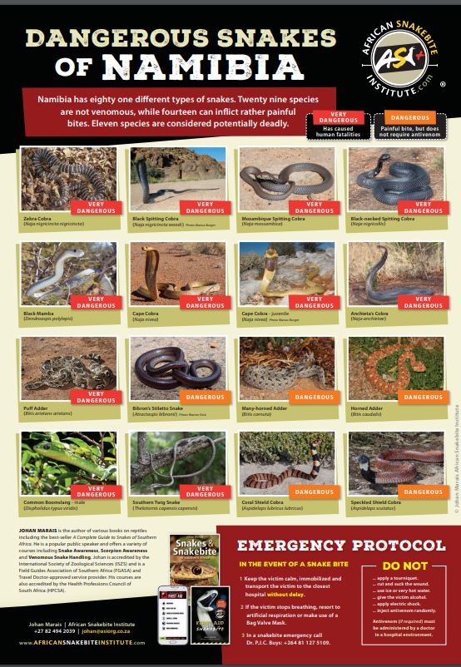
Namibia Standard Treatment Guidelines courtesy of the Ministry of Health and Social Services of the Republic of Namibia http://apps.who.int/medicinedocs/documents/s19260en/s19260en.pdf
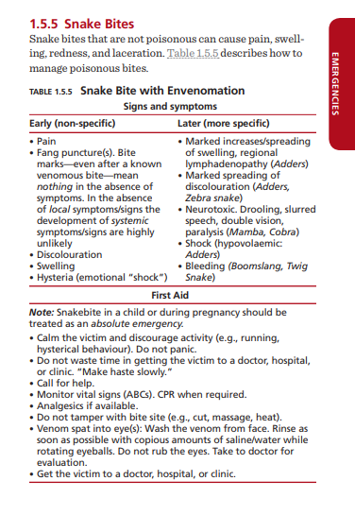
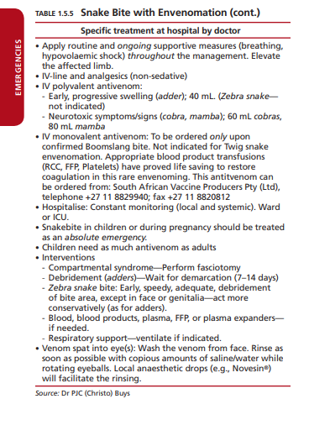

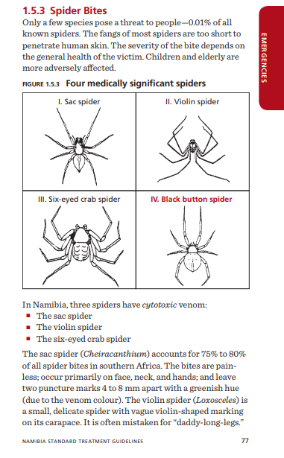

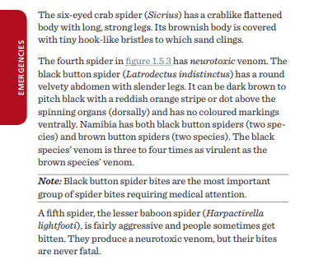
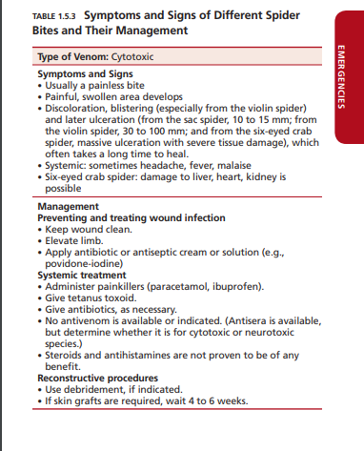
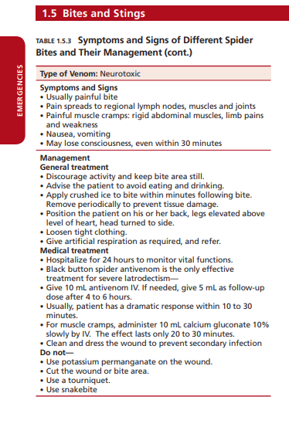
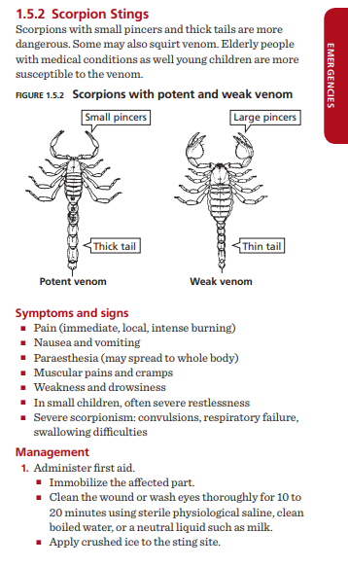
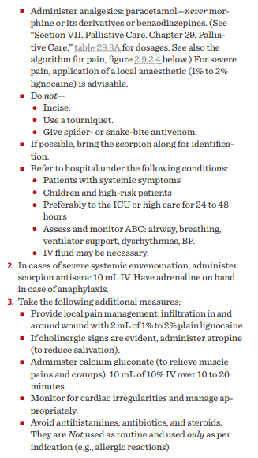

Appendix 20: Sample Fence Survey Form

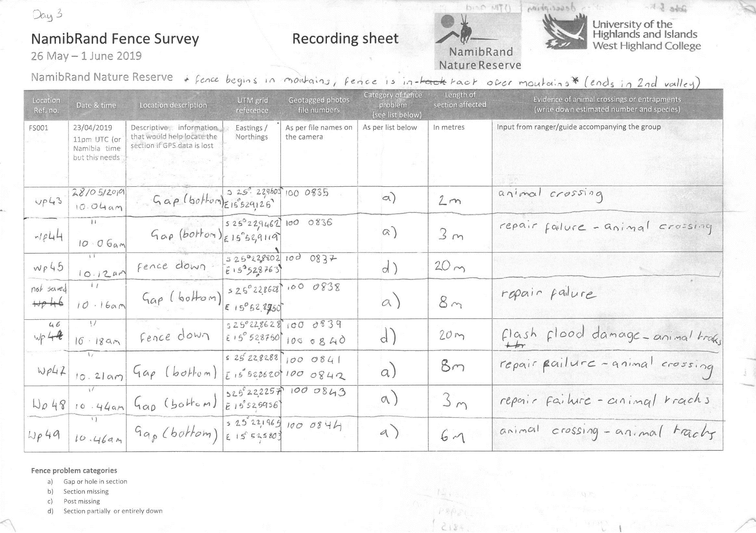

Appendix 21: Expeditoin photographs

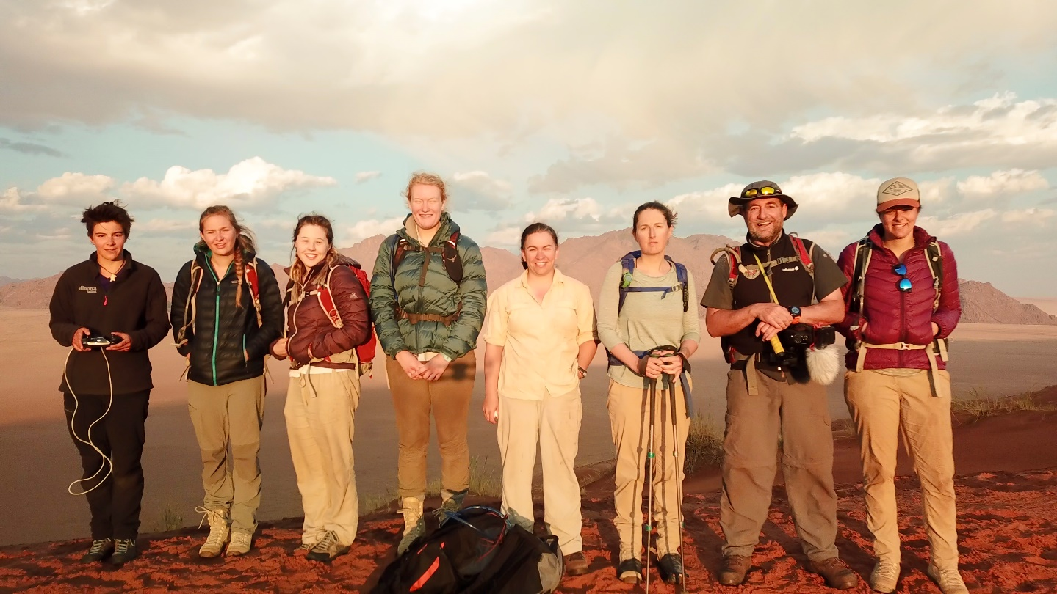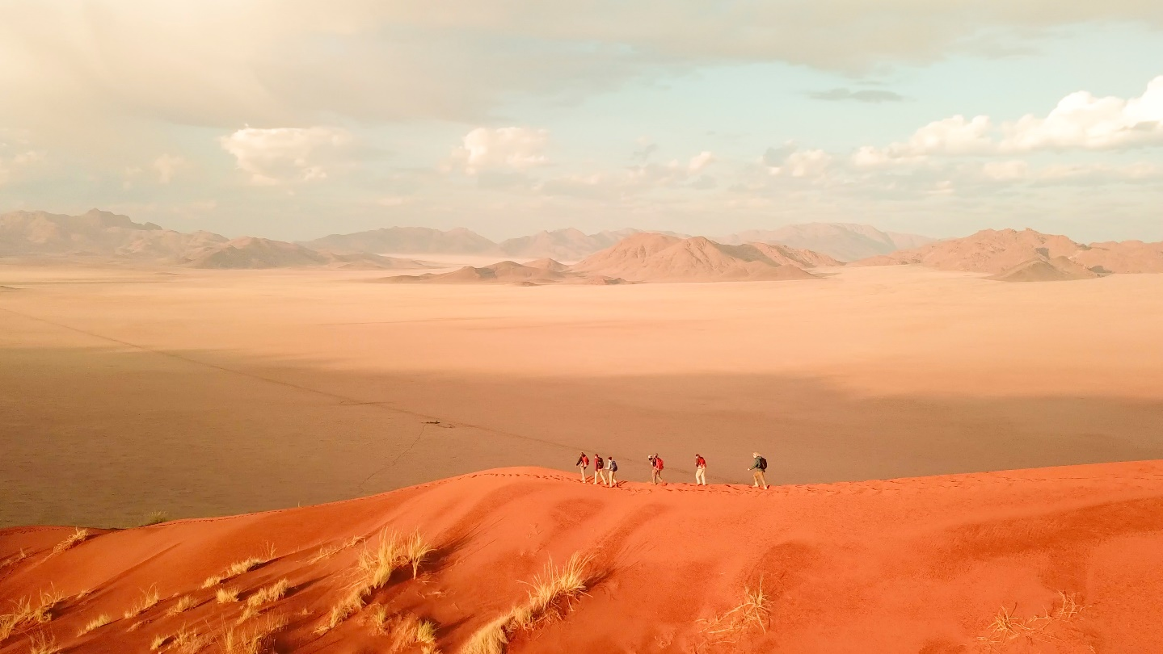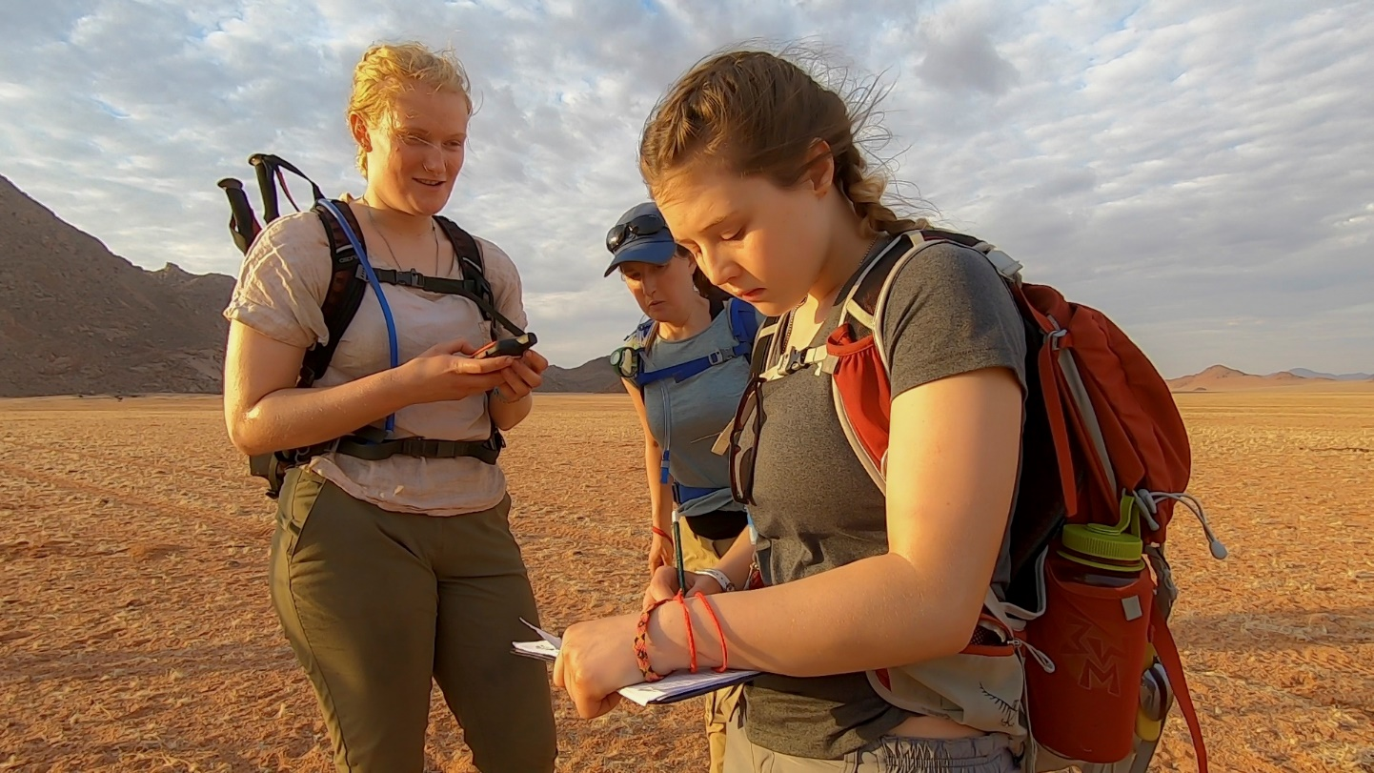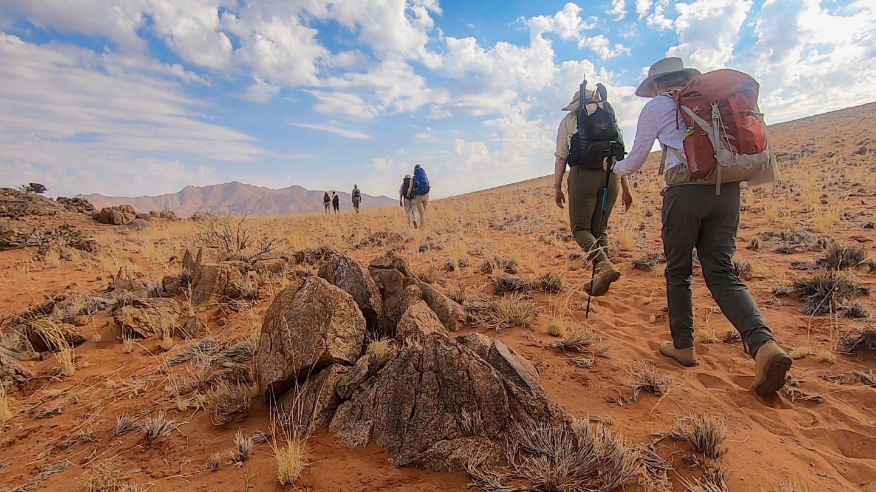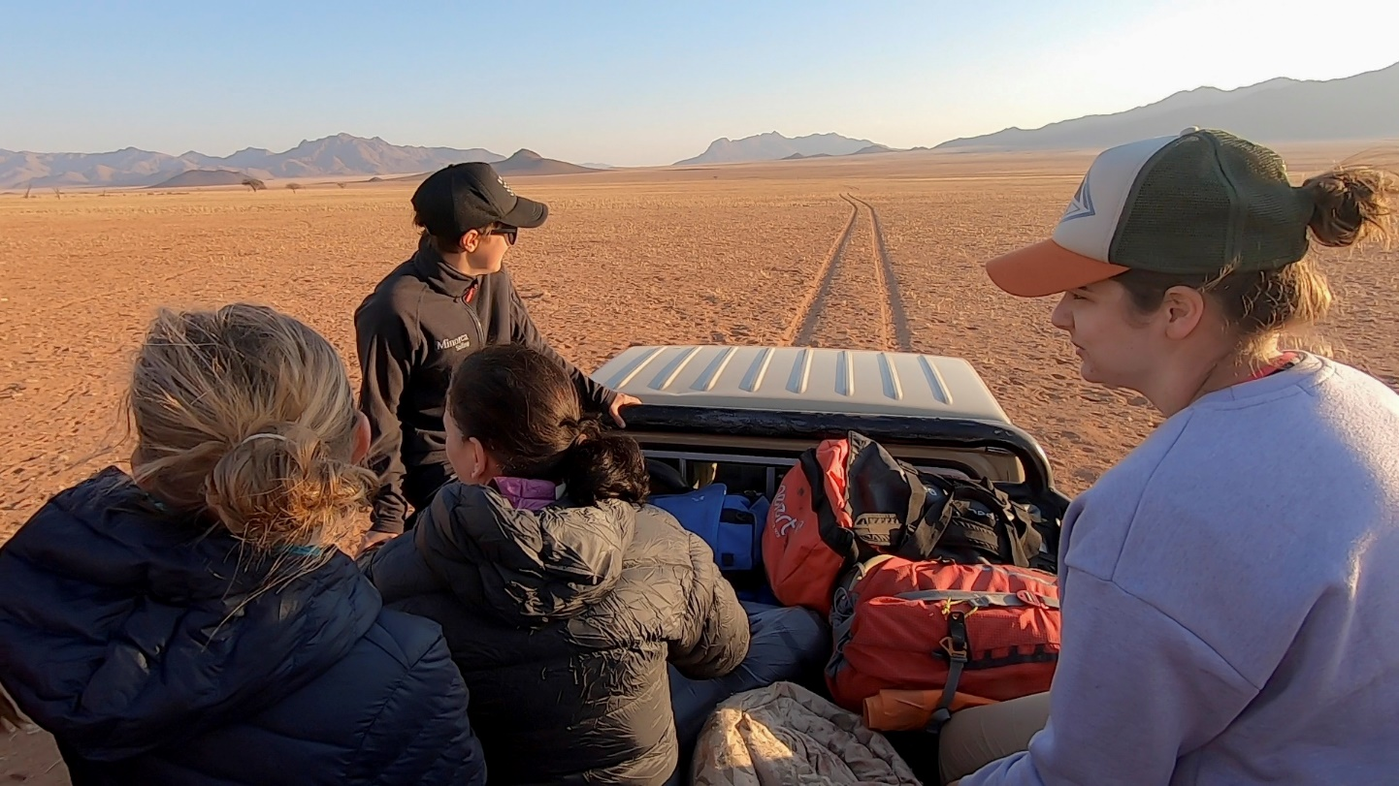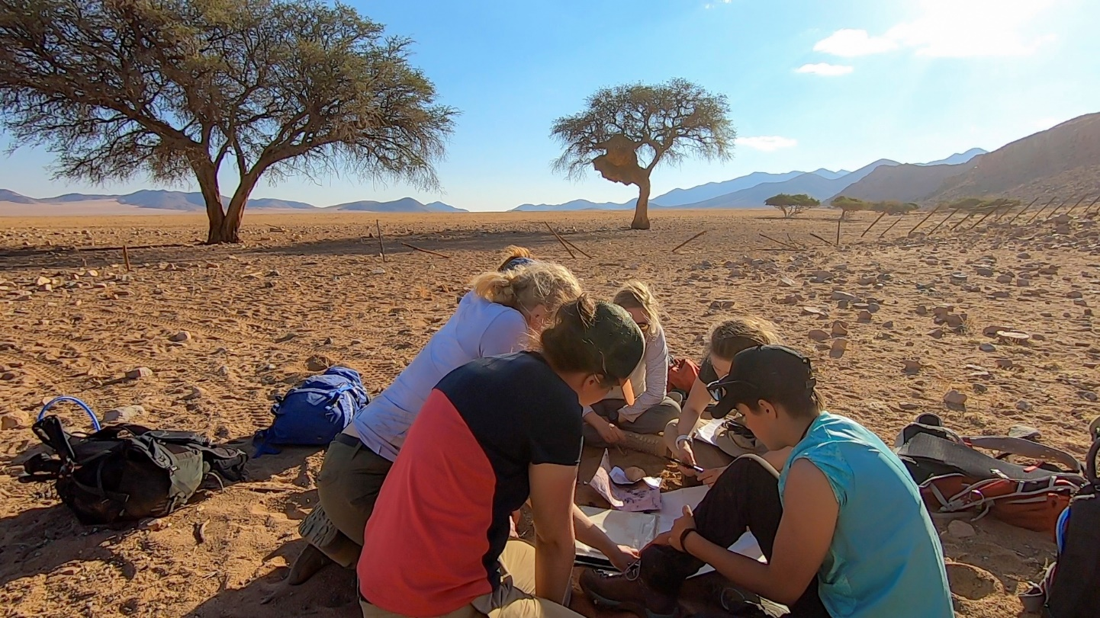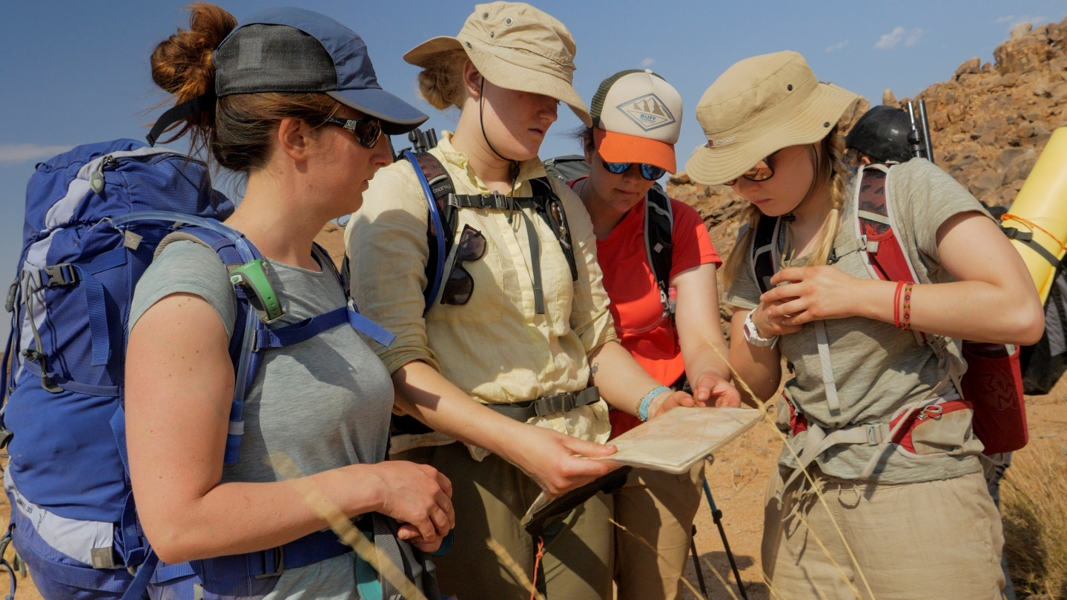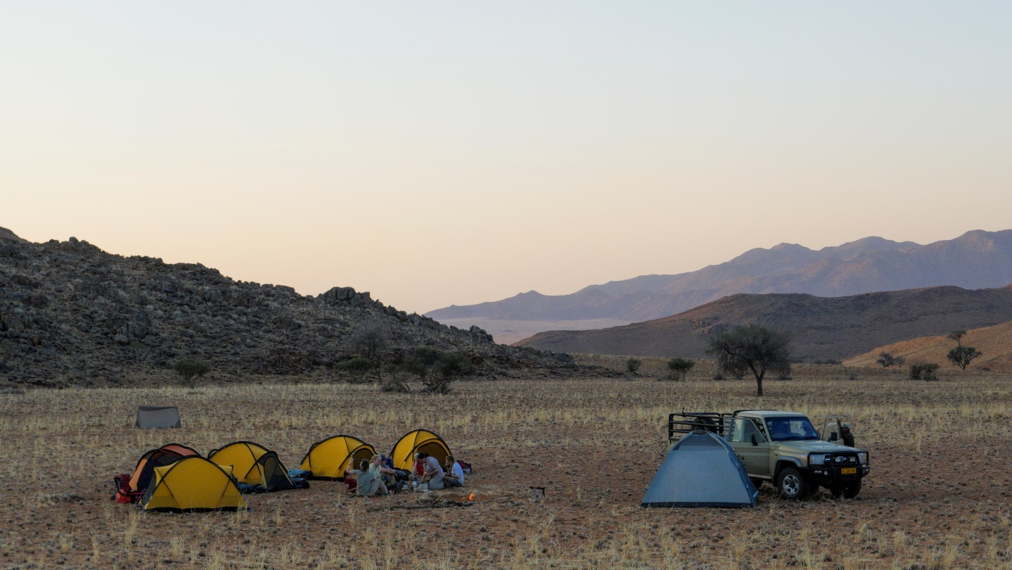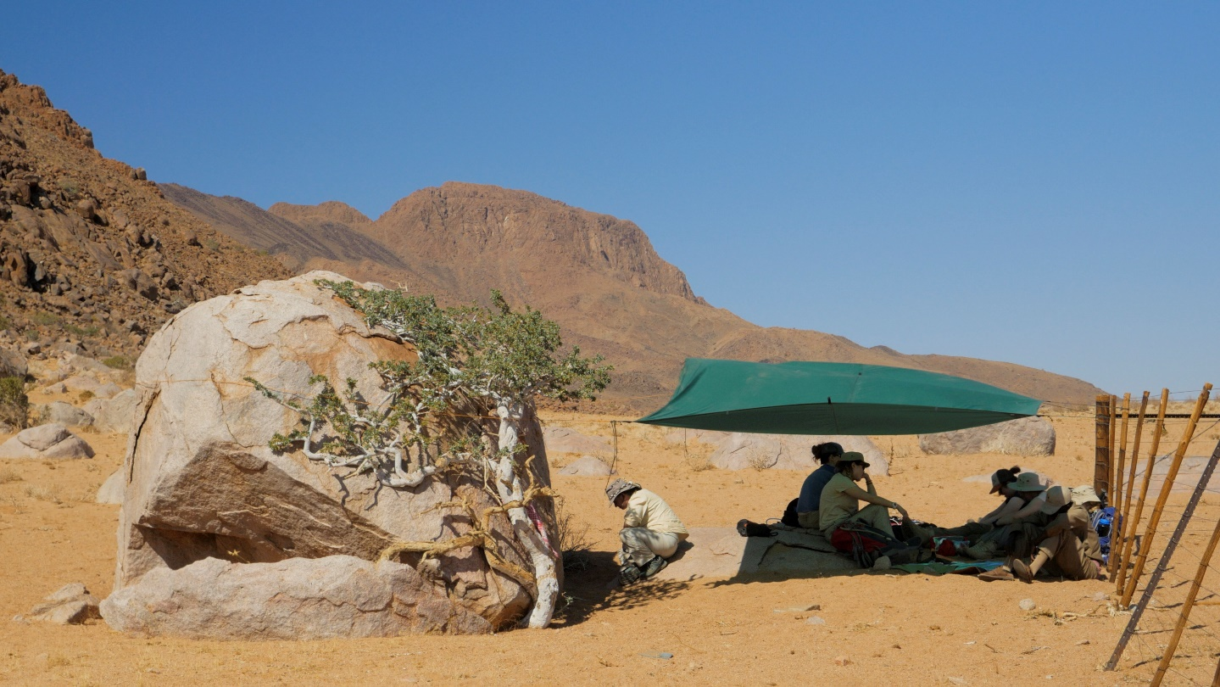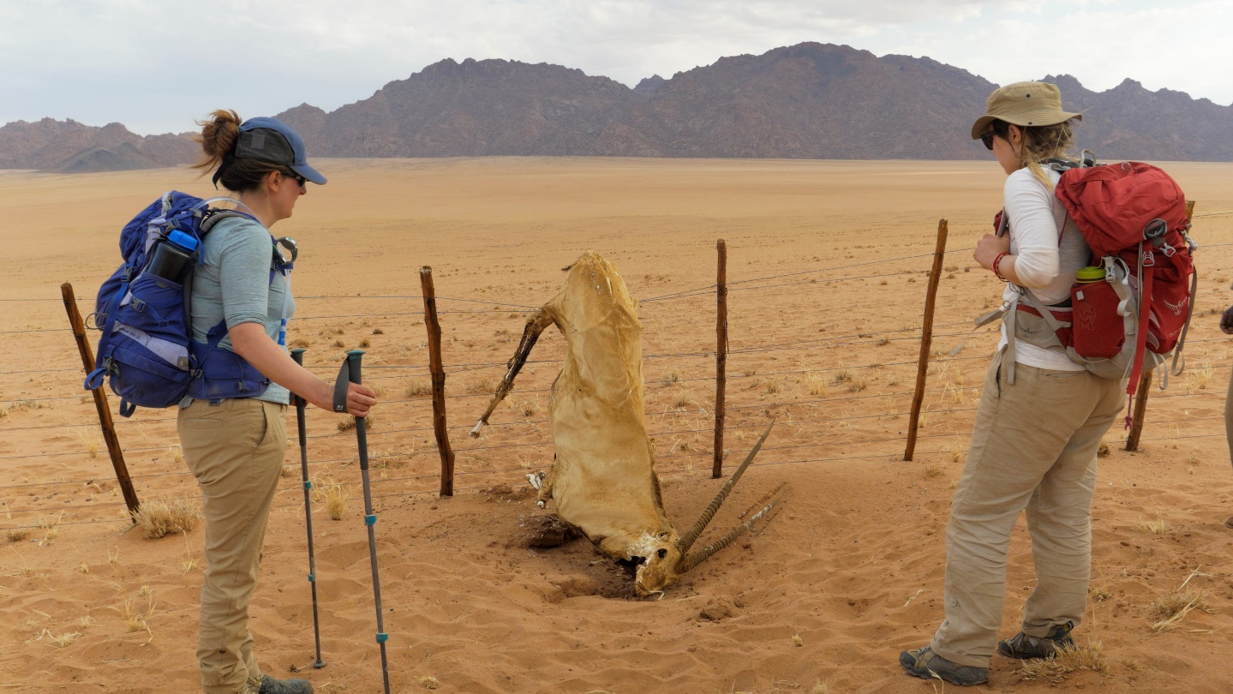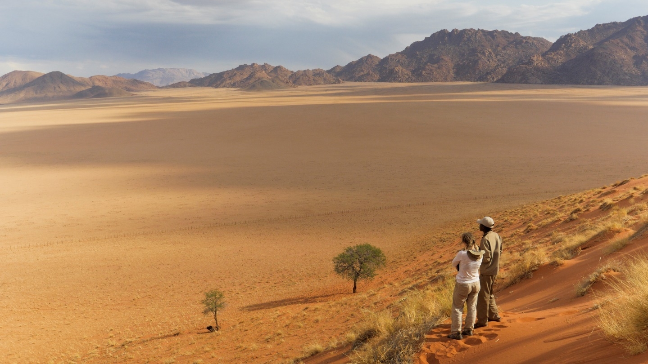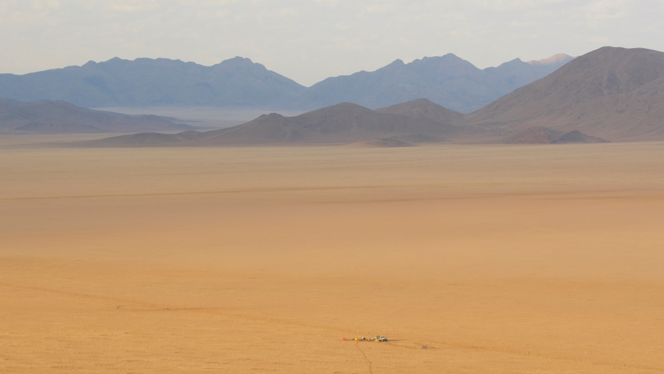

Appendix 22: Excerpts from students personal statements

“…Going on this expedition has been a dream come true and this has been the most fantastic experience of my life….A strong bond has emerged from this trip and even though I was a little wary pre-expedition, not being sure if I would find my place, this feeling quickly disappeared….This experience was a good lesson for me in how important it is to listen to every member's opinion and making the right decision that can satisfy everybody…I realized how complex it may be to make a decision within a team and finding a solution that could suit everybody while taking into account many factors, such as time, fatigue, weather, safety, wildlife, etc…I am very happy to have been on this expedition, to have had the chance to experience it and to have shared it with such a great team. I hope to have the opportunity to get involved again on similar adventures and be able to organise some too...”
“…Reflecting upon my experience I have identified several thoughts and feelings that I wish to explore. The expedition became an experience that will be unforgotten and generated a new desire within myself to explore the idea of developing and carrying out future expeditions. Feelings of strong self-achievement and personal ability are generated, and I left the experience feeling a lot more capable of individually planning and achieving both future expeditions and future personal tasks and challenges…I feel the experience affected me personally. The isolation, purpose and individuality of the expedition created an experience completely unique to anything I’ve previously encountered. The entire process from planning to execution was an amazing journey that was both beneficial to me personally and successful as an expedition...”
“…It’s now three days since we got back and I’m still waking up at 5am, ready for some porridge by head torch among the snakes, still doing a head count before going to the toilet to make sure it’s free and still singing the first line of song that comes into my head, only to discover that there is no one else around to finish the song with me. I am now consulting my bank account to arrange my next big adventure…”
“…The expedition was an incredible and inspiring experience during which I had the time and space to think clearly. Being disconnected from everything we knew before, whilst doing our small part to improve the environment we were living in, was rejuvenating. For me, it facilitated a feeling of wholesomeness and content. I was able to clarify my views of the potential of sustainable adventure and outdoor tourism and how the development of trips such as ours will solidify travel with purpose…”

