Greenland 22nd July- 7th August 2022. Hannah Mortlock, Tom Litchfield and Bethany Carol from St Andrews Univeristy Mountaineering Club alongside the Scottish Artic Club and with the support of The Neil Makenzie Trust.

On the 22nd July, Bethany Carol, Hannah Mortlock and Tom Litchfield flew from Glasgow to Keflavik (Iceland) to join the Scottish Arctic Club’s 50th Anniversary Expedition to Tasiilaq and Ammassalik Island. After landing in Iceland, we enjoyed walking around Reykjavik before meeting the remainder of the 25+ other expedition participants in Reykjavik City Airport the following morning. After a slight delay, we boarded a propellor aeroplane to Kulusuk, East Greenland. From here, we transferred by boat to Tasiilaq, the largest village in East Greenland, where we were based for the next few days.
While in Tasiilaq, we got to know many of the other Scottish Arctic Club members (many of whom had different objectives for the expedition, so we would not see until the flights home), stocked up on supplies, ate a delicious meal and watched the finals of the East Greenland football competition. We also walked up Sømandsfjeldet (a 718m hill behind Tasiilaq).
After this, we were transferred by boat up the Ammassalik fjord, then Ikerasagssuaq fjord to a granite cirque (65.91258694575762, -37.579071692925346), identified by Scottish Arctic Club members. We were initially alone in the cirque for several days and enjoyed the solitude and remote feeling (it was a 90-minute boat ride from Tasiilaq and over 5km from, and out of sight of, the nearest settlement (Tiniteqilaaq)). After that we were joined by six members of the Scottish Arctic Club expedition and enjoyed their company and the chance to learn from their expertise.
While in the cirque, our primary aim was exploration, hill walking and mountaineering. Active for most of the 10 days we spent in the cirque, we particularly enjoyed climbing (and a planned bivouac on) the West Flank of Pt. 2000 (we yet to find any details of previous ascents of this mountain), the West Ridge of Nîniartivaraq (the big ‘N’) and making an attempt (we reached a fore summit to find the final 80m to the summit to be extremely loose and steep) on the South Ridge of Pt. ~1120 (we yet to find any details of previous ascents of this mountain). We had an enjoyable afternoon multipitch rock climbing and loved the chance to spot wildlife (we saw Minke Whales regularly in Ikerasagssuaq fjord and Arctic Foxes sniffing around our food barrel most evenings. We also successfully fished in the fjord, catching trout and cod.
After a fantastic 10 days in the cirque, we headed by boat back to Kulusk, where we enjoyed the supermarket, and then flew back to Iceland. In an incredible, but manic, layover with a friend (who now lives in Iceland) we were thrilled to relax in a geothermal pool before heading out in the evening to see the volcano, which had started erupting two days before: A truly awe-inspiring way to cap off an incredible trip. Exhausted but hugely satisfied, we arrived back in Glasgow on the 7th August. We are hugely grateful to the Neil Mackenzie Trust for their incredibly generous support of this trip. We had a hugely inspiring, enjoyable and educational experience and are all eager to enjoy further international expeditions and, where possible, to assist other young people planning their own expeditions.
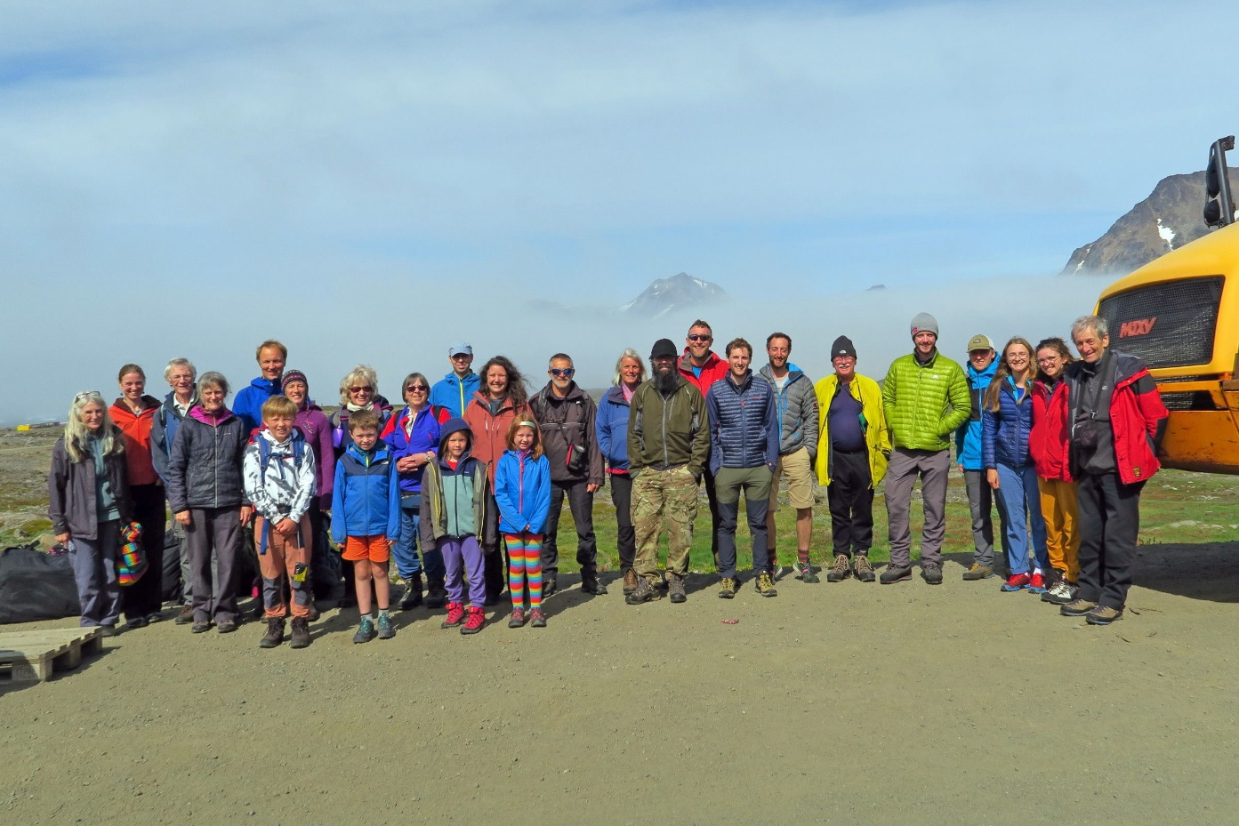
- Having safely landed in Kulusuk in Greenland the whole expedition gathered for a photo, we are on the far right, Tom, Hannah and Bethany second from the right.
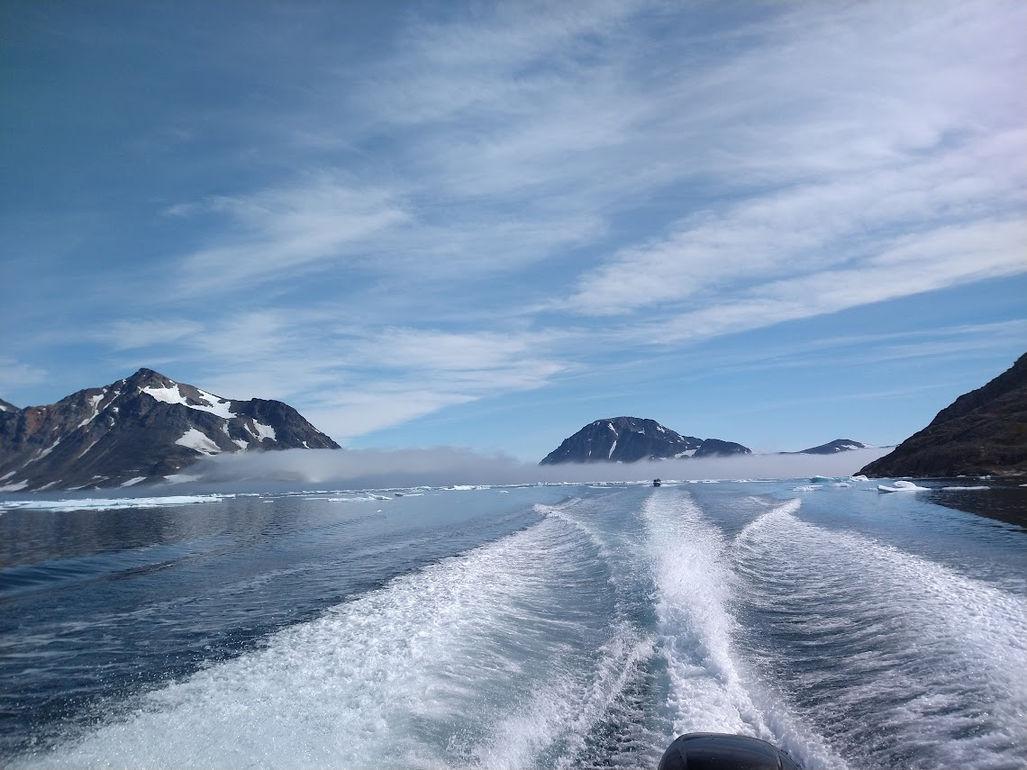
- We were already blown away by Greenland on our boat transfer to Tasiilaq as we sped past icebergs and mountains.
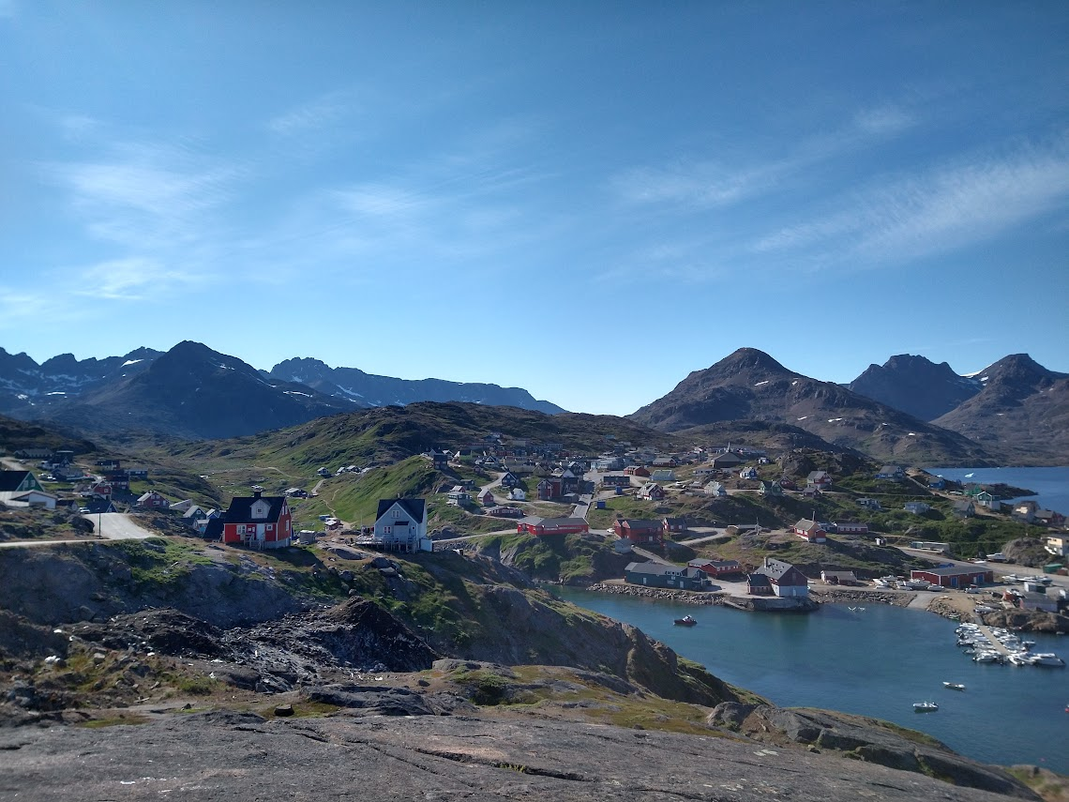
- Tasiilaq, the largest town in east Greenland.
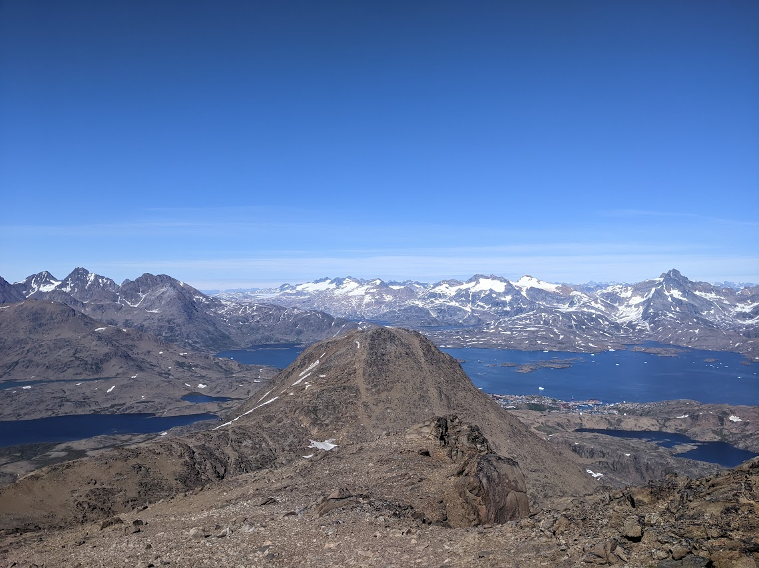
- First Summit of SØmandsfjeldet taken from the second summit, Tasillaq is visible behind it. The granite cirque we spend the expedition in is behind the mountains directly above the first summit (due North). This was a great first outing for us, helping us adjust to mountaineering in Greenland.

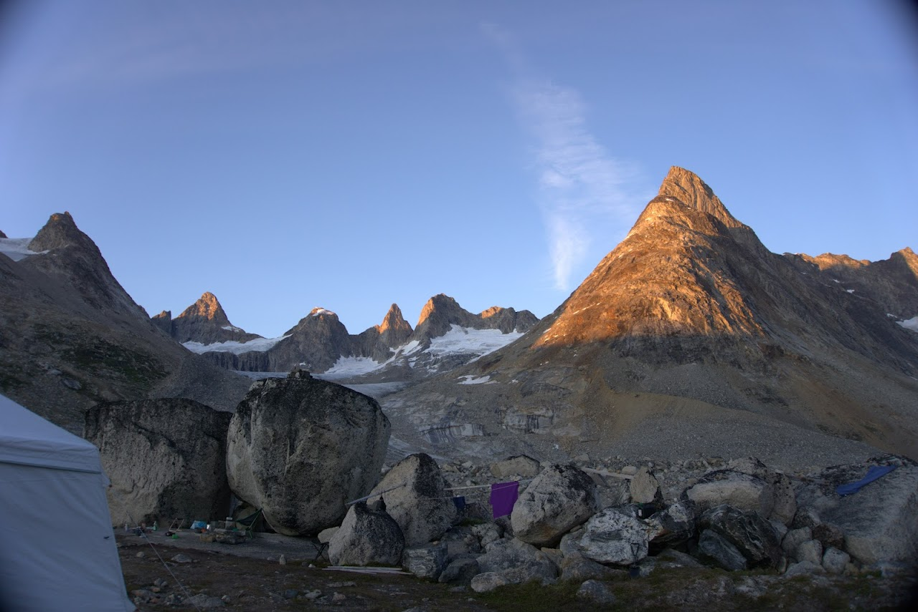
- View of the main granite cirque from camp on a sunny evening. The Peak on the far left is Pt. 1120 of which we reached the fore summit via the south ridge.
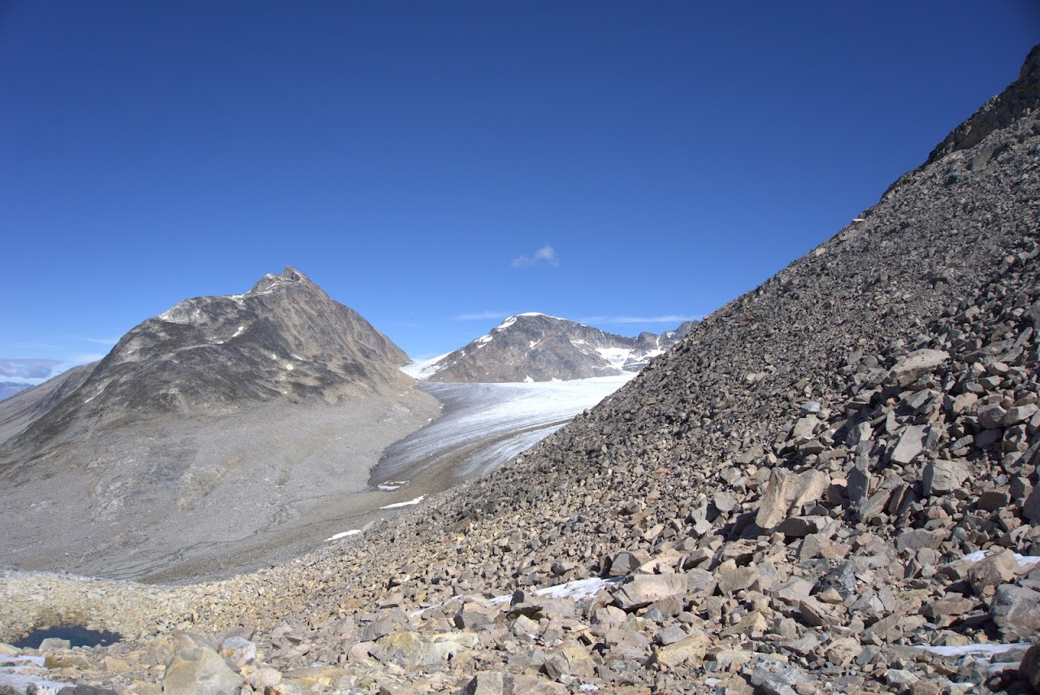
- First view of Pt. 2000, centre back, having crossed over the col below Nîniartivaraq. Having decided this looked a great target we set off across the glacier to climb the west flank (left hand ridge in photo).

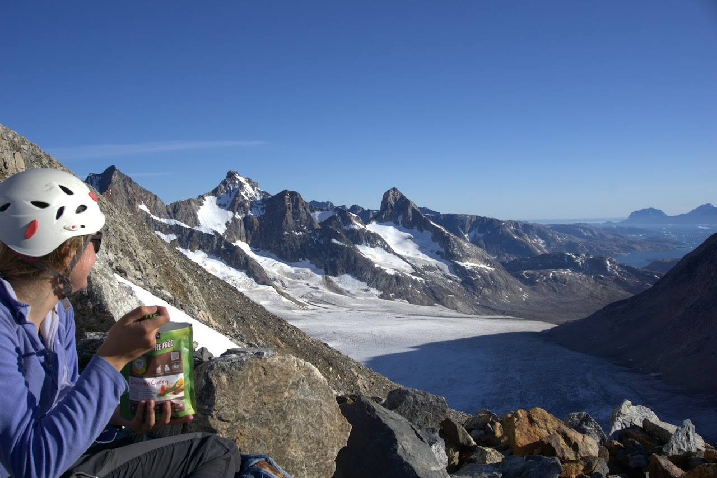
- Hannah enjoying dinner at our bivouac on the west flank of Pt. 2000. This was an unbelievable evening and situation. The red sky of the sunset lasted all night over the icecap and in the morning we set off with high hopes of the summit.
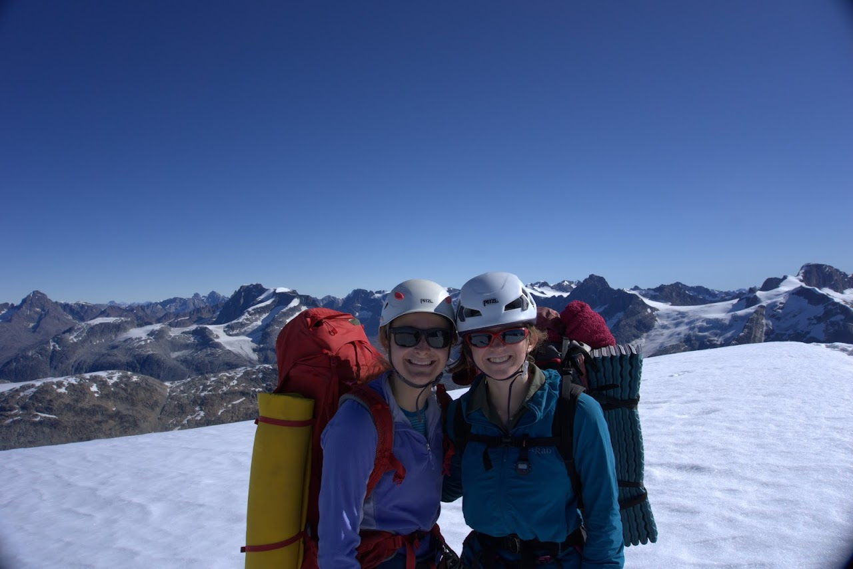
- Hannah and Bethany on the snow dome summit of Pt.2000. The seemingly endless mountain ranges extending north behind them.

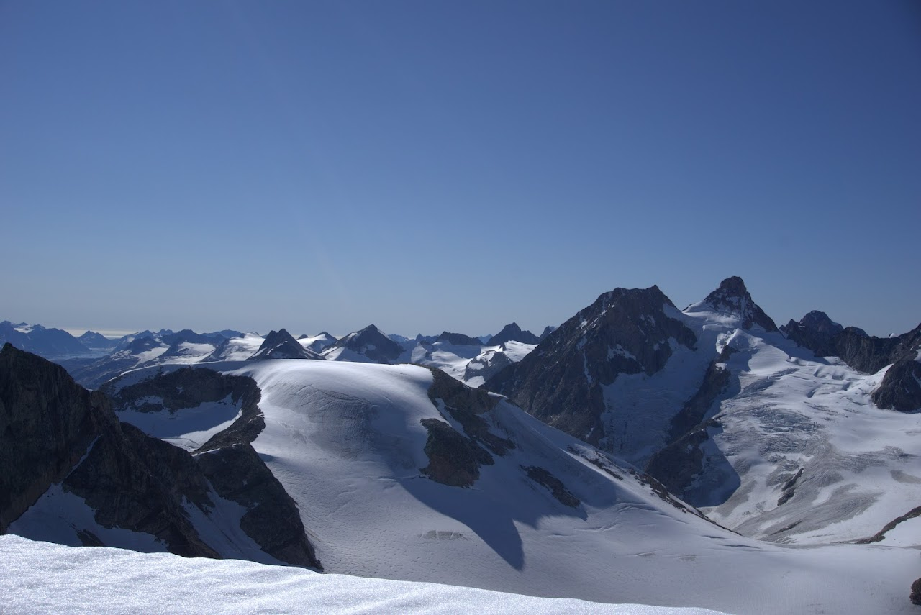
- The east ridge of Pt.2000 from the summit, the back peaks of the main granite cirque and the Atlantic beyond.
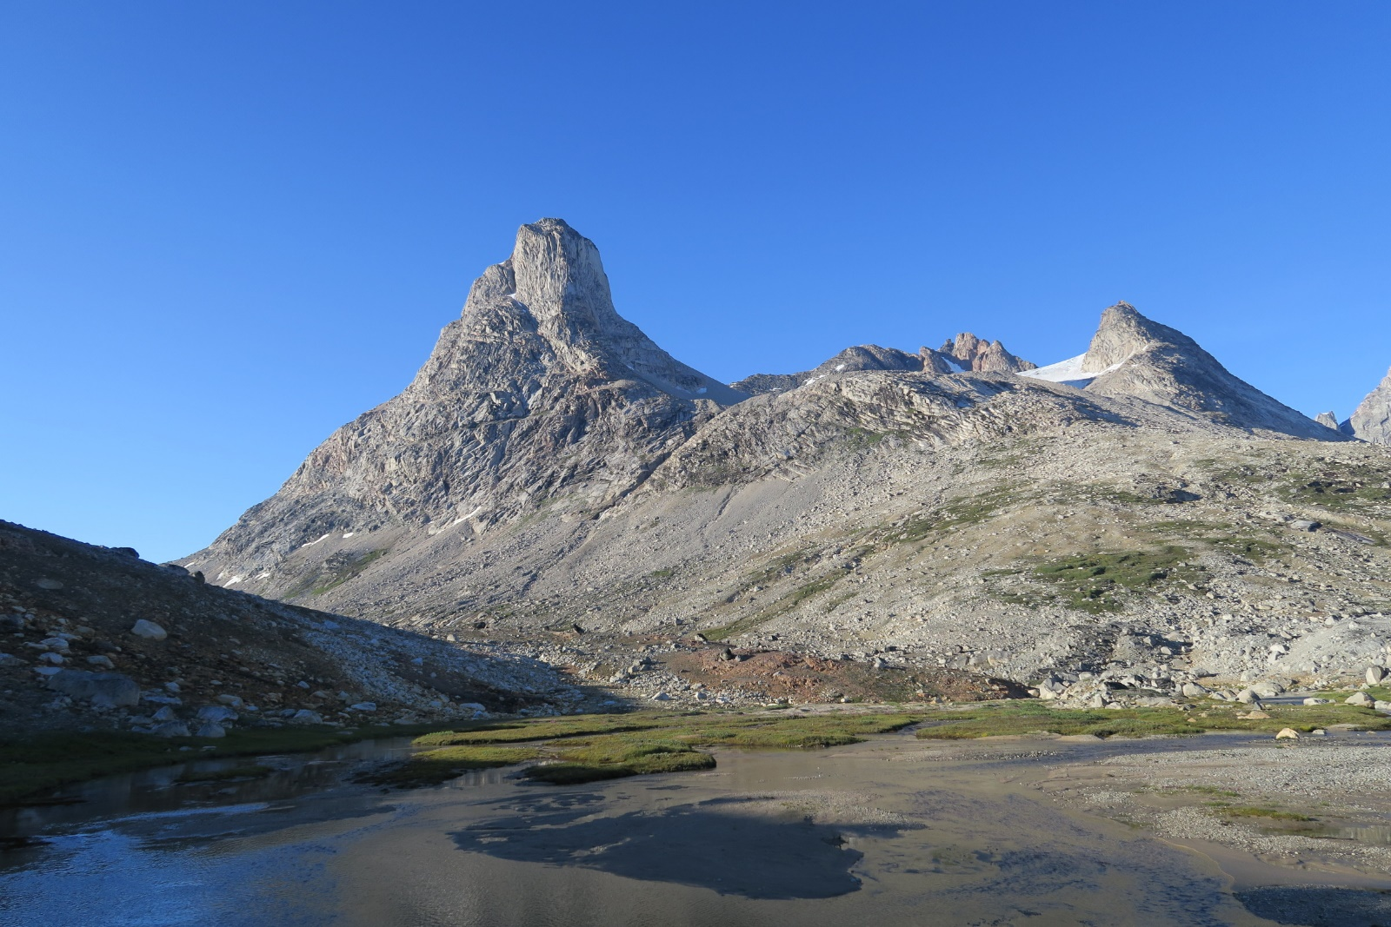
- Nîniartivaraq or “Big N” (left) is a fantastic mountain, we enjoyed the west ridge (left-hand skyline above) with continuous granite slab scrambling to the summit.

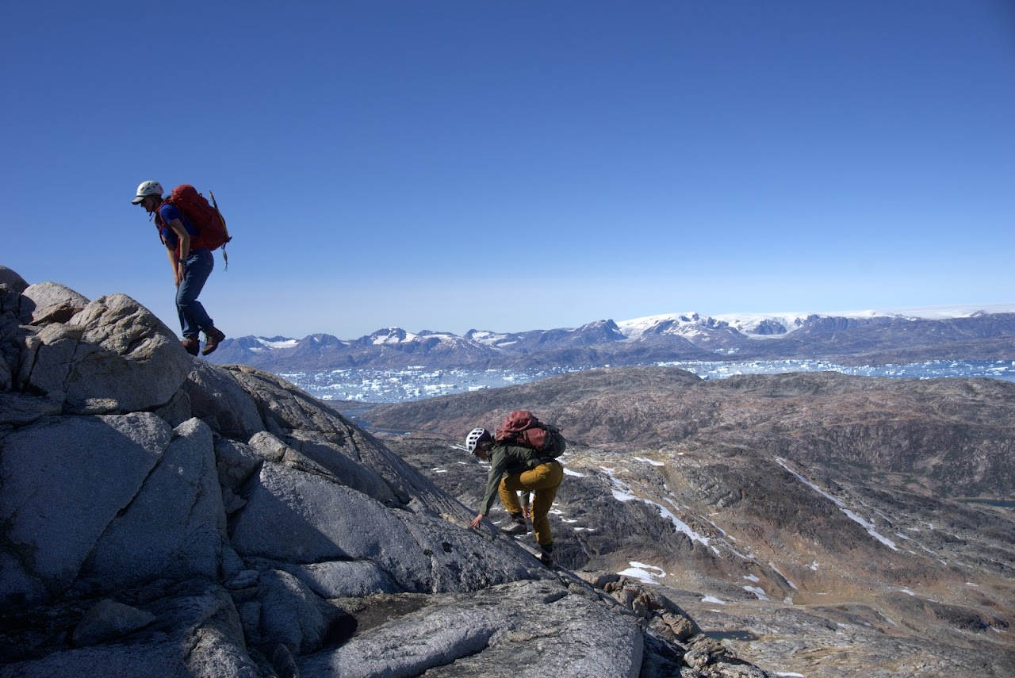
- The superb scrambling on the west ridge of Nîniartivaraq, the icesheet and icebergs behind.
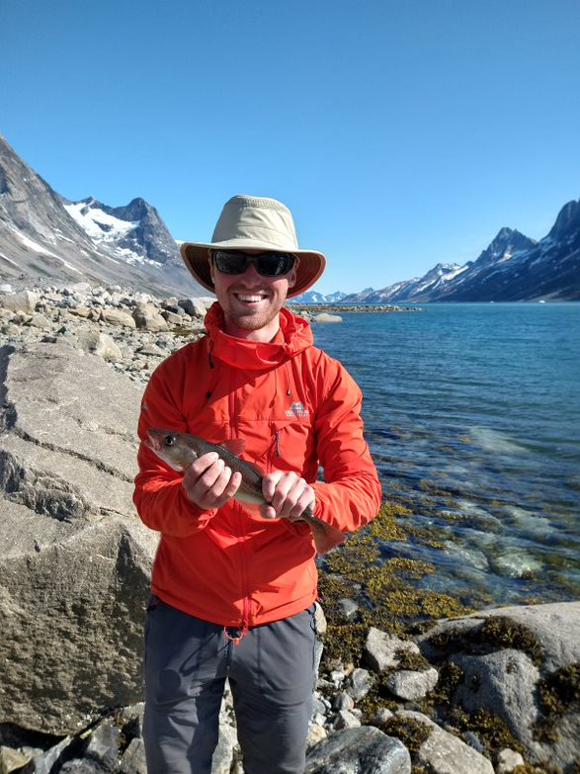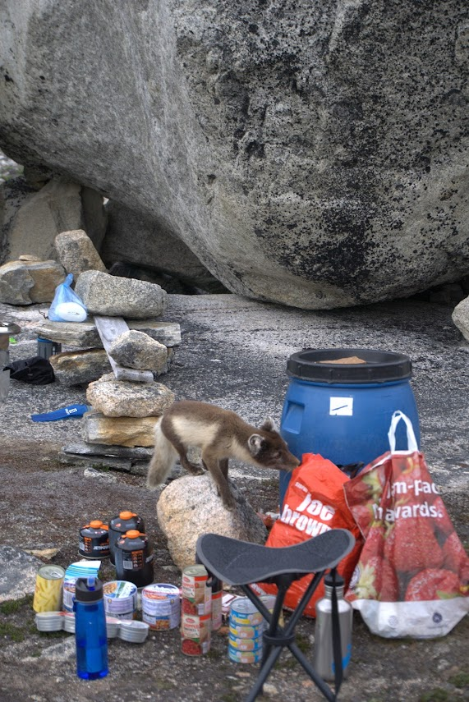

- Tom with his first catch – it was delicious!

- The Artic fox making us glad we had the barrel, her two tiny cubs also made an appearance

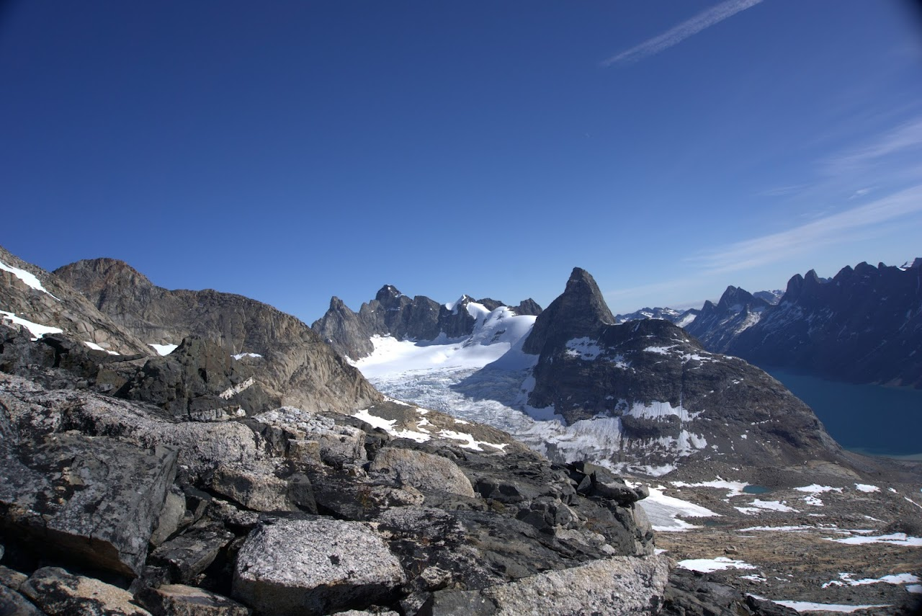
- Our final outing was a hill walk to an easily attained summit in the north of the cirque. This is the view across the cirque, base camp is just of camera to the right.
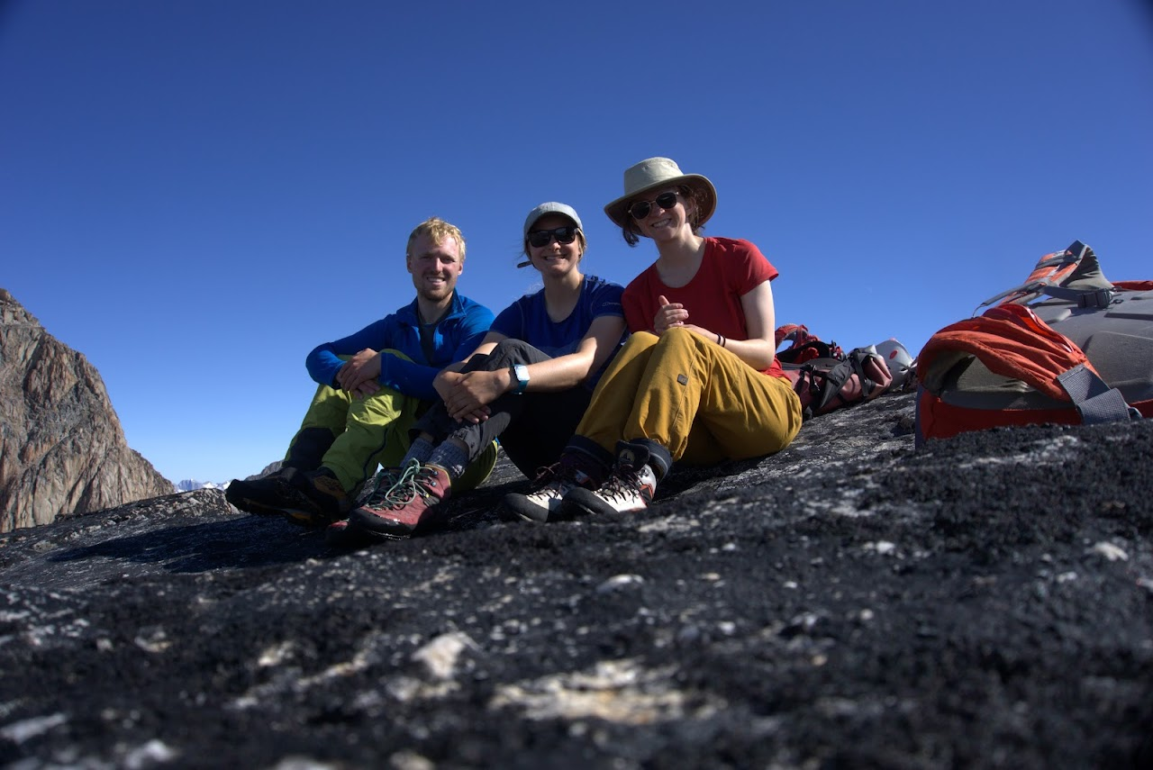
- Tom, Hannah and Bethany on our final summit in Greenland (Pt. A on map), we were sad to leave the scenery, but it was time to head back to civilisation.

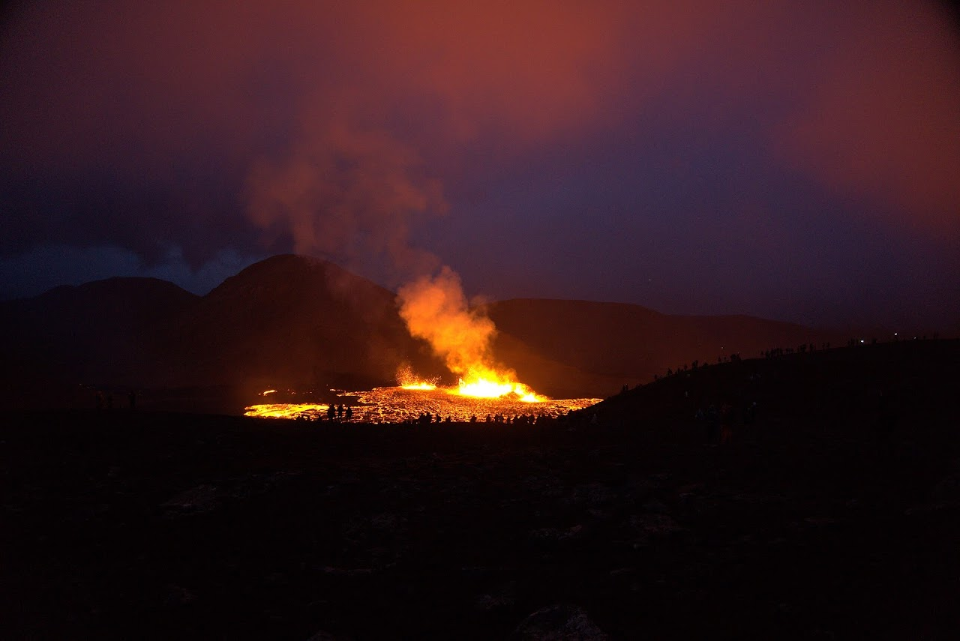
- To our utter amazement we were able to see the erupting volcano during our overnight layover in Iceland, simply incredible!
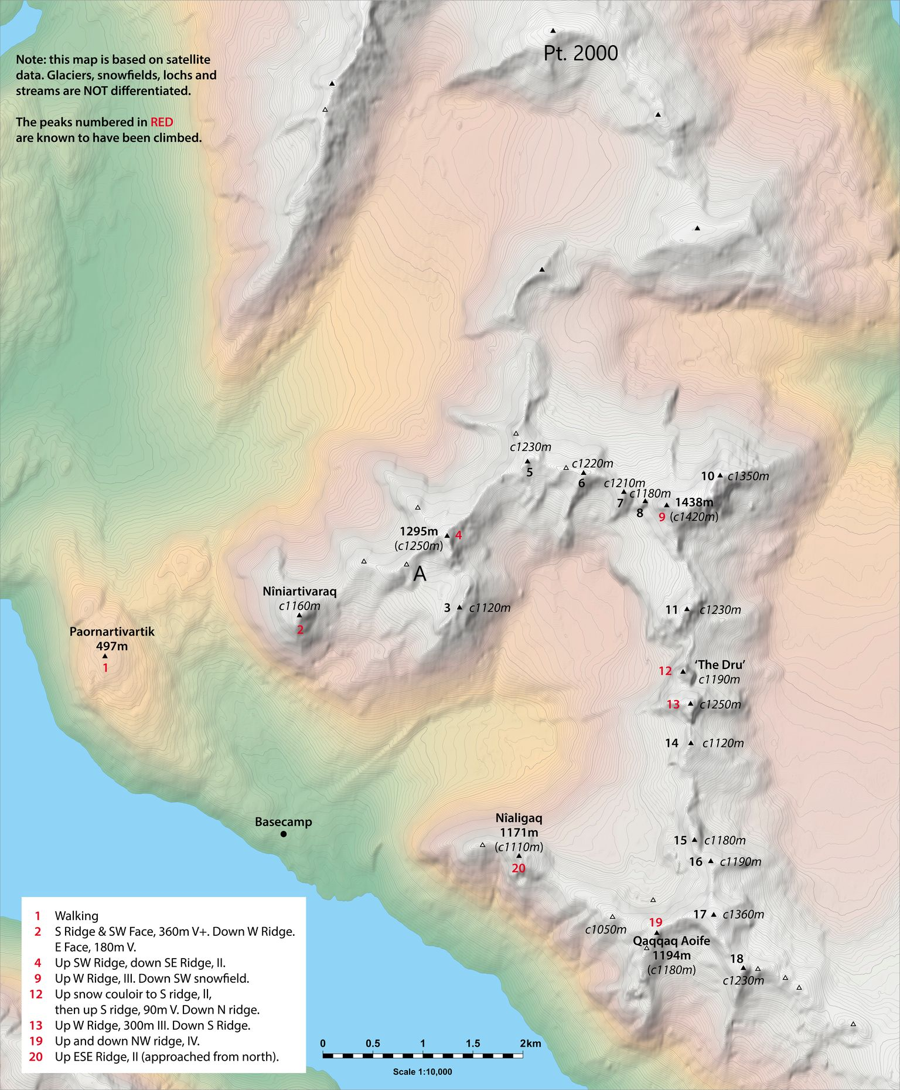
- Map of the cirque made by Noel Williams, a member of the SAC who joined us in the cirque.

We could have chosen hundreds more photos, many of which don’t do justice to the experience and scenery but in this small selection I hope the incredible trip we had is clear. We are so grateful for this opportunity and the extremely generous support we received from the Neil Makenzie Trust, so thank you!

