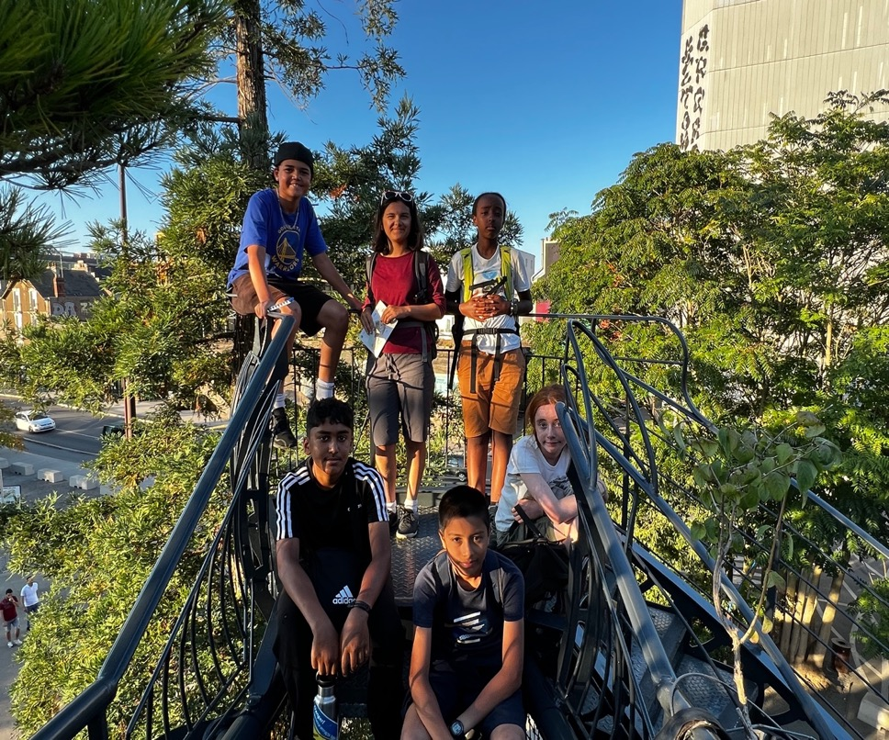

OUR ADVENTURES TO THE LOIRE VALLEY

by Avantika, Avalon, Hannah, Yameen, Yusuf, Jake, Celia and Alex.

Firstly, thank you very much to the Neil Mackenzie Trust for their generous grant that enabled us to have this amazing trip altogether.

We have decided to split this report into three distinct areas:

A diary with details of our trip and the kilometres travelled.

Feedback from young people – including challenges and highs.

Feedback from parents

The Trip – 19/08-28/08/2022

Our original application was for a cycle trip to the southwest of France cycling towards the Spanish border. However, we had to change this at the last minute as the whole area was sealed off due to large forest fires which meant that the original route had been closed and many campsites along it. Climate Change in action and this theme continued throughout our trip and feed into our John Muir Award Project.

We followed part of the EuroVelo 6 route, the section we chose to cycle started at Tours and finished in Nantes, it was a cycle ride of approximate 337km over 7 days, averaging 48km per day.
It was indeed a challenge for all, we carried our own panniers with equipment, clothes, and food with the aim of being as self-sufficient as we could be. The route followed most of the time the river Loire and along designated cycle paths for around 70% of the journey.

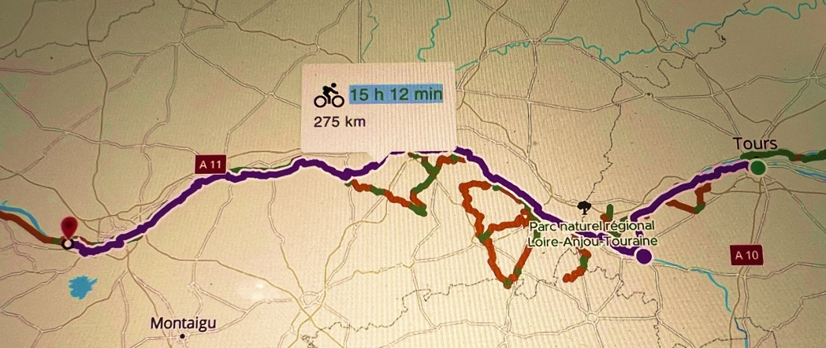

Day by day summary.
Friday 19th London to Tours

We just about all meet at 16:30 at St. Pancras International Station all of us ready for our adventure, if not a little nervous at the same time. We set off for France at 17:30 pm, two hours later the Eurostar arrived in Paris Gare du Nord from there we took the R3 to Austerlitz station the other side of the Seine, Avalon really loved the doorhandles on the R3. We had a little wait here before the next train, so we took a break to eat our packed dinners and we had a few fries on the side. The train we took to Tours was very plush, sofa like seats and we were the only ones in the carriage. The journey lasted around two hours and we arrived there at 1.15am. From the station it was a good 15-minute walk to the hotel, and we all struggled carrying the pannier bags as they were very awkward. By the time everyone was settled, and, in their rooms, it was already 2 am and we all fell asleep very quickly.

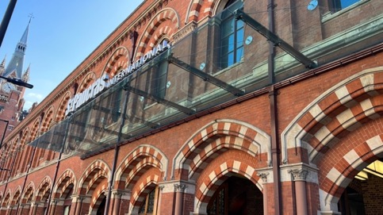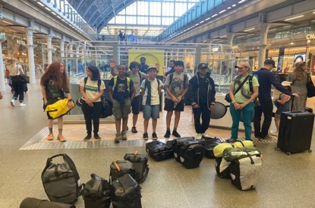
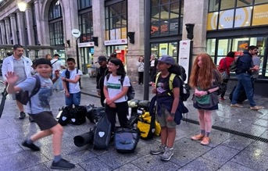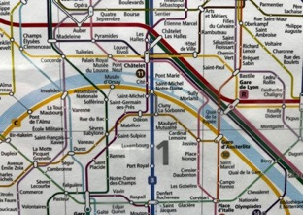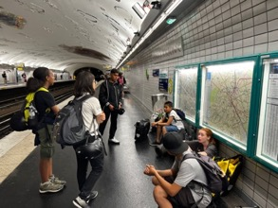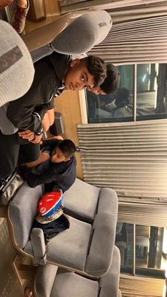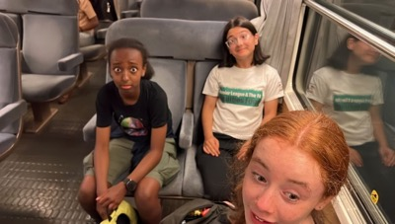
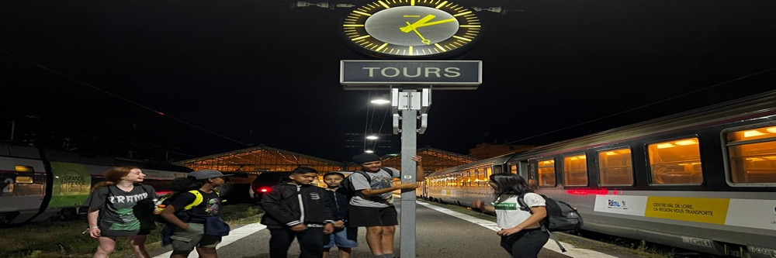

Saturday 20th
42km to Indre – Wild Camping
Saturday the day started with us eating breakfast in the hotel. This was our first taste of French cuisine, crêpes, pain au chocolate and croissants, as well as French yoghurt. It was amazing French breakfast tasted good. At 10 am, we left the hotel and went to the bike shop Détours de Loire our booking was made in advance because they had a huge demand on bikes at this time of the year, but we had just six bikes prebooked with no more bikes available and the group grown we had our first dilemma. After ten minutes the owners had come up with a solution and we now had eight bikes…phew. We rode back to the hotel and after putting the panniers on the bikes, and doing the final adjustments with the saddle height, putting the tents on the racks, and working out the best way to tie the bungies, off we set. First cycle was already a challenge as we had to ride uphill to decathlon to pick up gas and a few last-minute necessities that some of us had left at home. Having picked these up we then had the fun bit of going back down the hill to join the Loire path. We were already hungry so stopped to buy lunch before leaving Tours. It took us a while to get used to the bikes and Yameen had a couple of fall offs, the worst of which was on the dusty track down to the river campsite.
40 km more of cycling through the countryside whilst following the river Loire, stopping once for very yummy ice cream and then we were somewhere near La Chapelle. We were thrown into the deep end straight away as our ‘campsite’ consisted of a half grass, half sand field and our toilet were some bushes. It was a riverbank with nice cold water, and on the other side was clearly visible. The day ended with a nice swim, Jake, Celia, and Yusuf were the only ones who managed to make it to the other side. The current was strong, so Yamen was almost swept away. Just managed to make it to shore safely. Then we camped under the stars all we had was our sleeping bags for warmth, it was our first time sleeping under the stars and it was unsurprisingly not too cold. The stars were very bright, and no one had ever seen anything like it We even spotted Elon Musk satellite. Luckily in the night, the mosquitoes and midges weren’t so bad as we all thought, and no one really got bitten.
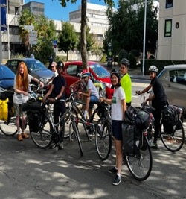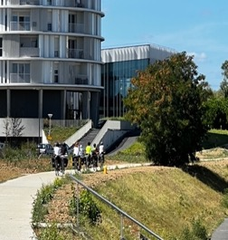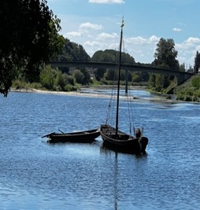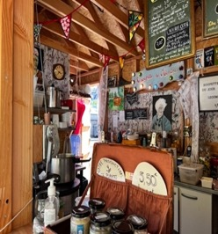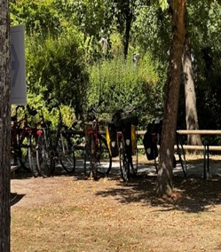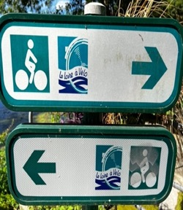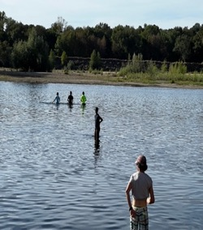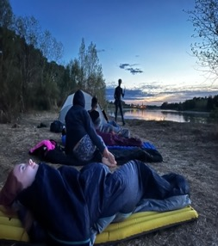

Sunday 21st
34km Indre to Montsoreau.

We all awoke grateful that we survived the night we started with breakfast and were ready for more cycling, the gravel paths made it tough to ride on, but we all managed to do it just fine, Yameen having the only fall of the day, at this point we decided to swap bikes over to see if the other style of frame made it easier for him. After a small diversion and a traffic jam we stopped in a small village for a snack a beautifully warm croissant and Avantika was brave and tried a Canelle, a cinnamon eggy treat. We also had a brief look around as they were holding a huge antique fair all over the village, hence the traffic jam.
We were determined to arrive at the campsite before the rain set in, and we managed. We were also so happy to see a cabin for the use of campers – this made cooking lunch a little easier and meant we could sit undercover to eat.
Having eaten the rain had stopped…. (the only rain we encountered on the trip) and we quickly put up the tents after which we walked into Candes St Martin, a really pretty village with very quaint shops and houses with loads of interesting alleyways that lead down to the river. Alex had a surprise planned for here and we arrived at a Street Art Exhibition where we saw different pieces of street art. There was great diversity in the art and choosing our favourite pieces was tough, but the final group vote was for the gorilla image. This was a good time for reflection and relaxation. In a tiring day of cycling. There was an area of the exhibition that included a slack line and Jake beat everyone getting the furthest along it. The exhibition was on high ground so there was a nice view from the terrace of the river valley. Just before leaving we played on the swing which hung from a tree near the exit. Walking back through the village we decided to stop at a fancy café for a drink, they were artisan made and had some strange flavours. Avantika had hibiscus tea, which made her feel very sleepy she said, and Yamen had a strawberry and basil drink, he needed to put two cubes of sugar in it, because he said in the UK drinks like that are so much sweeter.
When we got back to the campsite, we had another surprise pizza for dinner. It was delicious.

Monday22nd
36km to rock somewhere outside Gennes

We woke up refreshed and ready for a new adventure, Monday breakfast was the staple croissant and applesauce after which we packed up the tents and prepared the cycles for the day. Today was probably the easiest cycle ride as we continued to follow the river and we seemed to quickly reach the town of Gennes. We had lunch here and then we had some free time to go and wander around the town Alex went off and discovered a delicious bakery … which we all then went to find. Importantly we were able to stock up on supplies and goodies for the next few days. Some of the group were a little late getting back ...they got lost apparently ..!

We cycled a few more kilometres to a small village with some bakeries, we stopped here for some drinks as it was a really hot day, Jake tried to make some weird mix with the drinks that didn’t go down to well. After another 2 km, we arrived at the place we would be spending the evening, early enough to enjoy. Hotel for the evening was a structure made of rocks “Dolmen de la Pageire”, we were wild camping this time we were more prepared and knew what to expect the rock was an amazing experience. It had good sleeping conditions and great climbing; it gave us a chance to build even more skills and learn from each other. It also had amazing views of stunning fields and forest. We explored the forest which was very enjoyable and where we found two chairs. After dinner we were first set a challenge by Alex and Celia where we were in teams and had to label the bike parts after which we looked for different ways to climb the rock which strengthened our team building skills as we supported each other. We ended the day in a relaxing manner talking and listening to music while watching the sunset. We then went to sleep surprisingly comfortably.

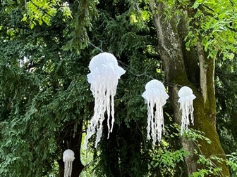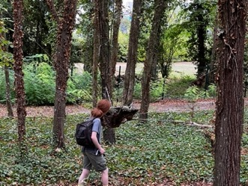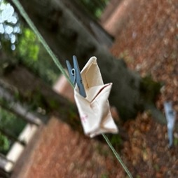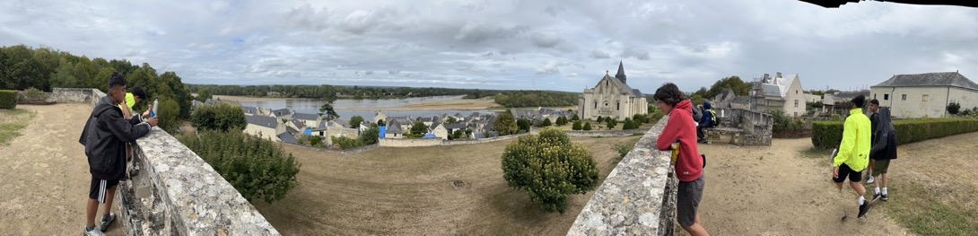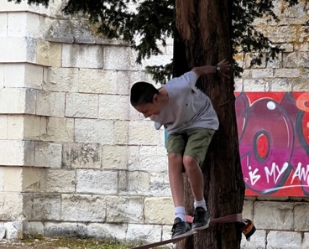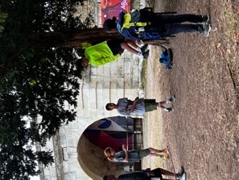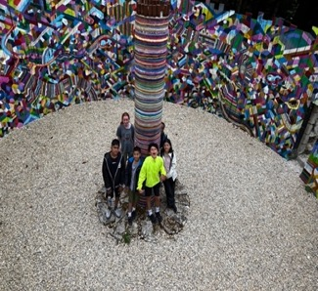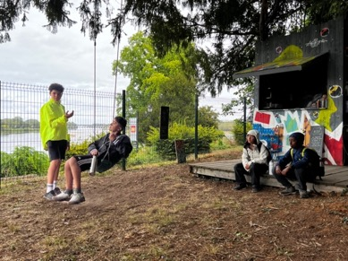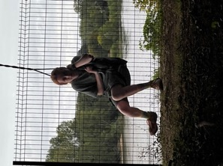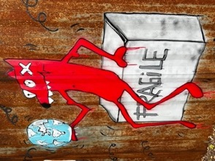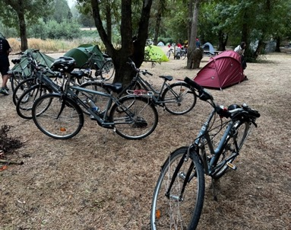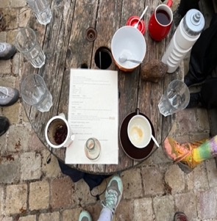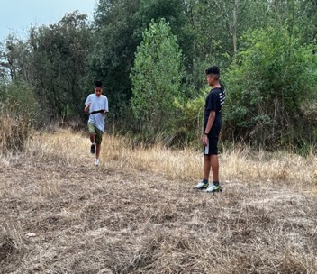

Our Trip into Candes St Martin

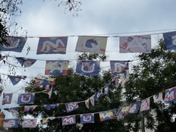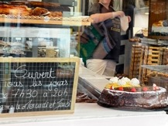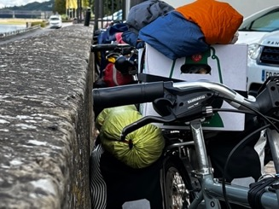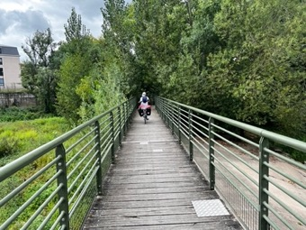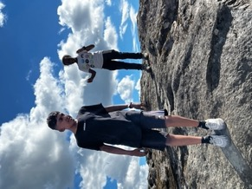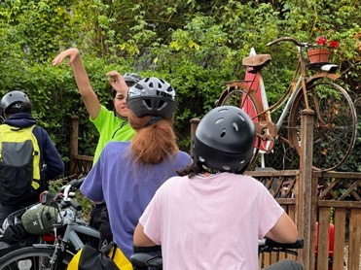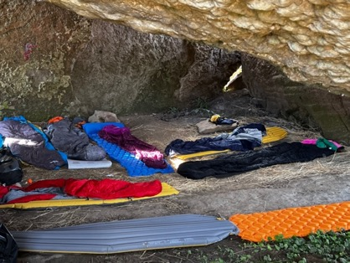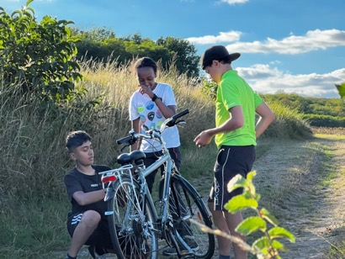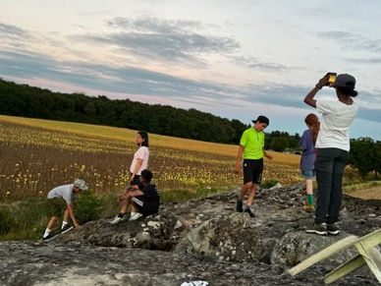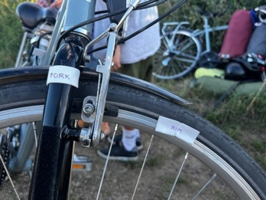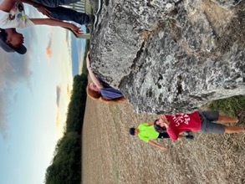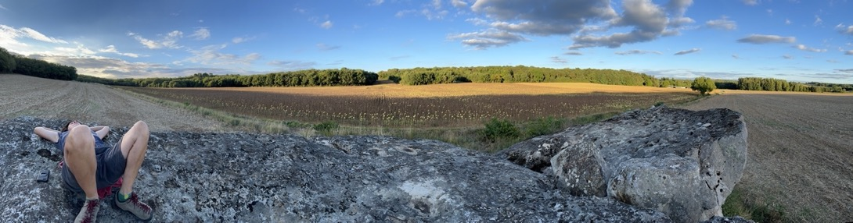

The ROCK!!!

Tuesday23rd
34km Gennes to Angers.

We awoke to a beautiful sunrise and ate breakfast while we watched the sky changing slowly. Having ensured we left the rock as we found it, we started off on our day cycle. We first cycled down to the village, and it was market day, so we stopped for a second breakfast, a common practice on this trip. We had Nutella crepes and Jake bought a whole roasted chicken which tasted amazing after so many days of pasta and pesto. The route was still following the flow of the river Loire and was again mainly car free, but there were some sections where the route joined secondary roads, but there were not too many cars, and they were all respectfully driving slowly when passing us. Today we passed a lot of fellow riders and walkers, and we played a game to say “bonjour” to everyone we came across and to count how many “bonjours” we received back. More than 100 today, a record.
We arrived early afternoon at the Slow Village where we had luxury tents to stay in that were already put up and had actual beds with mattresses. We were then given the choice to go to Terra Botanica in the evening as it was floodlit or to go next door to the swimming pool and flumes. We were all a little torn between what to do but eventually decided that the swim was the best option and saved us a further 20km cycle.
The water was freezing, but the slide was still a lot of fun, and we spent around two hours there before eating dinner. We then went to the guinette (small river side café) and had some chips and artisan cola which was a little strange but equally refreshing. It was a very peaceful evening as we sat by the river… Avalon climbing the trees by the river, although the river was a long way off and we even managed to walk all the way across the dry riverbed. We then retired to our posh accommodation (except sadly Alex and Celia who were camping still in their tent.

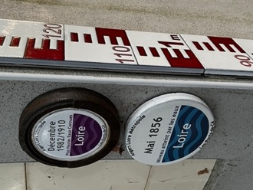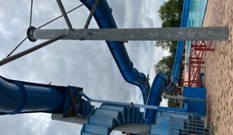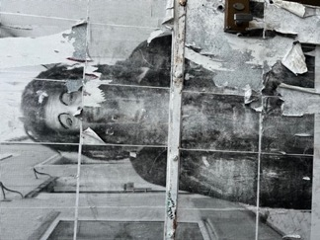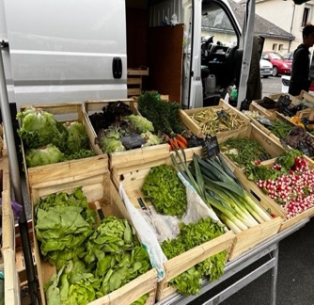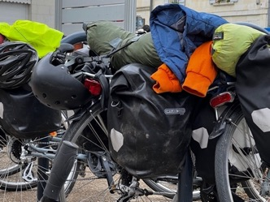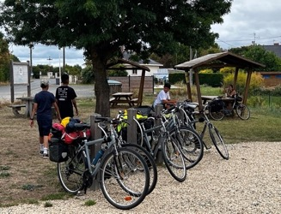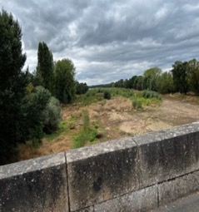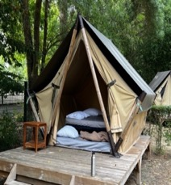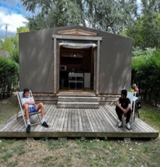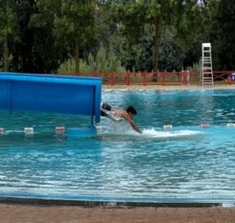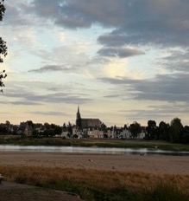

Wednesday24th
64km Slow Village to Le Grande Village

Today was to be the hottest day so far reaching 38 degrees by 2pm. So, although it was the longest day of riding, we took plenty of breaks.

We left the Slow Village a little later than planned and began with a gentle ride through the countryside after about 4km Hannah suddenly realised that she was missing her glasses, so Celia volunteered to ride back and get them after we confirmed they had been left in the tent. Not long after this impromptu stop we were suddenly meet with a very steep hill which took a lot of effort to get up, but we all managed. We were up high and could now only see the river in the valley, we continued along a flatter road with one more steep hill before arriving in a tiny village, we arrived in the village square which was a bit funny as people were sitting outside the café and they looked at us all at the same time. Due to our earlier delay, we had missed the shop so Alex went off to see if she could find anything but came back empty handed. Luckily, we all had some emergency noodles in our panniers, so we rode a little out of the town and found a shaded spot to cook lunch.
Our surprise of the day was that we were to visit a Kangaroo Garden. When we turned into the car park, we were meet by a long queue ... think the most people we had seen in one place for a while. It was such a hot afternoon that it really felt like we could have been visiting Australia, and due to the hot weather, the grass was also so parched. It was a huge area the kangaroos had to move around, and they were so friendly although the bread we bought to feed them might have helped as it’s like chocolate to them apparently.
Before we left, we all had ice poles that were much needed and then continued our cycle to the campsite. The afternoon was a gentle downhill ride which was good has we had weary legs. We arrived at the campsite just as it was getting dark – the first time this had happened to us and meant that we didn’t see the thousands of ants that were crawling around until after we had erected the tents. We had a feast of a meal which was really enjoyed by all, and Avalon tried avocado for the first time, she was brave on this trip trying new foods. We all had a good sleep and the young people even had to be woken up in the morning.

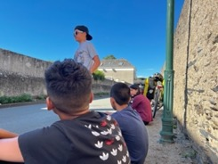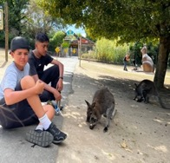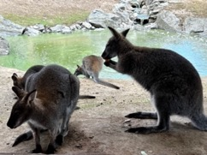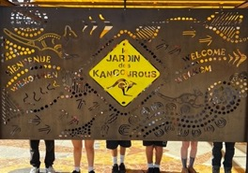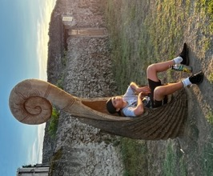
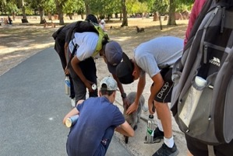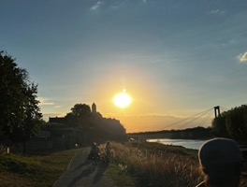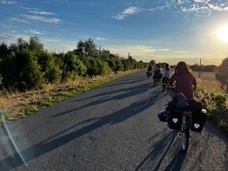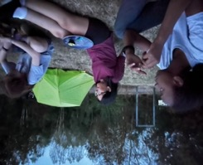

Thursday25th
62km to Saint Herblain

Thursday, the second longest day of cycling and everyone woke up with lots of ants in their tents and in their panniers. We emptied everything and tried to banish all the ants with limited success, we were to find out later. Having completed this task, we ate our breakfasts and prepared for the cycling.
We cycled along by the river all morning which was very pleasant until we reached a very conveniently placed supermarket at the end of the path, so we purchased lunch and ate it in the local park where Avalon found more trees to climb, and Avantika found some very sour grapes. We spent a little bit of time here before the afternoon cycle into Nantes. This cycle again was by the river and pleasant until about 3km outside Nantes when we suddenly started noticing a lot of fly tipping and burnt-out cars, to be honest we all found this piece of path a little scary. Having got through this we then arrived in Nantes and stopped for a quick water break where some of the young people played chase, Jake used his parkour skills and jumped over the riverbank wall… but then was unable to climb back up it and we had to put Operation save Jake into action.
Jake having been rescued we continued to Saint Herblain where we would find our accommodation for two nights. The cycle from Nantes was a little industrial to start with but then we found our way into a nature reserve and had to cycle along a boardwalk which was really fun.
Have unloaded the bikes we opened the tents in the garden to dry them off a little and Alex and Celia went to get some food. We had a feast that night pizza, chicken, salad and to finish off ice cream. After this we collectively choose a film to watch and relaxed with popcorn. We were all happy to be sleeping in beds that evening, although Alex and Celia slept on the floor in the lounge.

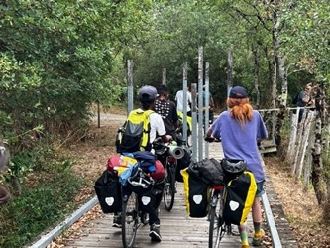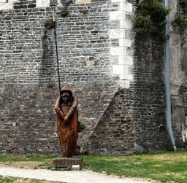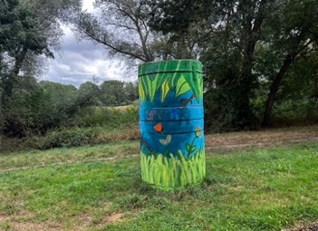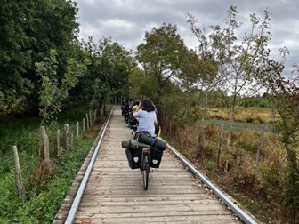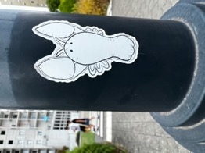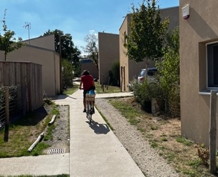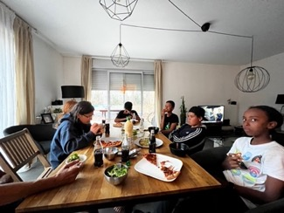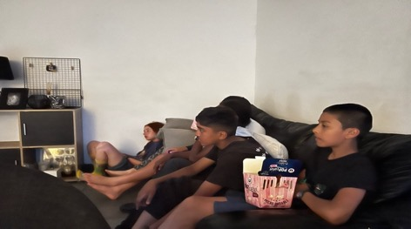
Friday 26th
Saint Herblain to Gueraude Salt Marshes

We woke up on Friday and had a feast of a breakfast, including the first lot of cereal for more than a week the benefits of being in a house.
Today, we were leaving the bikes at the house, and travelling on foot it was a short walk to the station and although we were not travelling far, we had to change trains three times and eventually we made it to the Atlantic coast.
We walked up to the museum on the way purchasing a new ball after we lost the last one in the river. The salt museum was very interesting. It showed you how long they had been harvesting salt from the area and we were all surprised to see that it was from the 15th century. Also, in the salt museum they had a lot of the instruments that they used to correct the salt, and a good demonstration of the different layers and different types of salt that were harvested, the museum was a good one and interactive with some very good displays upstairs. They also had a photographic exhibition of salt harvesters in Bolivia high in the mountains. The process was the same but obviously without the use of the sea and the tides. It was interesting the amount of involved historically of women that panned for the salt in both countries.
After the museum, we then took a short walk to the beach. It was a small, but very nice beach with plenty of rocks as well for Avalon and others to climb a few of us braved the sea which was freezing to start with but after a few minutes our bodies warmed up. Some of us were tempted with the waffles and ice creams from the van and then we slowly walked back to the station. On arrival at home. We had pizza and film night again. Today was the only day we had a small problem within the group but by the time we watched the film all had been resolved and everybody was happy and in fact the group had a good conversation about the use of words and how different groups of people can relate to certain phrases.

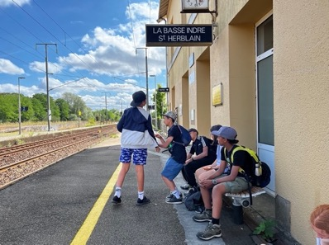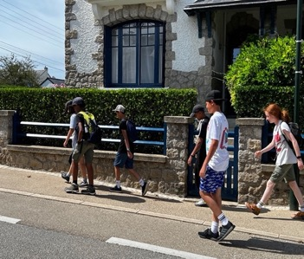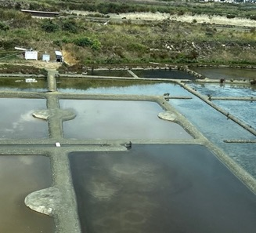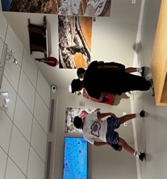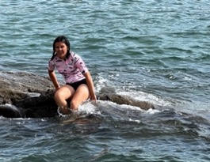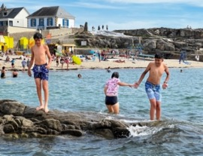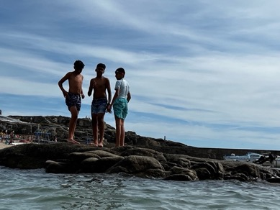

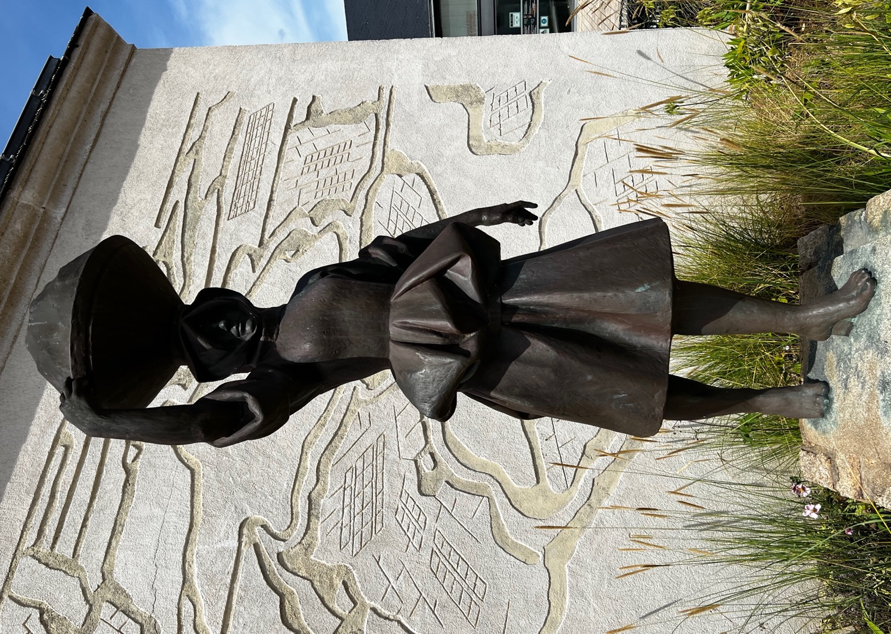
Saturday 27th
Travels around Nantes

Saturday was the last full day of the holidays and we had to leave the house as we were staying in Nantes that evening to make catching the train easier on Sunday morning as it was at 5.30am.
It was a nice gentle cycle into Nantes and the first stop Alex, took us was to the market where there was plenty of fresh produce. The plan here was for all of us to have €5 and to spend it on something for everybody for lunch. With the aim of trying some new produce. We bought some lovely baguettes and many of us tried some empanadas which were delicious. We also had an abundance of beautiful fresh fruit, and the strawberries were amazing, as were the fresh apricots which everybody liked as well and was a first for many in the group. After the lunch stop, we had one more place to visit, and that was the Jules Verne Museum. It was a little bit out of town and up a lot of stairs and a big hill. Many of the group were not aware of the name of the author of the book Around the World in 80 days, but the Museum gave a good overview of his life and showed many props from films and theatre productions of the book at the end of the museum you had to walk down through the botanical garden. This was very nice too. The only problem with that was you had to walk back up the stairs but some of the group found the handrails very exciting and perfect for sliding down. From the Museum we rode back into the centre to return the bikes this took slightly longer than we anticipated as twice we passed the bike shop but didn’t see it as it was on a boat, and we were looking for a shop similar to the one where we had picked the bikes up from in Tours. It was very weird not to have the bikes any longer and now we had to rely on our legs now. As it was such a hot day we stopped for a cold drink or ice cream at McDonald’s and then we made our way for the evening surprise. We followed Alex onto the island of the machines were, we were informed that we would be riding the huge elephant in the middle of the square this we couldn’t quite believe. We waited for a while until the elephant had been unloaded, and then we took our place on the elephant the walk about was for about half an hour and it was a beautifully hot day so the water spray from the elephant was very refreshing After the ride on the elephant, we then went inside and there was a greenhouse area with many more machines and there was a talk and demonstration of these machines and although it was in French watching the machines move was really good. By this point we were all very hungry and instead of going back to cook Alex suggested that we eat at a Tapas place on the island. This received everybody’s vote and was a really nice way to finish off the trip except for there being some almond in the ice cream that slightly triggered Jakes allergy, but he recovered well after taking medication and then we walked back through the slave memorial exhibition, which was all about the people that had arrived and departed from Nantes as part of the slave trade. This we all found quite sobering to see the names of people and the boats they had travelled on, some of name plates showed the age the person had died at.

We were staying in a lovely apartment about 15-minute walk from the station and we all had a good night sleep even if it wasn’t for very long as Alex woke us up at 4:30 am.

This diary just gives a taster of all the things we learnt and experienced on this trip, and we all feel that we have grown in some way having completed this amazing Journey.

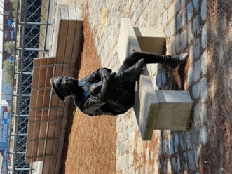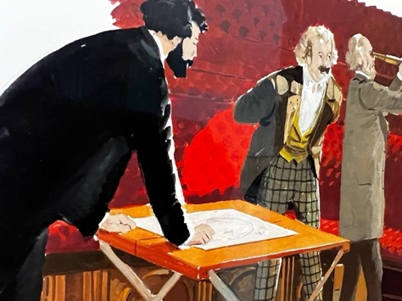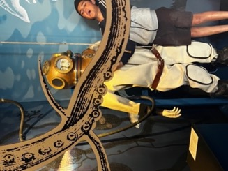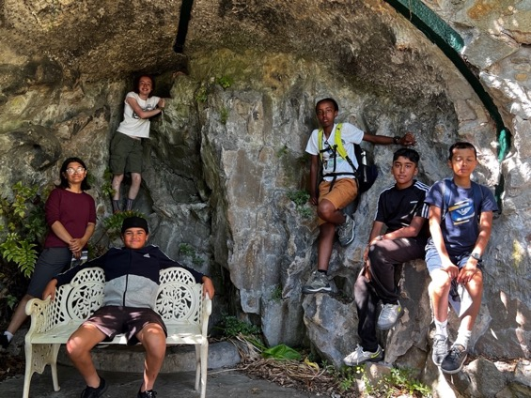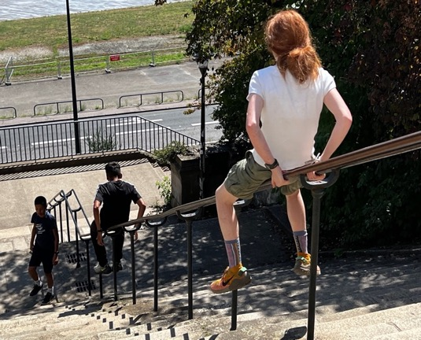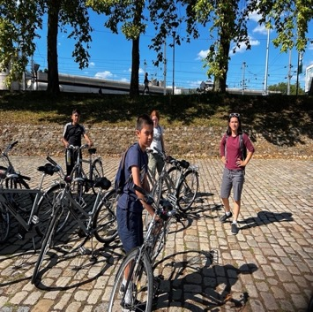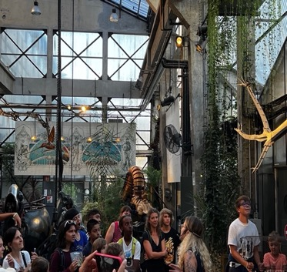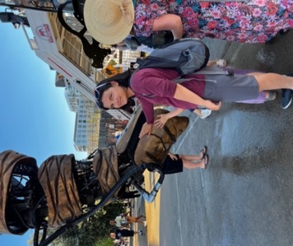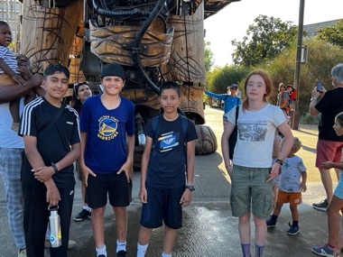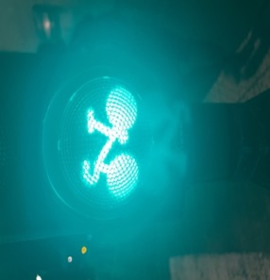

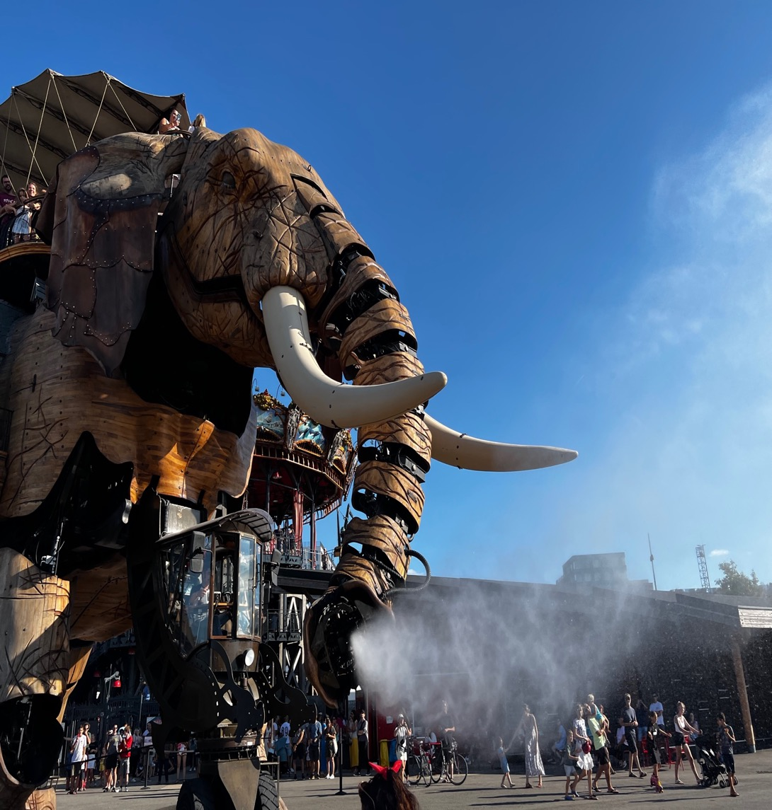

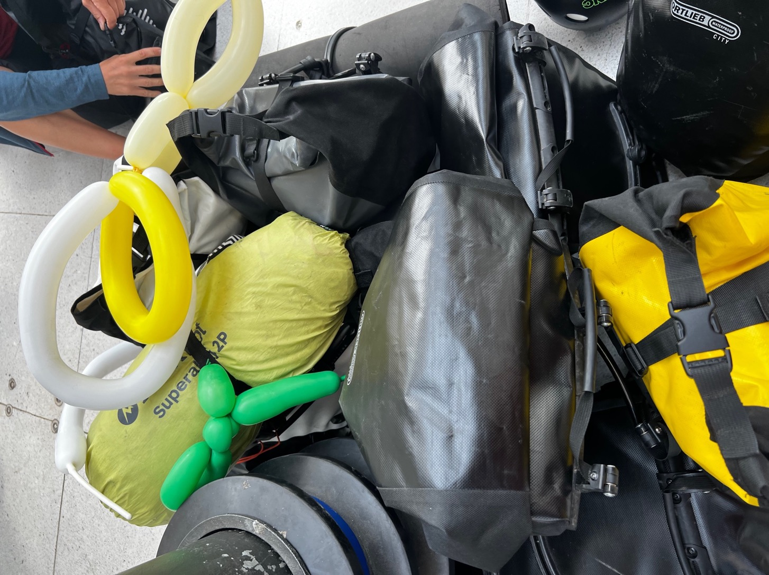

We had a five hour wait in Paris …but finally made it back to London with many stories to share.

Young people’s feelings and thoughts about the trip

“This trip showed me another side of the culture of the French. It allowed me to truly experience life as a local which I would never have seen if it wasn't for this trip. We pushed past our previous thought to be physical limits through kindness and encouragement.
We went through a short trail, where multiple people kept on falling of their bikes, but through perseverance and prioritizing the team goal over one's own (which we learnt from Alex) we successfully made it through to arrive to a warm bed and running water (which this trip allowed me to see its value).We all had lots of fun on this trip and got to learn a little about ourselves as a bonus.”. (Hannah)

“I’m very proud of myself for cycling, such a long way and distance in such a short amount of time and sleeping out in the open and in the cave” (Yameen)

“The trip was a very positive experience. There were some challenges, but all had a positive outcome. The cycling was of course difficult, but it strengthens the resilience and determination and of course as well to strengthen us mentally. It also improved as physically make it stronger. Furthermore, the campaign had lots of benefits. It improves our relationships of the people we were with made us feel grateful for our homes and gave us new experiences, especially while camping and the stars were amazing. In addition, we had lots of other unique experiences along the way, for example, seeing kangaroos and riding a mechanical elephant both, of which were amazing. The landscape was beautiful and nice and specially enjoyed exploring the towns. There was some of the most beautiful towns I’ve ever seen. I also enjoyed swimming in the river which is not really something you can do in London. It was also a great bonding experience. It was very interesting to learn more about our peers and develop relationships with them the museums inspired me to learn more about everyday things. I’m so grateful for the opportunities that I have been offered. They were truly life changing and I really enjoyed this wonderful experience”. (Avalon)

“I found the trip a good experience and I learned a lot of skills about camping. One of the biggest challenges were the big hills we had to cycle up. It was very fun, and I enjoyed it all.” (Yusuf)

“The best parts of the cycling trip for me were the cycling through all the French towns, the farmers market, monumental landmarks (slave Exhibition, salt marshes, Jules Verne’s house and garden, machine de Lile). We went to a campsite with water slides, and when we slept in beds for the second time on the trip this felt good after a long cycle.
I enjoyed eating bread, pain au Chocolate, croissants, rotisserie chicken, Alex’s vegetables with stock (this was the best)! and all the apple sauces!
We played games, we swam in lakes and the sea, we wild camped which wasn’t my favourite as I like tents, but it was a good experience. We saw a wild otter, some stray dogs, and kangaroos at the kangaroo sanctuary. I learned a lot from my experience, there were ups and downs at points.
I missed my Mum a lot, but I knew I just had to get through it.
Alex and Celia were very nice to us, supportive and were encouraging all of the time. I felt safe with them, and I would do it again because it was a once in a lifetime opportunity.
I’ll be sure to take my mosquito net and my army tent next time as the mosquitoes left their mark on me”. (Jake)

“On the first day of cycling, we collected the bikes and cycled 40km to the ‘campsite’. We were thrown into the deep end straight away as our ‘campsite’ consisted of a half grass, half sand field and our toilet were some bushes. The bikes were nice and light which helped me to enjoy the ride each day more. On our last day, which turned out to be 60 kilometres of riding, there was a large off-road section which would’ve been more fun to ride along if it weren’t for the heavy panniers and the fact that the bikes had virtually no suspension. I enjoyed the glamping and going down the water slide at the swimming pool. I must’ve gone down that slide at least ten times even though slopes were not that steep. I also really enjoyed the beach because the sea was so cold, and it was so exhilarating and refreshing. Something I found tough was putting up the tents and making dinner even when I was exhausted and all I wanted to do was eat something and go to sleep. Something else I enjoyed was a hill at one of the campsites which was so exciting to ride down on the bike as it was quite steep, and it was tarmac rather than gravel or dirt.” (Avantika)

Parents feedback – it is easy as a worker to forget how these trips can change the prospective of a young person and the feedback we received from the parents after this trip really helps to high light the necessity for all young people to have access to such schemes no matter their family background or parental income.

Avantika’s Mum

“Over the last year, the Urban Adventure Base has been a lifeline for my daughter. The cycling trip has been a life-changing experience.
Lockdown affected Avantika’s mental health, although this is something that is only becoming clear to me now. There was a real sense of being cooped up for two years and a real sense of frustration. This was finding an outlet in overuse of social media but some fear of actual IRL socialising. She moved into sixth form but did not really settle down. It seemed like she had not really grown in the last two years and was not ready to mature and take on the responsibility for her education. Her school suffered; she went from being a high achiever to failing several exams. She contemplated dropping out of education.
The cycling trip really helped with a lot of things. First, her physical health improved. She is reasonably healthy girl but the enduring the demands of the cycling trip made her believe in her body’s abilities. She knows she can do it. This also led to an improvement in mental health and confidence. Her faith in herself is so better now. In addition, she is also far more organised; she looks after her equipment and plans. This change was obvious as soon as she came back from Amsterdam trip. In preparing for the France trip, she was totally independent, she did all the necessary shopping, packing etc herself. She is also more aware of diet ensuring she eats properly. She has been telling about eating protein, carbs, sweets etc with some knowledge about how to balance these appropriately. She also has learnt to take responsibility for others in her group. Socially, it has helped her to spend time with the boys. She goes to a girls’ school and has a sister, no brothers. Overall, this is about getting on with people from different backgrounds and dealing positively with differences. She is better at managing money. Finally, the wild camping has given her a chance to be with nature and less dependent on her phone. Now she has made a lot of new friends and she has more to talk about when she is asked what she did in the summer. She has also spoken about her trip with quiet confidence and pride to her teachers. Thank you for giving her these experiences which I could never have given her. I did not have the opportunity to learn to cycle as a child and although I can do it now, I will never be confident enough to give my daughter these experiences.”

Yameen’s Family

“Yameen is a very quiet boy not too outspoken. He liked the idea of going away and loves outdoor activities. He was upset on the day of departure because he will miss his family. This was the longest he had been away from me.

He absolutely loved his experience. When he got back, he spoke all the way about how wonderful it was and described all the places he went and his camping experiences. I could hear the excitement in his voice which was nice to hear because Yameen doesn’t really express his feelings. He shared what he learnt with his sister, and he said he would love to do it again.

When this opportunity was offered to Yameen I was so happy because this is something I would like him to do and become more independent and learning never ends. He thoroughly enjoyed his experience.”

Avalon’s Mum

“I've been meaning to write to you about how the trip away has impacted Avalon's life.
She seems different, more buoyant, more confident, more resilient, more positive, less anxious, and much much happier. Avalon seems to have settled more into herself and for the first time actually likes herself. School is presently ok; this has never happened before!!!!
I wish all young people who struggle could have the same opportunity. Experiences like this can raise people up and out of their darkness and give them the confidence and resilience to make positive life choices leading into young adults”. Linda (mum)

Hannah’s parents
“We were very fortunate for Hannah to experience this amazing trip abroad and have the opportunity many children will not have in our borough. She travelled with some children and staff who she didn't know very well but she as well as us were open to this fantastic new chapter.
Hannah took great pride in being able to be responsible for her belongings including tent etc, money management as well as her travel experience and interpretation of it afterwards.
There were many places she was passionate about, people she met there as well as the culture of life and some things which could have been better in comparison to England and our way of life.
We felt reassured and supported by Alex and felt like we were part of the trip as we had multiple photos of her daily trips as well as plenty of opportunity to reconnect with Hannah and catch up with her about her day.
Alex and her team have been fantastically supportive, and we are excited for Hannah to hopefully continue these epic experiences.” Sam Baroot

Jakes Mum

“I feel that Jake learnt some valuable lessons on this trip emotionally and physically, he has matured because of them. He Developed more independence but being away made him value his family more. The trip improved his confidence and self-esteem because he has more self-belief.
He’s gained more motivation to take parts in multiple sports clubs and activities on a weekly basis which is so important for him. As he has a lot of nervous energy and playing sports and cycling keeps him busy and fit and has helped with his focus at school. I think he’s learnt a lot more about what his body needs to function as an athlete and is now taking more of an interest in nutrition to fuel his body. I’m so pleased he took part”. (Laura)

