Phil Amos - MLW training course report 6th – 10th February 2023

“You want feedback?” John looked confused.
“Yes please.”
Should I have called him Sir? It was the conclusion of my MLS assessment at the RAF Air Cadets Adventurous Training Centre in Windermere, and formalities had been dropped for the full five days. Maybe I’d mis-read the protocols now we were back in civilisation?
“YOU want feedback?” Now I was getting worried – we’d just been told we’d all passed, come into the office if you want feedback. So…?
“Well, Phil, you should be sat in this chair” – he gestured to his own – “directing these courses...”
Oh. That was a bit more positive than I expected. In fact a LOT more positive, to the point of being something I’d never considered or contemplated.
“…so get your winter ML as soon as you can...”
Let’s back up a little bit. I’ve been walking in the hills – initially summer and then winter - since I was eight, over four decades ago. At university, my horizons expanded into Scotland, bigger winter days, rock climbing, winter climbing and then the Alps. Moving to Scotland after graduation was inevitable, and I became a fully committed winter climber. I still am, with the rough and ready navigation skills to match. Winter walking fell by the way side – the lure of thrutching up snowy Cairngorm granite and the sweet thunk of an axe into Ben Nevis styrofoam ice overruled everything for more than quite a while. Self-organised trips to unclimbed mountains in Bolivia, Pakistan, Nepal and Tibet followed on. So much amateur fun, a few stories to share in the pub, and at least a couple of occasions where we had to dig deep into our reserves of luck and chutzpah (skill and knowledge reserves by then being well spent) to get away with it.
Then family arrived, and days out had to become more tactical. We taught them (told them?) to enjoy walking in summer hills, and family munro bagging trips became a summer thing. Our eldest joined the RAF Air Cadets (“Are you sure – there’ll be a lot of marching and polishing shoes…”) and within six months I was a staff member. What could I do - they could make use of my outdoor experience, the other staff seemed a nice bunch of people, and there was the golden ticket of encouragement from my wife. But first they would need to put me through MLS training and assessment.
Wiling away in lockdown, banned from travelling to the hills, I’d read a few accounts of Winter ML while backdating my DLog. My DLog plan had been to enter the bare minimum for the MLS and RCI schemes, but lockdown dragged on, and I ended up putting about 80 – 90% of my experience into the system. At that point Winter ML sounded hard, maybe too hard – I couldn’t quite picture myself confidently leading a group across the Cairngorm plateau in a whiteout blizzard - if the weather was like that then its not a climbing day so better to stay at home and claim the family brownie points!
The problem with that strategy was the weekends I could get away inconveniently clashed with Atlantic storms or turbo-thaws, so I would end up staying at home mumping like a bear with a sore head because I was missing out on time in the mountains. I started to use non-climbing days to fill gaps in my Munro chart, dipping into ‘Scotlands Winter Mountains With One Axe’. But my skills were still self-taught, learnt the hard way, and felt amateurish, or at least lacking a point of reference. So being a MLW hadn’t really featured in my game plan - time spent gathering QMDs would be time spent not climbing, wouldn’t it?
Despite that, three hours after the MLS assessment feedback conversation the euphoria of becoming a professional summer mountain leader was being replaced by a different burn – I wanted to be an MLW now.
Why? Partly I wanted the challenge, to compare my self-taught skills against a professional standard, and to improve. The more you expose yourself to risk, the more likely it is that that risk occurs, so with the time I’ve already clocked it would be well worth upping (or at least checking) my skill base. Partly I want to give others a chance to taste the challenge and enjoyment of winter hills that I have already had. And partly because I just want to spend more time in the winter hills myself, to catch the (occasional!) alpenglow at the end of a long day with like minded people – even better to immerse in the glow as you reach your final summit and descend into the gloaming, to feel the warmth of wind burnt cheeks as you sit later in front of an open fire, knowing that you have earned that satisfaction.

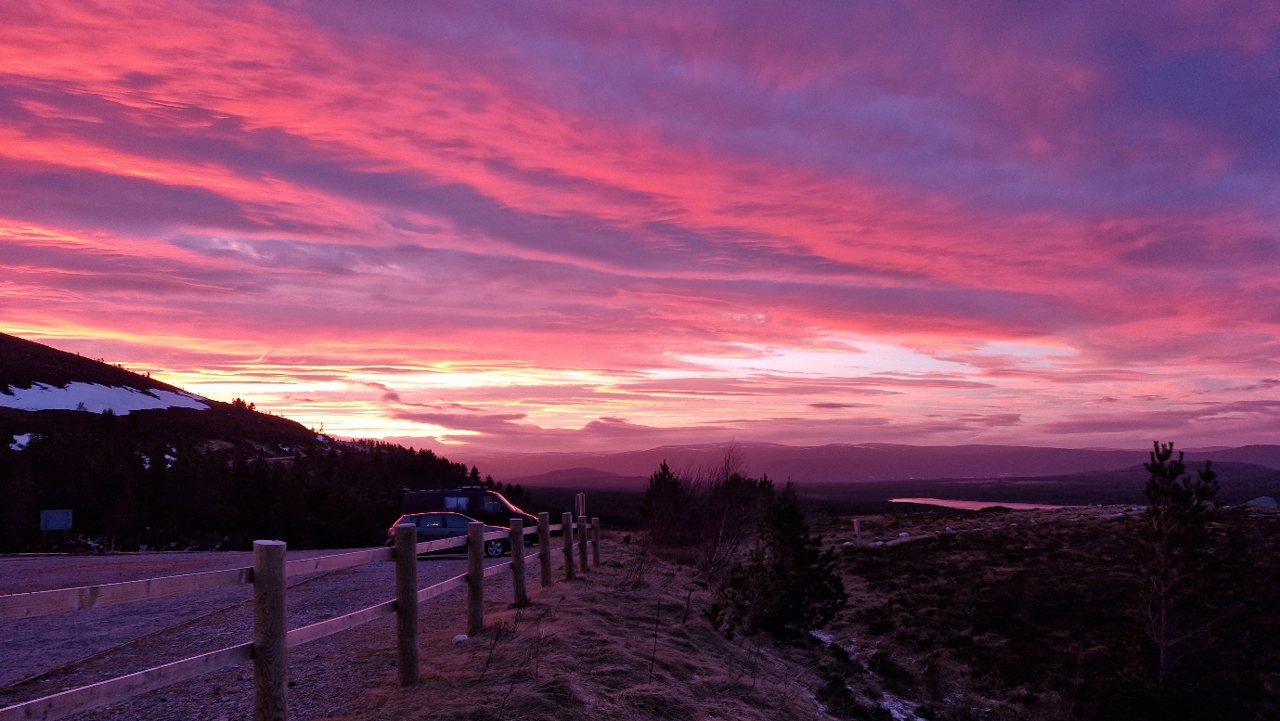
Sunset at the end of MLW training day 1.

I’m writing this nine months after completing my MLS assessment, and two weeks after my MLW training. I went with Scotch on the Rocks Guiding, and was awarded a grant by the Neil Mackenzie Trust, to whom I am extremely grateful for the support. The six day course was timed for the second week of February 2023, usually a reliable month for winter conditions, but not this year. The usual thaw over Christmas, a good dump of snow in January (the January 2023 WML training course wore crampons for half a day and spent the rest of the time trail breaking), but then a deep thaw, followed by warmer weather and storms had left the plateau bare and the pickings slim. Still wintery but the local knowledge of the instructors would be fundamental to a successful course meeting all of the MLT UK requirements.

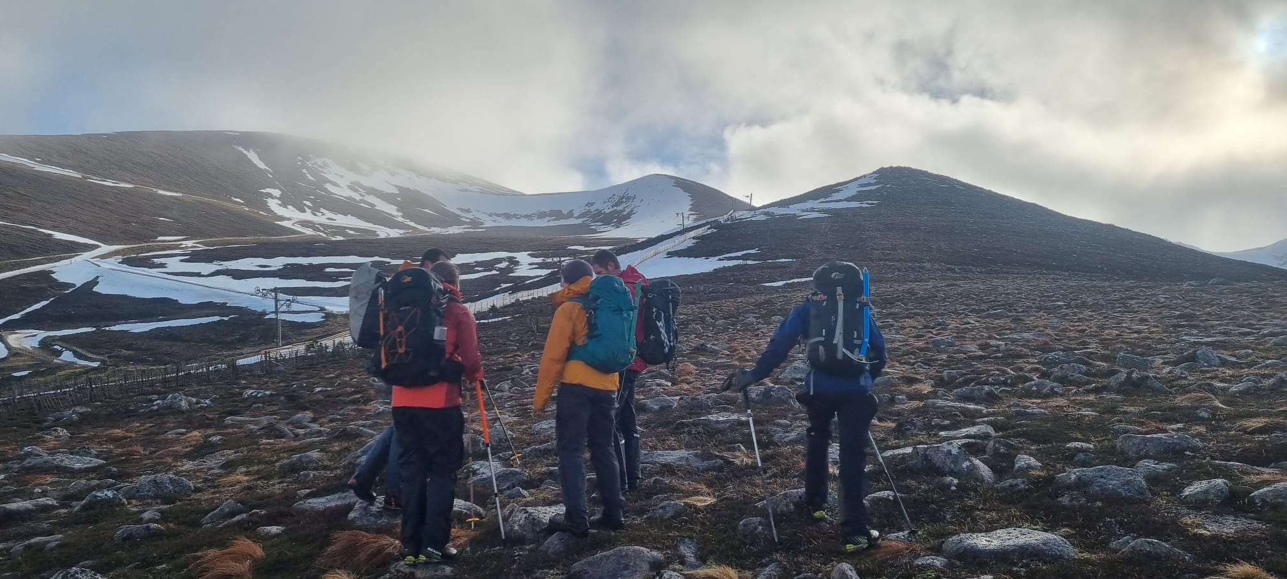
Day 3 – heading up for some steep ground management (photo courtesy of AP Mountaineering – apmountaineering.co.uk)

The course not only exceeded all of my expectations, but also broadened and deepened my winter hill skill set, which I thought was already pretty comprehensive. By the end of the course I found my navigation, with a bit of application, was better than I thought (excluding the odd terrible mistake that is the inevitable result of switching off for only a few minutes!) Steep ground party management – I am more or less calibrated to the appropriate boundary between comfortable and hairy, the years dangling on ropes haven’t de-sensitised me (or maybe its just an age / being a parent thing?) Personal snowcraft skills fine, (but its not just about my skills, its about whether I can teach them to others and still get a good, safe day in the hills).
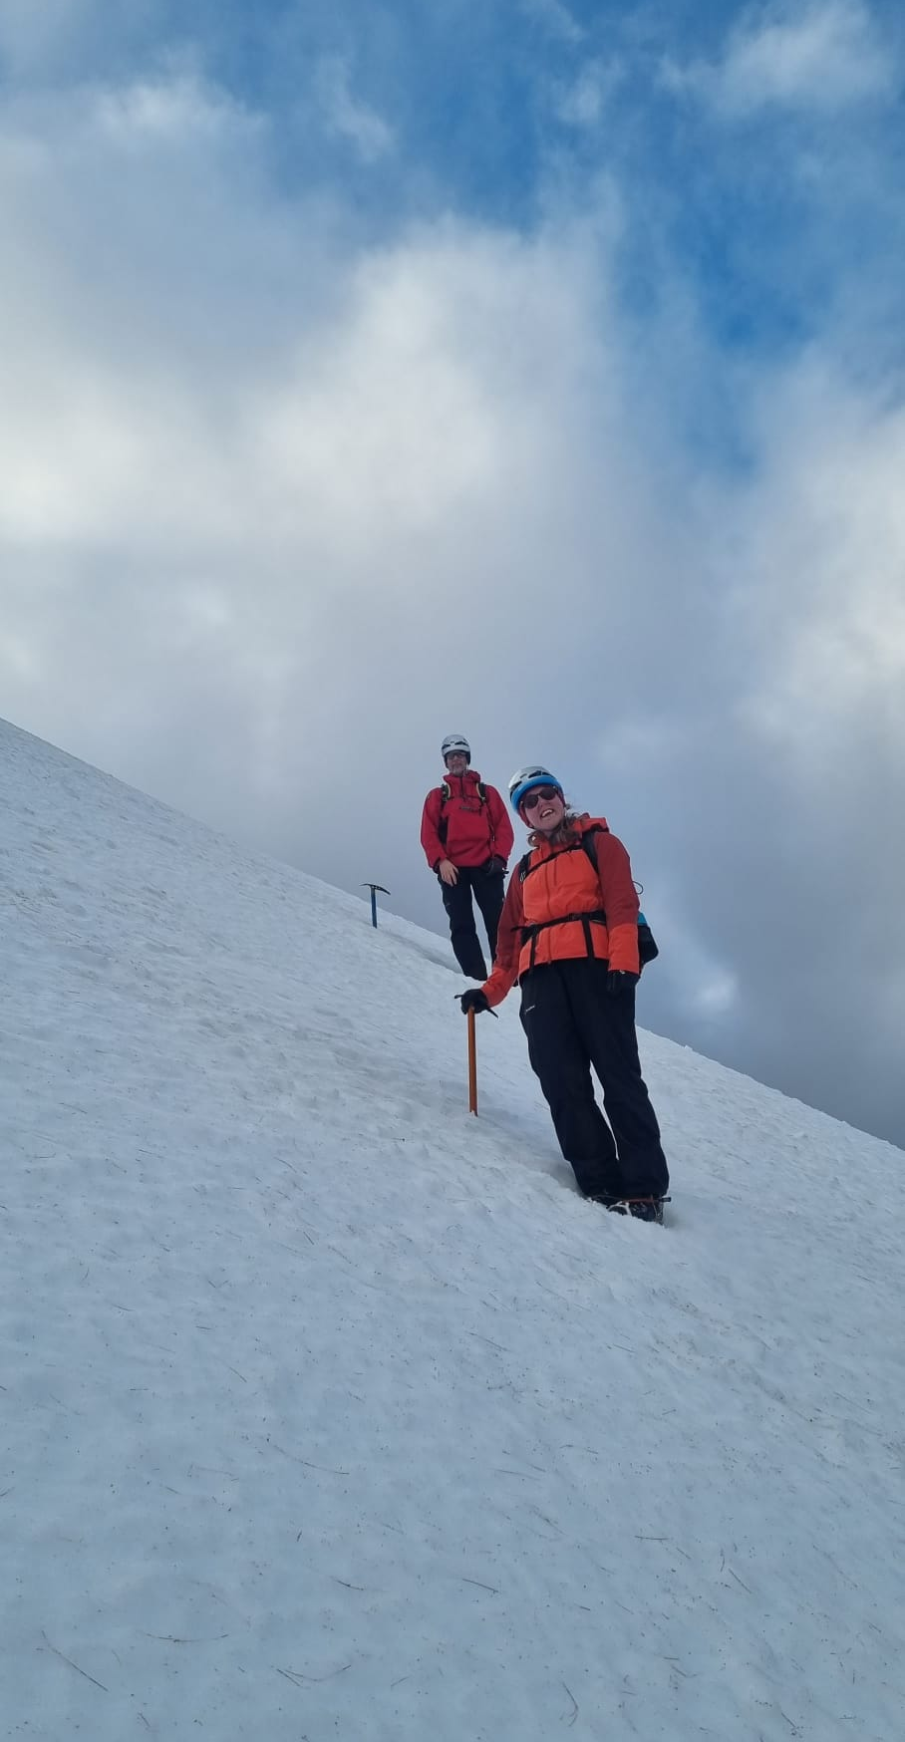
Day 3 – Peter and Sophie at home on steep ground (photo courtesy of AP Mountaineering – apmountaineering.co.uk)

But there many parts of the course that sharpened my focus. Avalanche awareness – previously I’d always taken a ‘considerable’ to be halfway between “where’s all the snow gone” and “death on a stick, stay at home” – so “not that bad”. Reality – it is bad if you are not 150% on your game, all of the time. Take your party onto the wrong slope in a ‘considerable’ state of avalanche risk and you are likely to be in an avalanche big enough to make your day and theirs very very bad. And how to read a forecast – the SAIS “pizza of death” is not much more than a final plea by the forecaster for the reader to remember just a tiny bit of the forecast, and the emphasis is on reading the various sections in the daily report to understand the processes that are giving rise to the avalanche risk conditions – almost every word in that forecast is carefully chosen and placed there for a reason.
Prior to the course it hadn’t really sunk home that coaching and leadership were core skills that sit above everything else. Snowcraft, navigation, avalanche awareness, route planning, appreciating changing weather and conditions, steep ground skills all bubble away continuously in background, but the coaching and leadership is key to giving your party a safe, happy and fun day in the hills.
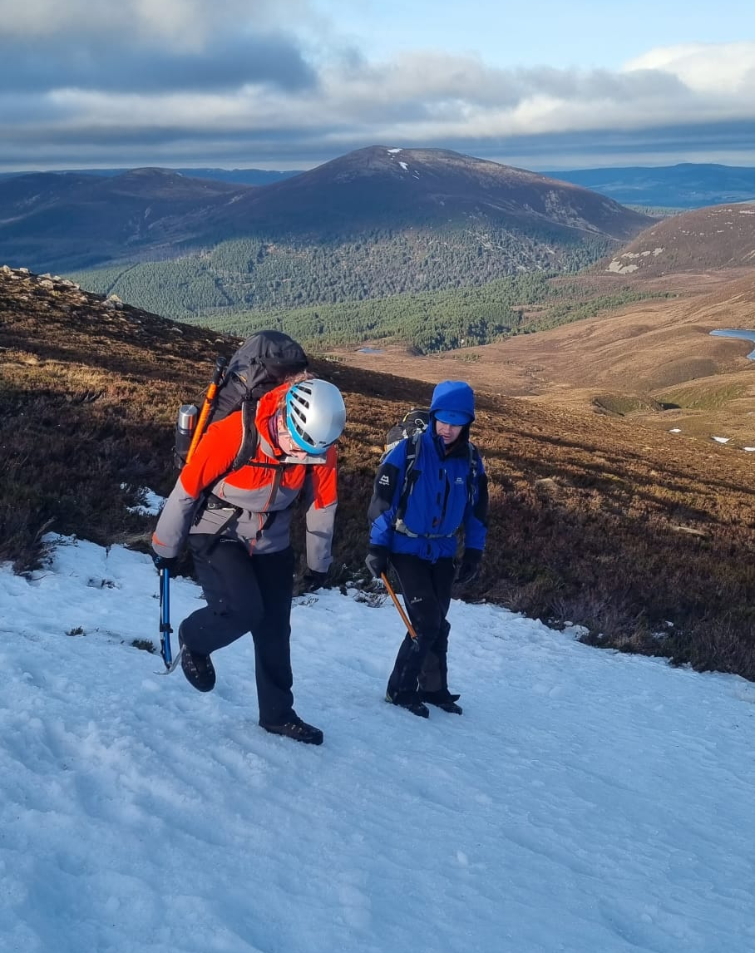
Day 2 – step cutting and coaching skills with Sophie (photo courtesy of AP Mountaineering – apmountaineering.co.uk)

But of all of my expectations, the one that was exceeded by a country mile was the professionalism, knowledge, skill and enthusiasm of Sandy and Jonty at Scotch on the Rocks Guiding. It simply blew me away. Going for a walk in the winter hills is challenging. Leading a party on the same walk is more challenging. Teaching the same party to become safe and competent leaders adds another level to the challenge. Do that in the conditions we had – plateau and slopes bare of snow except for isolated pockets of bullet hard icy neve, 80 – 100mph winds on the tops – and you’ve got your work cut out. And then immerse professionalism, knowledge, enthusiasm and fun throughout every hour, 8-12 hours per day, every day for six days and you have a truly remarkable mountain learning experience.
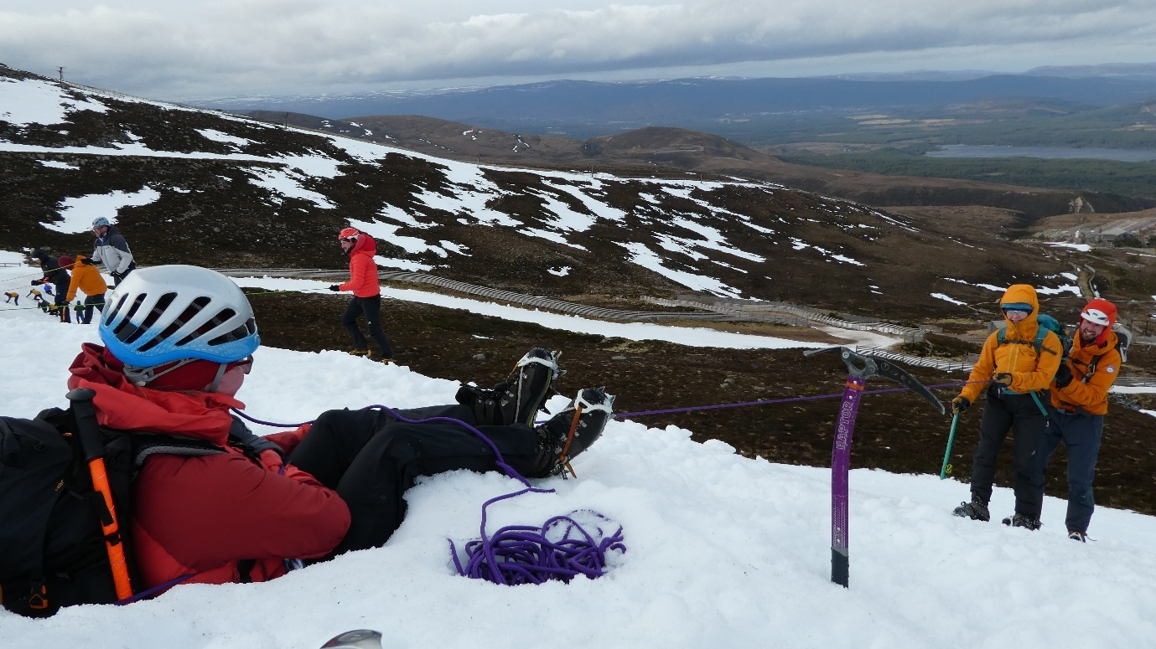
Day 4 – Sharon testing Sophie’s bucket seat and belaying, Jonty adding an extra element of assurance

So what’s next? We learnt a lot. An awful lot. Each day kicked off with a student led recap of the previous day, and that generally took 45 – 60 minutes, followed by indoor learning sessions on avalanche awareness, weather, route planning, coaching skills, leadership and other subjects. That all needs to become deeper than second nature to me – instinct isn’t enough, you need to be able to explain why your instinct is what it is and challenge it, because it could be too risky, it could be too conservative, or it could be just plain wrong.
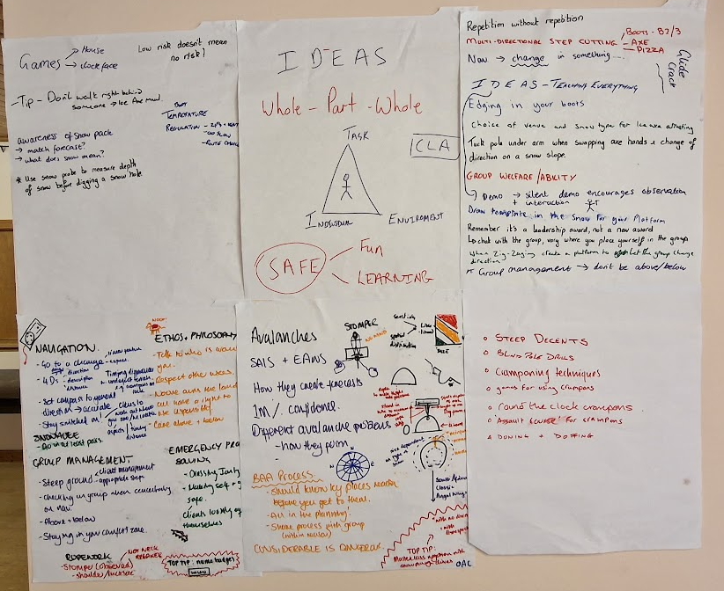
A few of the reflective learning reviews – the wall was full, the other sheets had to go on the floor!

I said I fancied a challenge, a test of my skills, and I now know I’ll be getting it when I go for assessment next year. And I am looking forwards to it, immensely. I’ll need to develop, I’ll need to practice, I’ll need to consolidate. And that means I’ll just have to go into the winter hills again. And again. And again.
Mission accomplished (partly)!

+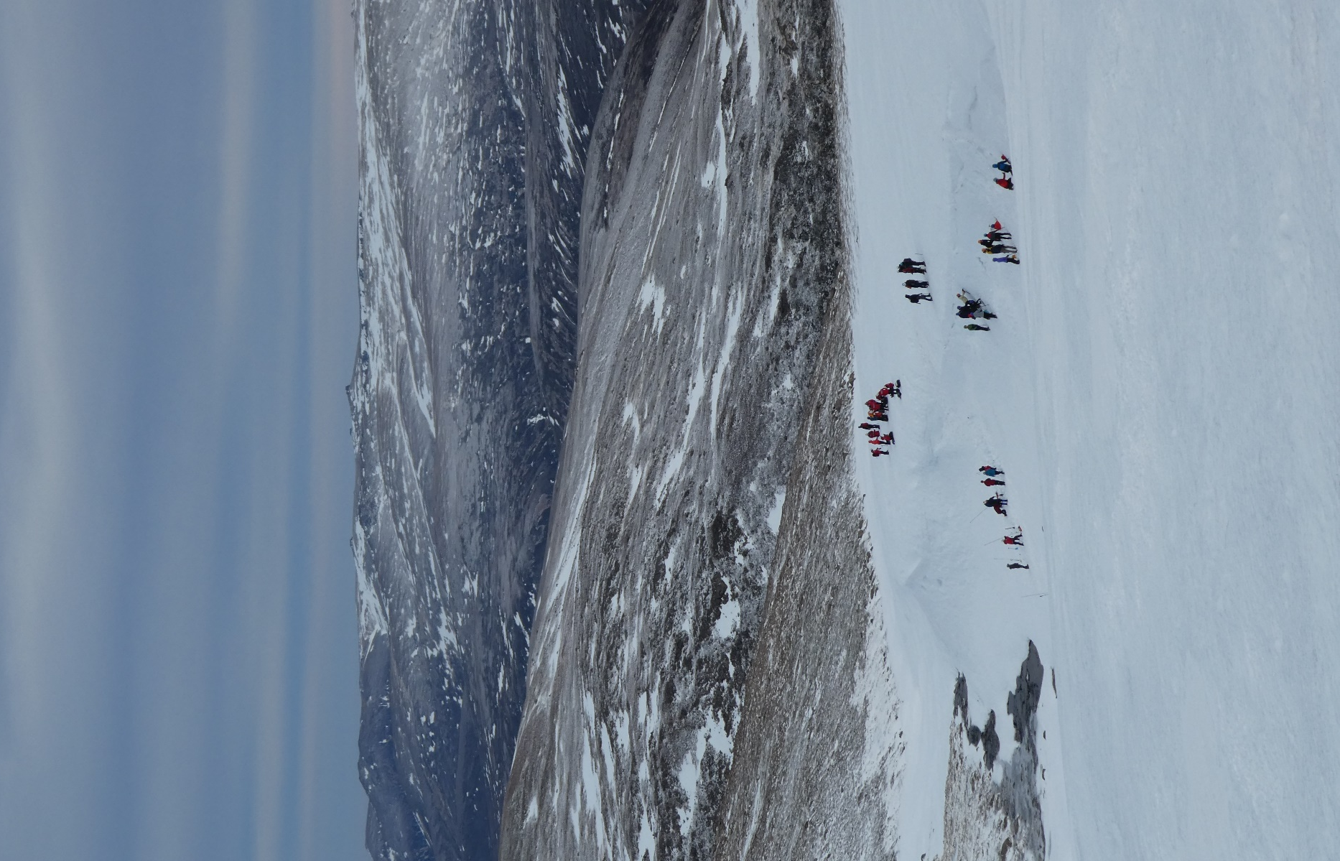
Winter skills crowds in Ciste Mhearad making the best of slim pickings
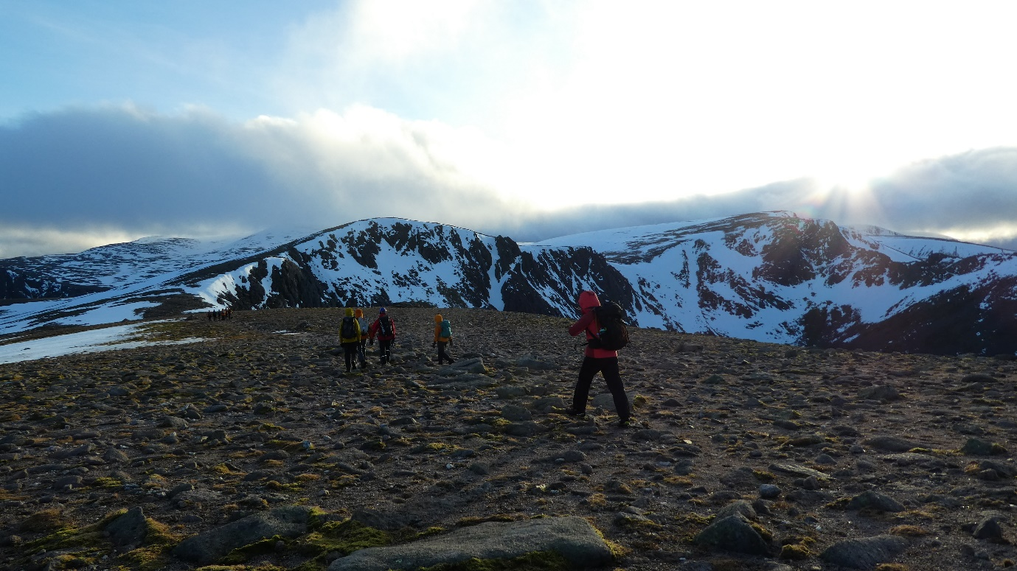
Day 3 – headlining off for day into night navigation

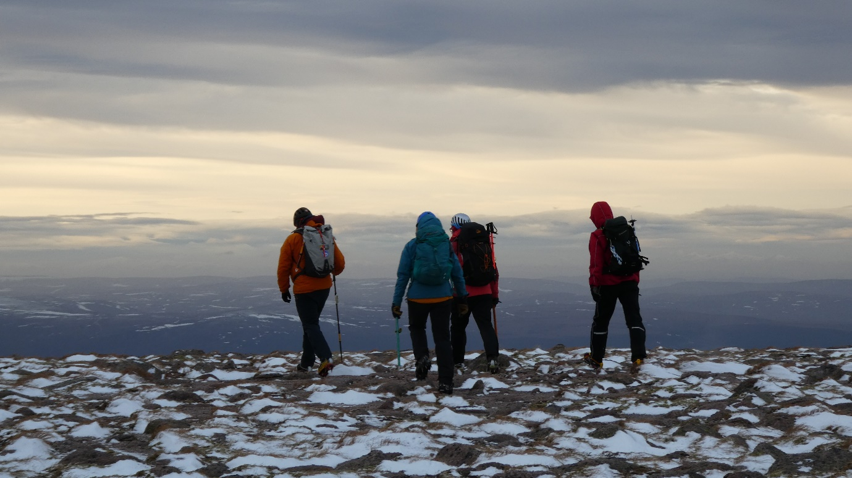
Heading for home at the end of day 1

