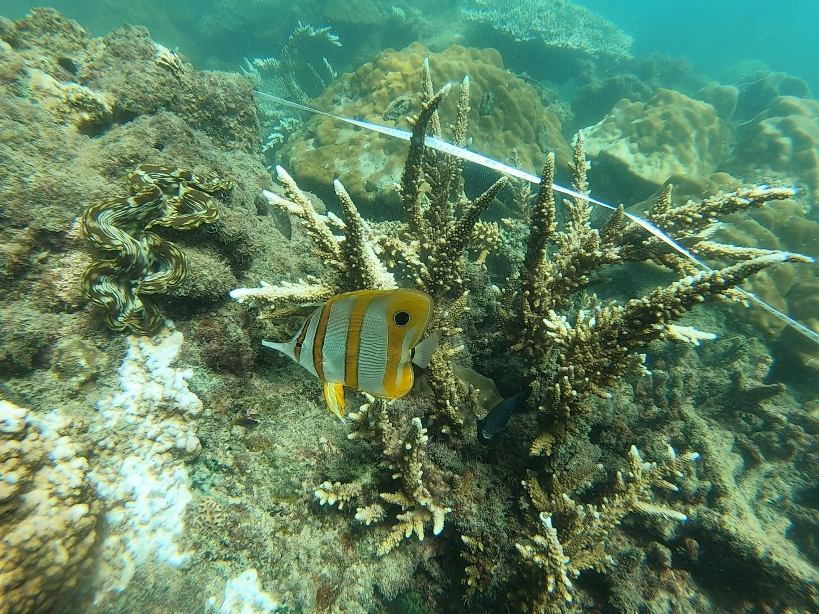
Thailand Marine Expedition 2023
Post-Expedition Short Report

Neil Mackenzie Trust Education Expedition Grant 2022/3


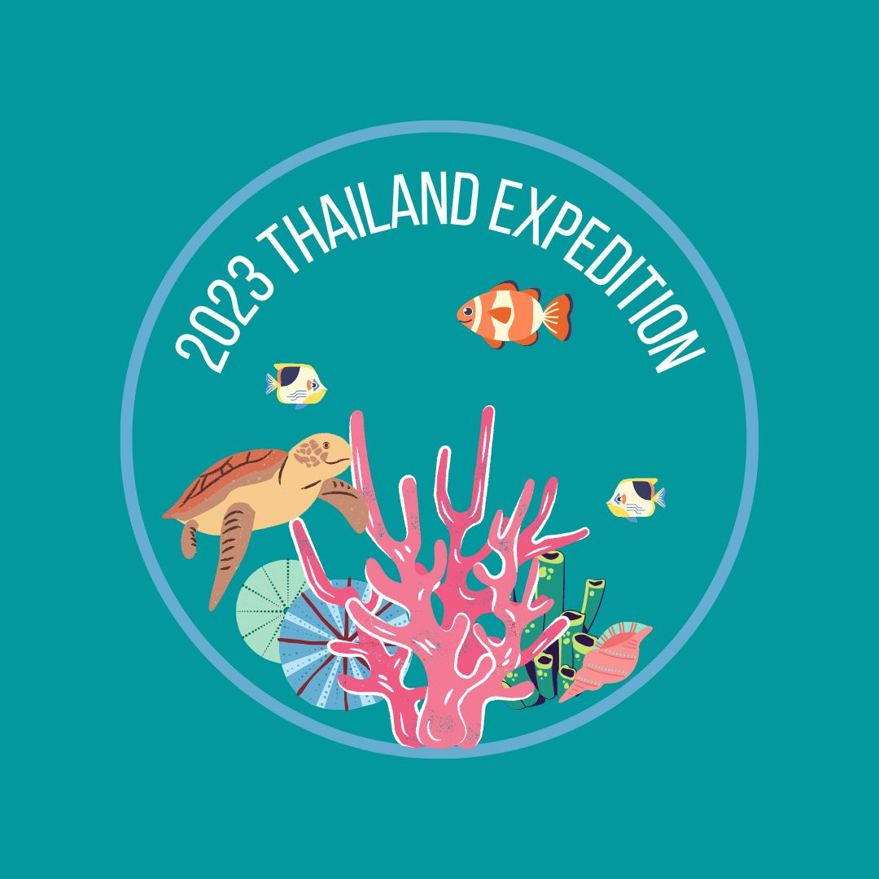

Report Outline
The following document aims to provide a short overview of the work conducted by the Thailand Marine Expedition 2023, organised by University of Glasgow students in association with the Exploration Society, to be read in addition to the full expedition report that will be completed within six months of the expedition’s completion. It overviews the undertaken research projects, highlights the activities conducted by the team, how the expedition achieved its aims, and overviews the expedition budget and logistics. It should be read as supplementary information to the original expedition research prospectus. Additional documents available to the reader upon request include the approved University of Glasgow risk assessment, and whole team dive log.
The University of Glasgow Exploration Society has been running geographical and zoological research expeditions since the 1920s. The society, and therefore this expedition is affiliated with the University of Glasgow, Scottish Charity Number SC004401.
Cover Photo: Kerensa Ballantyne, Thailand Expedition Team 2023

Contact Information
Email: expeditionthailandgu@gmail.com
Website and blog: https://expeditionthailand.wixsite.com/uofgthailand
Facebook: @University of Glasgow Thailand Expedition
Instagram: @thailandexpedition23
Callan Gallacher
2/1 698 Dumbarton Road
Glasgow, G11 6RB
callan.gallacher@gmail.com
+447923852586

Kerensa Ballantyne
0/2 18 Montague Street
Glasgow, G4 9HX
ballantyneKM@gmail.com
+447860372019

Table of Contents
Thailand Marine Expedition 2023 Post-Expedition Short Report 1
Report Outline 2
Contact Information 2
Table of Contents 3
1.Marine Thailand Expedition 2023 4
3.Research 6
3.1 Investigating Sea Urchin Abundance In Correlation with Coral Reef Structure 6
3.2 Investigating the Effects of Structural Complexity and Coral Cover on Butterflyfish Abundance 9
3.1.1 Introduction 9
3.1.2 Aims 9
3.1.3 Methods 9
3.1.4 Preliminary Findings/Preliminary Results? 9
3.3 Can the Soundscape of a Coral Reef be used as a Proxy for its Biodiversity? 9
3.1.1 Introduction 9
3.1.2 Aims 10
3.1.3 Methods 10
3.1.4 Preliminary Findings/Preliminary Results? 11
4.Logistics and Finances 11
4.1 Logistics 11
4.2 Budget 12
4.2.1 Income 12
4.2.2 Expenditure 12
6. Acknowledgements 13

1.Marine Thailand Expedition 2023
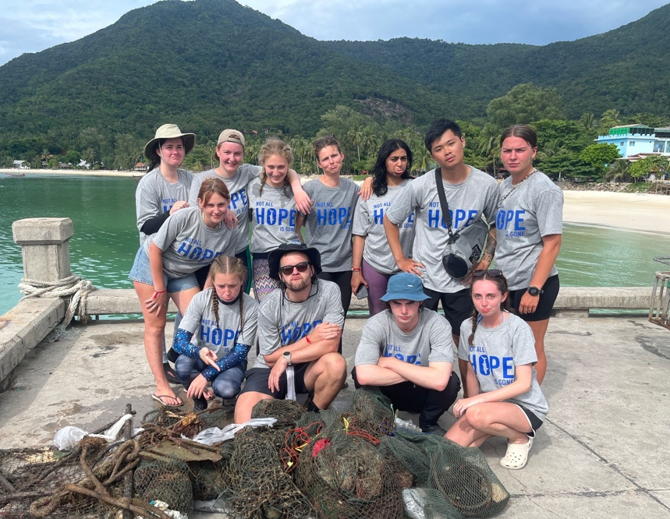
The Marine Thailand Expedition 2023 was undertaken by eight University of Glasgow undergraduate students for seven weeks over the course of June and July 2023 on the island of Koh Phangan, Thailand Working in conjunction with the Centre for Oceanic Research and Education: Southeast Asia (COREsea), data collection for three research projects was completed by SCUBA divers on the inshore fringing reefs to the north of the island.
The full Thailand Expedition Team 2023 alongside COREsea interns (C) at a DMCR reef clean up in Chaloklum Bay.
The first two weeks of the expedition were characterised by all team members who had not done so previously, completing scientific diving training lead by scientists and dive instructors at COREsea. This allowed the team to get used to diving in tropical conditions, after completing their PADI certifications in Scotland; to develop essential working buoyancy skills, minimising their contact with the reef and making surveys more efficient; and to familiarise themselves with the various surveys required to collect data for the expedition projects. One team member had completed this training previously and so began pilot studies for all projects alongside COREsea staff. This dive training was accompanied by a lecture series informing the team on the ecology and geography of the Gulf of Thailand and its coral reefs.
COREsea had three interns working with them upon our arrival (some of whom left during our stay and were replaced by new students) and one student completing their PADI Dive Master. Not only were these interns able to assist in the expedition’s data collection but our team members assisted in all research projects being conducted at COREsea during our stay. This included a coral bleaching project and an investigation into the feeding preferences of butterfly fish (both student projects) as well as a project looking at sedimentation being undertaken by researchers from Singapore. Alongside these projects, all team members completed surveys contributing to COREsea’s long-term monitoring of the Koh Phangan reefs. COREsea operate as a ‘seeing eye station’ for the Thai Department for Maine and Coastal Resources so all data they collect and reports they publish can be used to inform conservation and marine management in the area.
Data collection diving was undertaken for a total of four weeks with one dive conducted each day, five days a week. All diving was undertaken in buddy pairs or dive teams and with COREsea staff. All divers were equipped with an alternative air source and buoyancy compensator as well as a dive computer and surface maker buoy either individually, between buddy pairs or dive teams depending on dive details. The maximum depth dive to on data collection dives was 9m. Due to bad weather, five days of diving were lost overall however, this was accounted for during expedition planning, so the majority of data was collected as planned by the end of the expedition. The exception to this is the full fish survey which due to weather, dive boat logistics, and team training was not completed in full. However, the two days of data collection required were collected by COREsea staff after the end of the expedition.
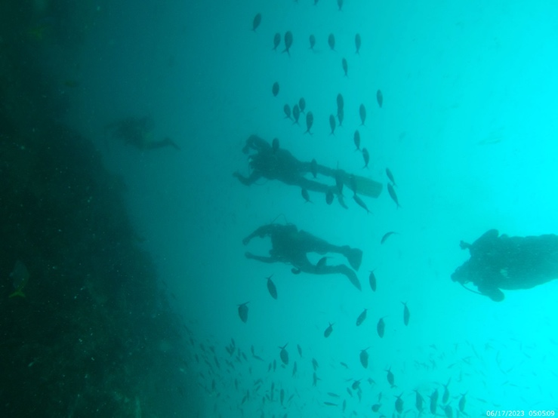
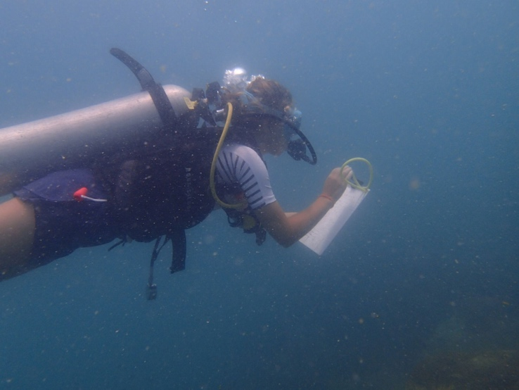
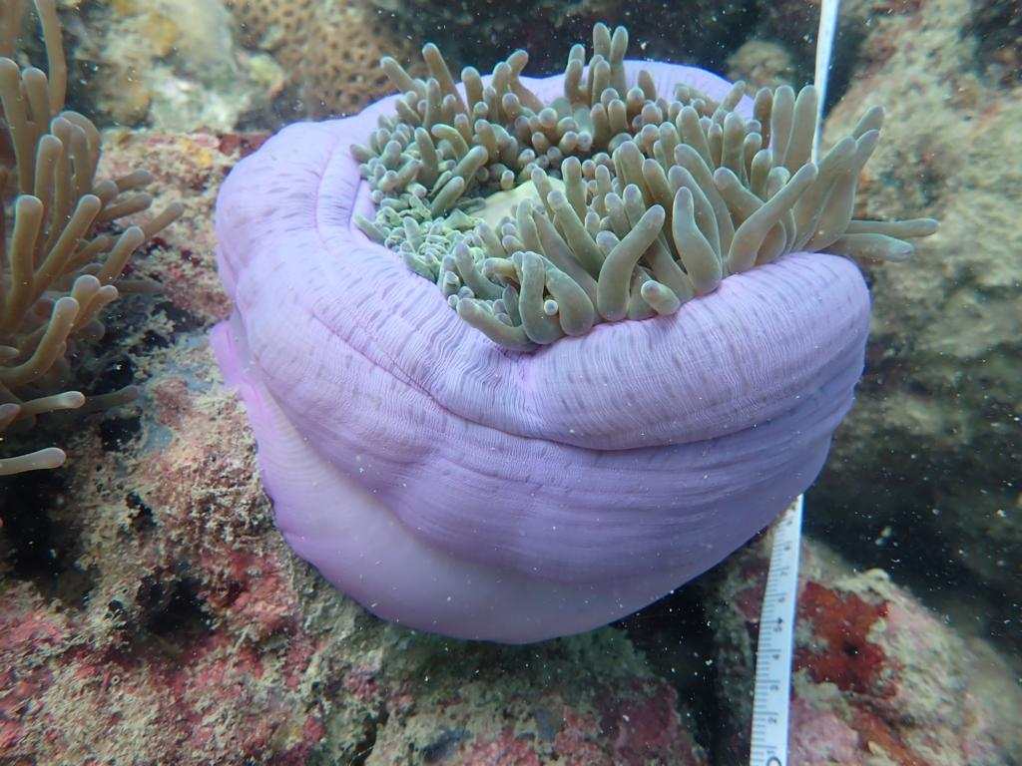
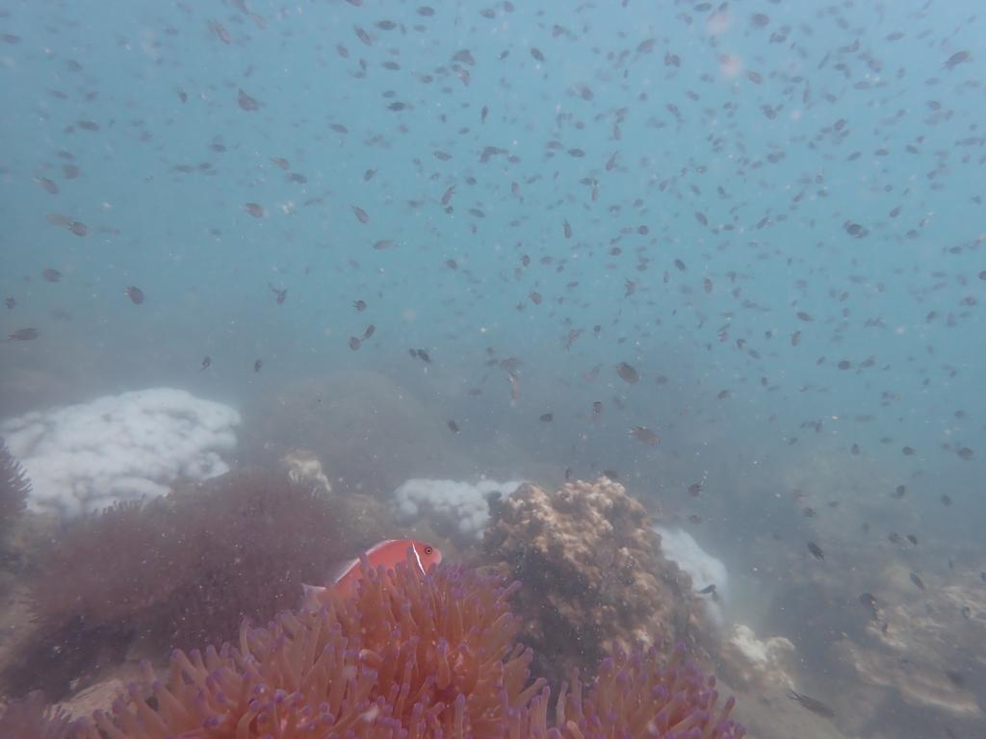
The expedition was completed successfully with not only research project aims being achieved but wider expedition aims. All team members were engaged in the research being conducted as well as active in engaging with the culture, events, and people on Koh Phangan through volunteering with local organisations, visiting religious temples, and attending events in the village like night markets and reef cleans. The research conducted taught the team members invaluable skills in scientific project planning, execution, and data collection as well as in problem solving, teamwork, and working effectively under pressure. Beyond research, the planning and execution of this expedition allowed all team members to learn valuable skills in grant writing, fundraising, and social media advertising. The expedition also provided everyone on the team a chance to develop leadership skills, all of which will benefit them in future careers both within and outside academia.

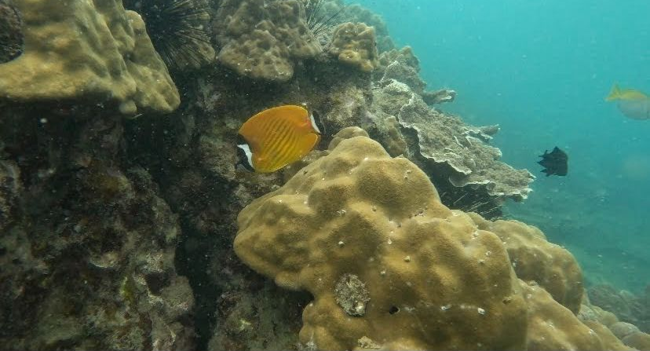
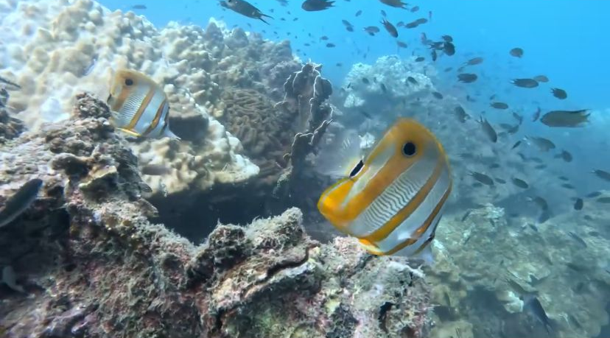
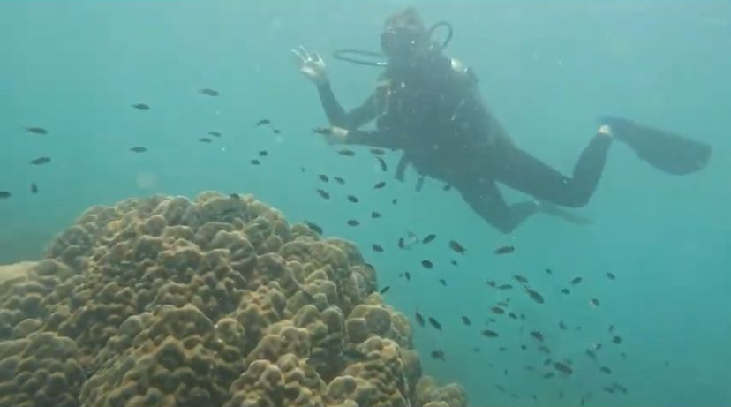

2.Research
The expedition set out to conduct three research projects, broadly investigating herbivorous coral reef communities in conjunction with coral reef structure and reef soundscapes. All three projects went ahead as planned, overseen by the three project leaders. Due to the nature of scientific research, methodologies for all three projects were slightly amended to meet local conditions and make the most of abilities of the team however, the project aims remained the same.
A brief overview of each project can be found below. Due to the nature of our research and the usual time frame for University of Glasgow expeditions, data analysis will not be taking place formally until the start of the academic year in September and we expect to have the full expedition report, including full project findings, completed within six months of the expedition’s completion.

2.1 Investigating Sea Urchin Abundance In Correlation with Coral Reef Structure
Kerensa Ballantyne
This project sought to investigate the sea urchin populations on Koh Phangan and assess if urchin abundances are correlated with elements of the reef structure, namely live coral cover, coral genus richness, algal cover, and coral reef structural complexity. These three elements have all be seen to impact sea urchin populations in other areas of the world and with varying affects. Literature indicates two sea urchins genera can be found on the Koh Phangan reefs, Diadema and Echinothrix. Both genera were recorded during surveys on this expedition.
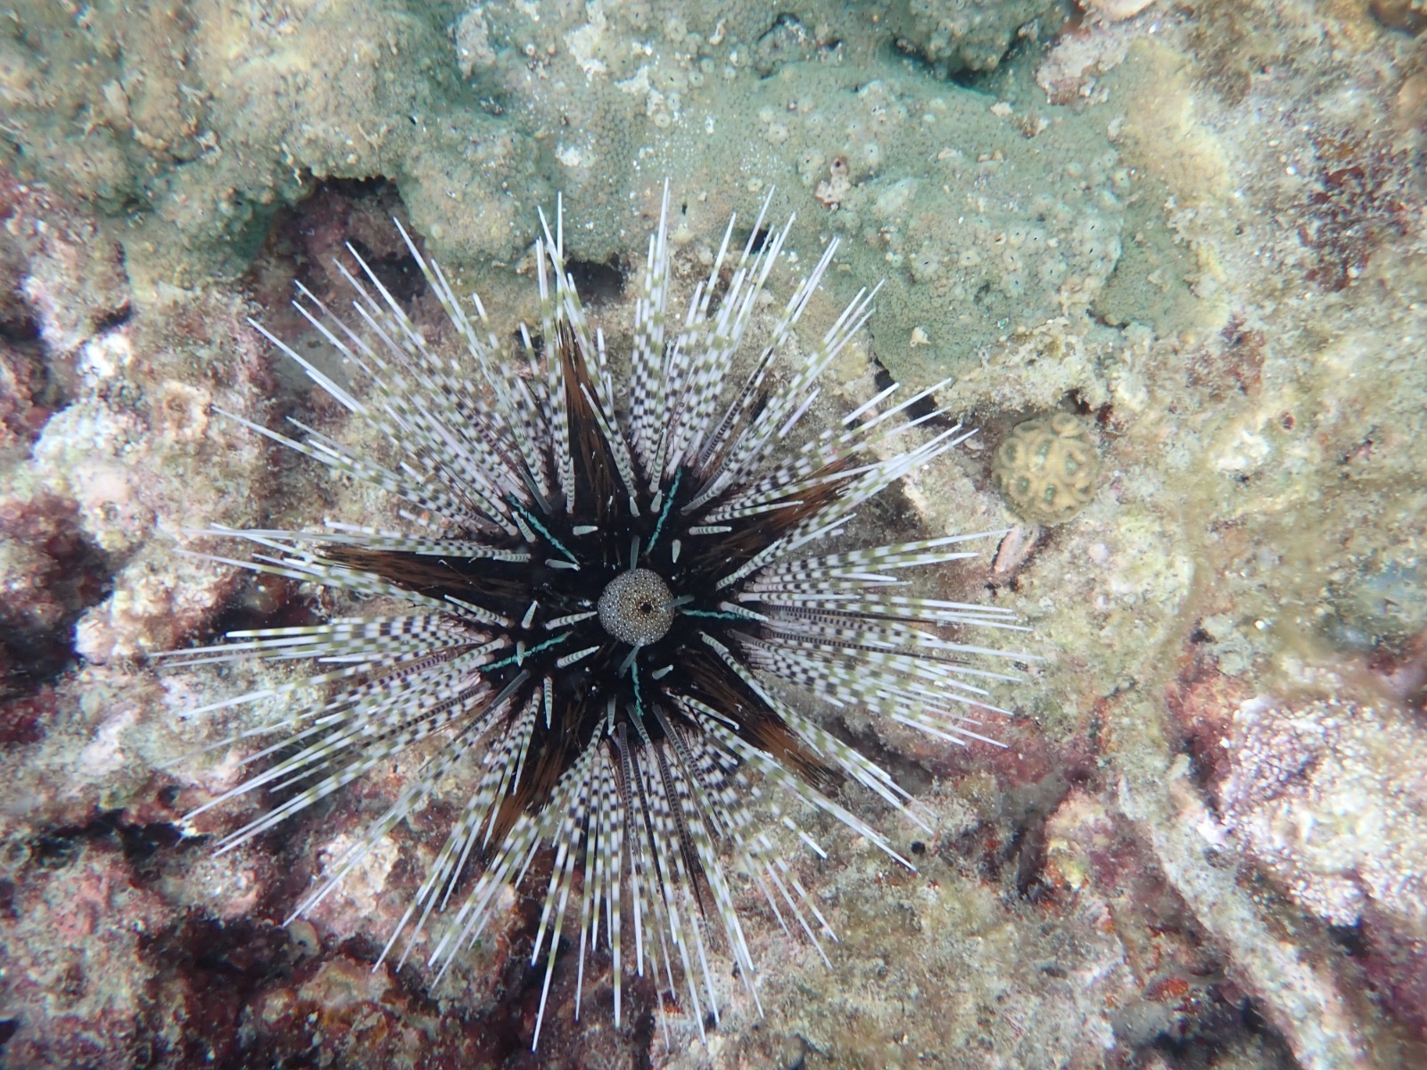
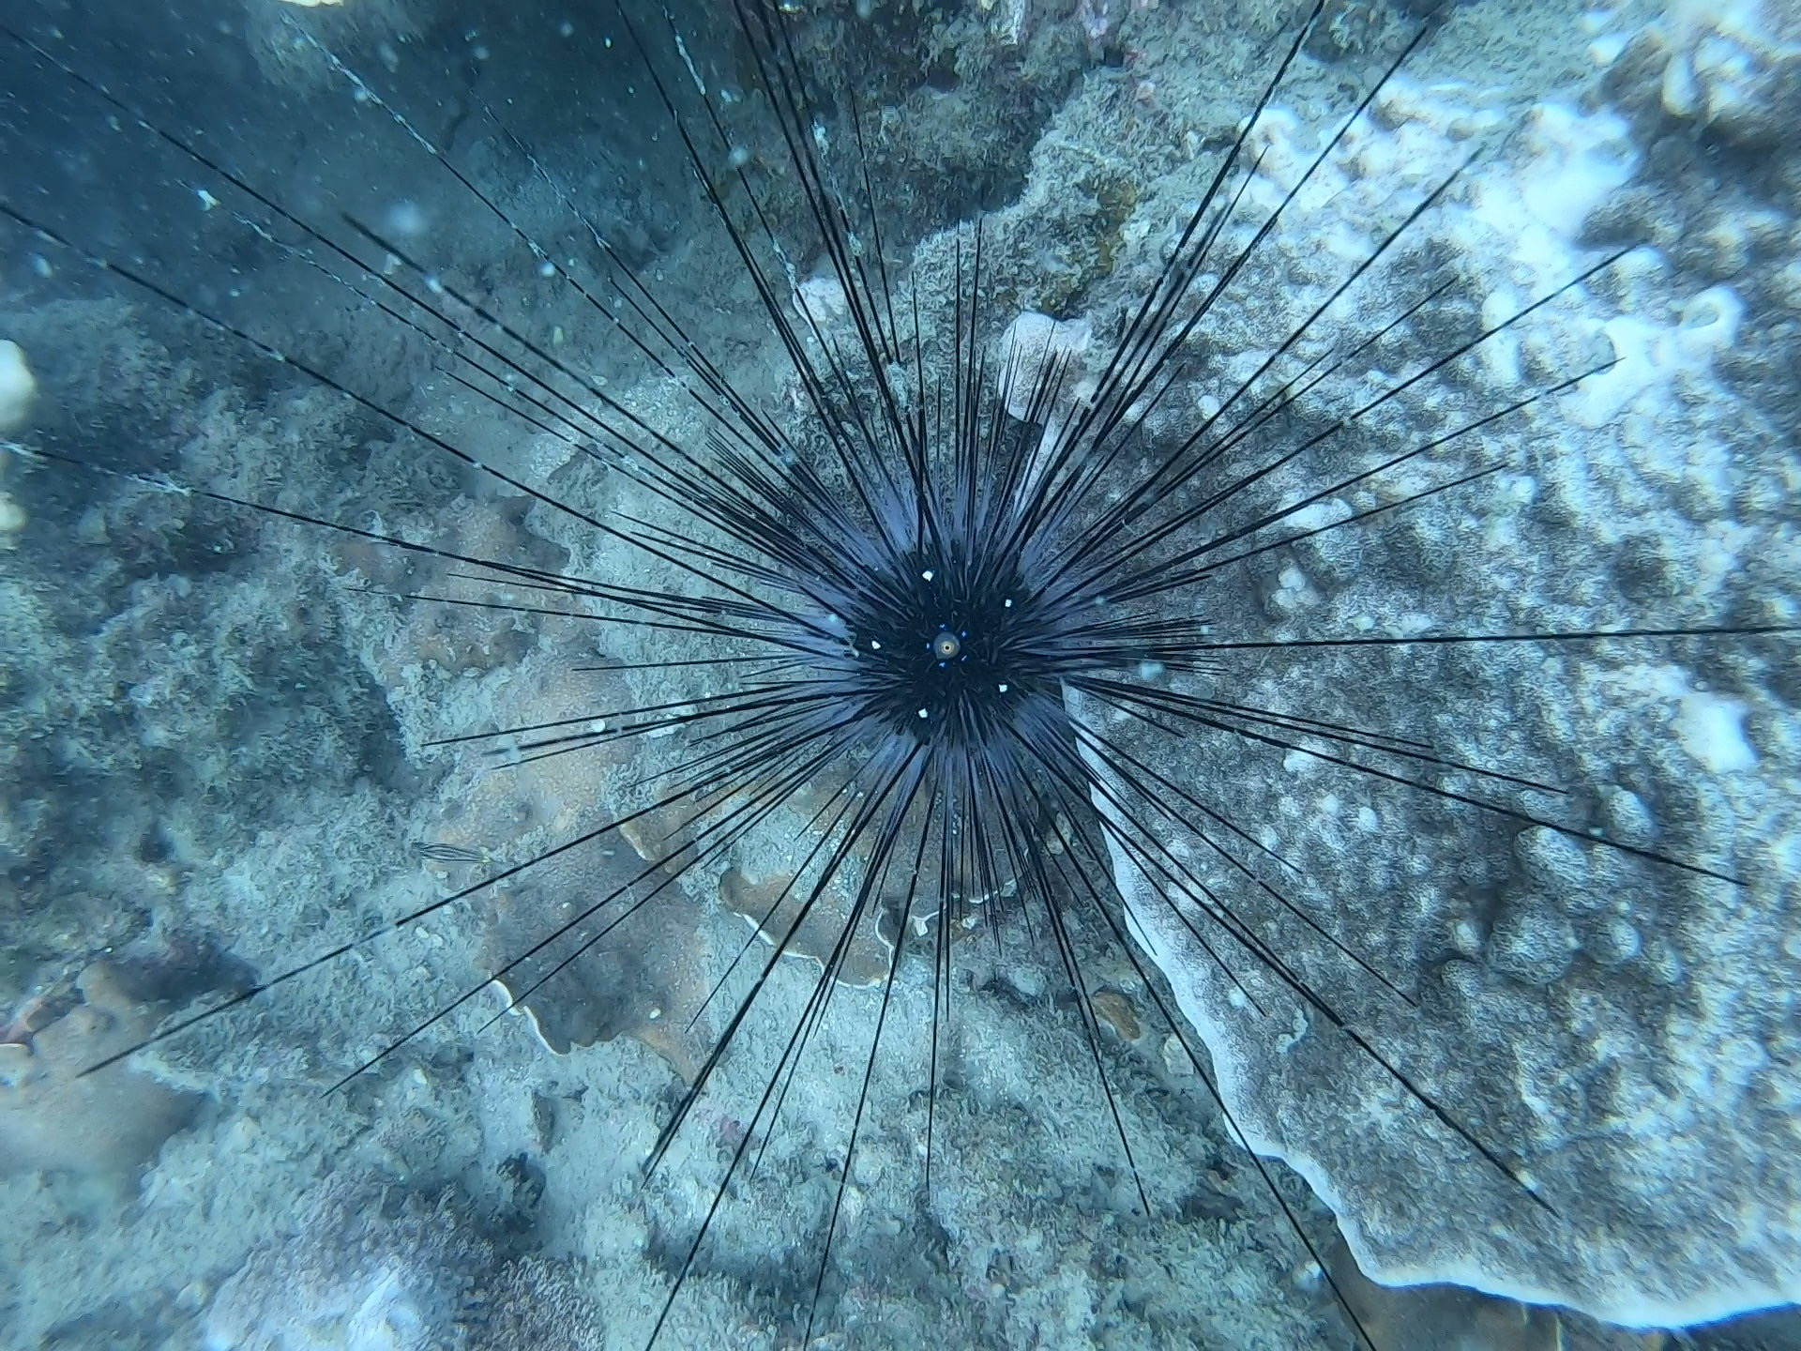
Left: Echinothrix sea urchin; Right: Diadema sea urchin
Pilot studies conducted during the first week and half of the expedition indicated far higher abundances of Diadema urchins than Echinothrix. This has also been observed by COREsea as part of their long-term monitoring programme on the reef flat of the Koh Phangan fringing coral reefs. As a result, this project widened the scope of their monitoring to investigate three reef zones: the reef flat, reef crest, and fore reef, to see whether the apparently more dominant Diadema were outcompeting Echionthrix urchins and resulting in their populations being found at higher abundances in other reef zones (COREsea’s working theory). Beyond this, parameters of the coral reef habitat were also investigated to determine whether urchin abundances were instead influenced by elements of the coral reef structure. Finally, the urchin’s substrate preference was recorded to inform if urchins were inhabiting reef zones due to their preference for elements of the reef structure (particular corals/algae/structural complexity) or if they were found on particular coral genera/algae because it is the dominant benthic element of the reef.
This project can be broken down therefore, into theses aims:
- What sea urchin genera inhabit the Koh Phangan coral reefs? D
- o different sea urchin genera inhabit different reef zones?
- Does sea urchin abundance vary in different reef zones and is this variation, or lack there of, associated with algal cover, live coral cover, coral genus richness, and/or structural complexity?
- Do sea urchins have a benthic preference?
Across two inshore dive sites, Mae Haad 4 and Haad Salad, found on the north coast of Koh Phangan, Thailand, one SCUBA dive was conducted each day in the morning over a four-week period. Dives were conducted at the different reef zones with data collection undertaken along three 50m transects. Transects were set out by SCUBA divers navigating using primarily the average depth of the reef zone. Three surveys were conducted to collect the necessary information, an urchin survey (using three 50x4m belt transects), a live coral cover survey (using the line point intercept method), and a structural complexity survey (using the chain and tape method).
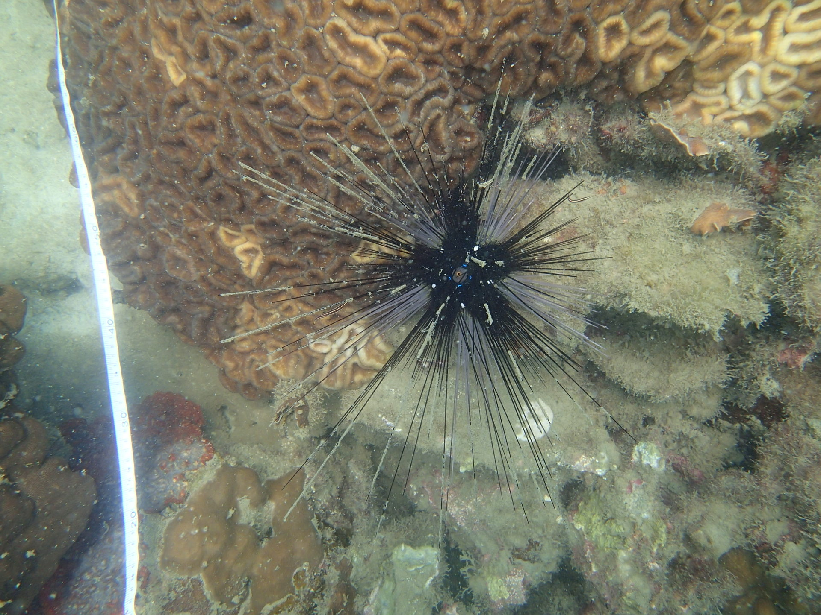
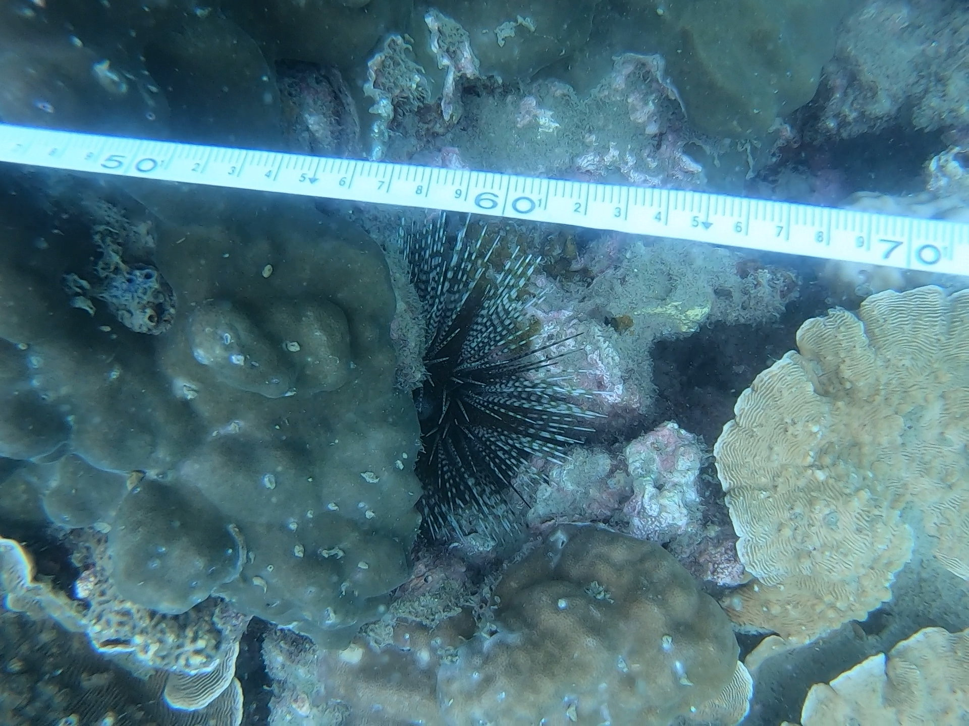
Left: Echinothrix urchin hidden in a crevice beneath the transect; Right: Diadema urchin with both black and white spines beside the transect
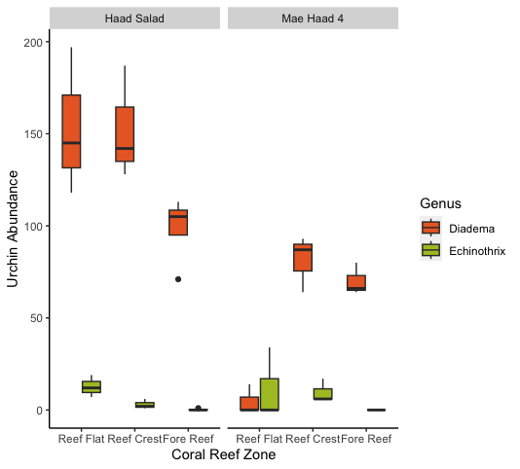
Although coral reef structure data has yet to be visualised or analysed, namely data from the live coral cover survey and structural complexity survey, data from the urchin survey has been visualised using R and R studio. Figure 1 shows a boxplot created using sea urchin abundance data, suggesting possible patterns of urchin abundance between the different surveyed coral reef zones and sites.

Figure1: Boxplot Showing The Abundance Of Sea Urchins At Each Coral Reef Zone and At Each Site. Orange bars represent Diadema urchins and green bars represent Echinothrix urchins.
Figure 1 shows far higher abundances of Diadema urchins than Echinothrix urchins across all sites. The exception to this is the Mae Haad 4 reef flat where overall more Echinothrix were surveyed than Diadema. However, both genera had an average count of 0 individuals. At Haad Salad, regardless of genera, the highest average number of urchins was seen on the reef flat, then reef crest, then fore reef. This suggests that sea urchins here are most abundance in the shallow areas of the reef. At Mae Haad 4 however, the reef flat saw the lowest average number of sea urchins, with the highest on the reef crest. These sea urchin abundance trends will be investigated using statistical analysis and in conjunction with environmental data taken from the surveys completed of the coral reef structure.
I am extremely pleased with the data collected for this project and look forward to investigating the trends described above and looking into the environmental data. Due to the importance of urchins within a coral reef ecosystem, I am looking forward to sharing this data with COREsea and hope it can go towards informing their long term monitoring and conservation efforts in conjunction with other Koh Phangan based organisations.

2.2 Investigating the Effects of Structural Complexity and Coral Cover on Butterflyfish Abundance
Emma Phillips
The area in which the Gulf of Thailand meets the coastline provides optimum conditions to support the growth and development of coral reefs. The reefs surrounding Koh Phangan reside within the ‘coral triangle’ and therefore hold a significant measurement of biodiversity, consisiting of a wide range of coral and fish species. Such species-rich ecosystems also provide protection to coastal towns during storms, along with supporting livelihoods and providing an income to locals via tourism and recreational means. However, in the last 20 years, several mass bleaching events have been recorded in Indo-Pacific reefs as a consequence of ocean warming and are expected to continue as the Anthropocene advances. This disruption to coral make-up allows for many questions to be asked about its effects on reef-fish communities and whether their presence is affected by such structural damage. The ecological question being asked involves whether the complexity and overall coral coverage of the reef has a major effect on an important class of fish,Chaetodontidae. By investigating the current state of the reef in Koh Phangan, via determining the rugosity and the scope of its coral communities, insight into the distribution and abundance of butterflyfish species could be indicated.

4.1.2 Aims

1. Does Butterflyfish abundance differ between different coral reef zones?

2. Are differences in Butterflyfish abundance influenced by coral reef structural complexity?

3. Is Butterflyfish abundance influenced by coral cover in different coral reef zones?

4. Do Butterflyfish species use coral reef zones differently?

4.1.3 Methods

Within Haad Salad and Mae Haad, surveys were carried out at 3 different reef zones: the reef flat, reef crest and fore reef. Researchers aimed to conduct one dive per day, alternating between each reef zone. Surveys were conducted by two scuba divers working in a buddy pair, moving along three consecutive 50 metre transects with 1 metre intervals in between, using the following methods:

(i) Butterflyfish Abundance Survey

To determine the abundance of butterflyfish at each reef zone, a 5-metre belt with a sweep distance of 2.5 metres was utilised along the transect. This survey was the first to be conducted during each dive, to provide the most accurate abundance measurement. To begin, a buddy pair was situated at the start of the transect, at 0 metres. By swimming at a steady cruising pace of 15 minutes per transect one individual recorded the butterflyfish on the left side, and the other recorded those on the right side of the transect. The fish were documented on dive slates, using a tally-marking scheme according to the following species: Chaetodon wiebeli, Chaetodon octofasciatus, Heniochus acuminatus, Chelmon rostratus andChaetodon lineolatus.

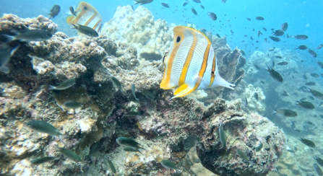
Chelmon rostratus

(ii) Live Coral Cover Survey

By carrying out a Live Coral Cover (LCC) survey along a line transect, the species make-up and coral coverage of the reef zone could be determined. This data was recorded via photography, using a dive camera. To begin, a buddy pair was situated at the beginning of transect 1. By swimming at a steady pace, a photograph was taken at every 50cm interval along the 50m transect (see figure 3). This resulted in approximately 100 photographs per transect, and therefore 300 photographs per dive. This survey was repeated at all three transects within the zone, and photographs were then analysed in the lab. During analysis, researchers identified the substrate type which was located at the 50cm band within each photograph.

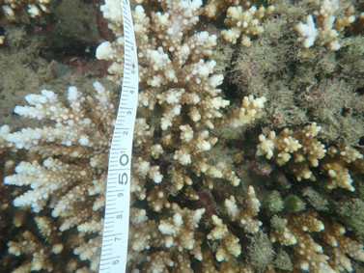
LCC image showing Acropora beneath 50cm interval

(iii) Rugosity Survey

To determine the structural complexity of each reef zone within Mae Haad Bay and Haad Salaad Bay, a rugosity survey was carried out along the transects. By utilising the chain-tape method, a rugosity index could be easily determined. The survey consisted of a dive buddy pair draping a steel chain over the benthos, following the transect line. Once the chain was in position, an additional measuring tape was stretched along the chain to determine the new length which was then recorded on a dive slate.

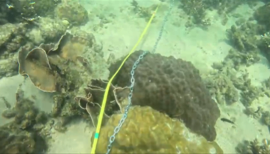
Rugosity chain draped over the benthos

4.1.1 Preliminary Findings/Preliminary Results?

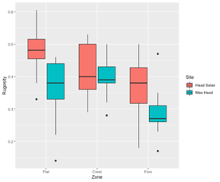
The preliminary findings of this study show that overall, differences in rugosity are highly influenced by the zonation of the reef. Results highlighted that the highest rugosity value was measured within the reef flat, and as depth increased towards the fore reef, the average structural complexity of the benthos declined. After further analysis, a difference was established between the two data collection sites, with Haad Salad having a higher overall rugosity measurement than Mae Haad (figure 1).
Figure 1: Boxplot of Reef Rugosity According to Reef
Zone and Site.

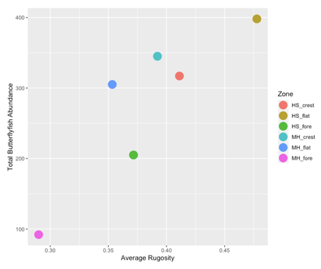
In addition, it is apparent that as average rugosity increased with each reef zone and therefore depth, the total butterflyfish abundance increased also. From figure 2 Haad Salad reef flat recorded the largest abundance of Chaetonidiae , and Mae Haad fore reef showed the lowest count. Moreover, when analysing the abundance of the five separate species, a clear trend highlighted that Chaetodon octofasciatus was the most abundant of the family at all three reef zones, however also showed a decline as depth increased.
Figure 2: Scatterplot of Butterflyfish Abundance According
to Average Rugosity at Each Zone.

Furthermore, the results from figure 3 highlight that within both sites, the reef crest has the highest percentage of coral coverage, whereas the reef flat shows the lowest coral cover. It is also apparent that percentage cover is overall larger at all three reef zones in Haad Salad. These results were expected as earlier findings suggested that rugosity was also higher at this site.

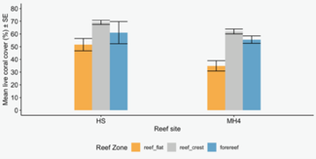
Figure 3: Barplot Showing Mean Live Coral Cover (%) According to Reef Site and Zone

2.3 Can the Soundscape of a Coral Reef be used as a Proxy for its Biodiversity?
Lara Herd

2.3.1 Introduction
Coral reefs are of extreme geographical and environmental importance both to the animals that inhabit them as well as the humans who depend on them for their livelihoods. Reefs provide costal protection to natural disasters such as tsunamis and support a variety of marine life (Cesar, 2002; Yeemin et al., 2006). Unfortunately, they are threatened worldwide, with Thailand’s reefs recently suffering several mass bleaching events (Phongsuwan et al., 2013). Not only are coral reefs important for ecosystem functioning and human livelihoods, but as a hotspot for biodiversity and natural beauty, they are considered natural wonders, with the Great Barrier Reef being one of the seven wonders of the world. However, due to human impacts, such as overfishing, costal construction, and unmanaged tourism, over 90% of coral reefs along the Great Barrier Reef have suffered bleaching as of 2022 and only 5% of reefs worldwide remain in good condition (AIMS, 2022). This devastating result of the Anthropocene means that these wonders may not be around for future generations to witness and learn from. Long-term monitoring of the health and biodiversity of these ecosystems is necessary to implement management in order to prevent any further damage (Haver et al., 2019). However, methods can be time consuming and invasive so alternative techniques such as soundscape ecology have recently been investigated (Harris & Radford, 2014; Haver et al., 2019; Sueur et al., 2008).
Each ecosystem has a soundscape which is made up of all the sounds present in that environment. Soundscape ecology takes into account the biological, geophysical and anthropogenic sounds within the landscape (Havlik et al., 2022; Pijanowski et al., 2011a).
Many studies have focused on using soundscape ecology as a proxy for ecosystem health and biodiversity (Chen et al., 2021; Harris & Ramadford, 2014). Kennedy et al (2010) found a strong correlation between sound and biodiversity, with a greater acoustic diversity signalling greater biodiversity (Harris & Radford, 2014). Methods for assessing the biodiversity of an ecosystem can be time consuming, costly and invasive, this is especially true for hard to reach habitats such as the deep sea (Chen et al., 2021; Harris & Radford, 2014; Haver et al., 2019; Sueur et al., 2008). Therefore, if indeed soundscape ecology can be used to measure long-term health and biodiversity of an ecosystem, management strategies can be put into effect quicker to achieve a more efficient outcome (Haver et al., 2019).
This study will investigate the biodiversity of three coral reefs in Koh Phangan, Thailand. This will be assessed by measuring the diversity of reef fish within the ecosystem and comparing it to the soundscape diversity of the reef.

2.3.2 Aims
To investigate whether or not soundscapes can act as a proxy for coral reef diversity by comparing soundscape diversity and reef fish diversity from two different coral reef sites.

2.3.3 Methods
The soundscape diversity and fish diversity was investigated across three reef dive sites in Koh Phangan in the Gulf of Thailand: Koh Ma, Mae Haad and Haad Salad, all of which are situated on the north point of the island.
Each site was surveyed a total of three times. The sites were reached by a long tail boat at the same time each day (between 11:00 – 12:30) and a fish diversity survey (FDS) was conducted by a team of SCUBA divers with dives lasting approximately 1 hour on the reef crest at a depth of 5m. Sound recordings were taken from the same sites, reached by kayak, again at the same time each day (between 15:00 - 16:30).

Fish diversity survey (FDS)
The FDS was conducted along three 50m transects at each site. A pair of SCUBA divers identified the fish on either side of the transect down to family level. If a diver could not identify the fish during the dive, a photo was taken to be identified back in the lab. To help with identification, all divers completed fish identification training with COREsea before data collection took place.
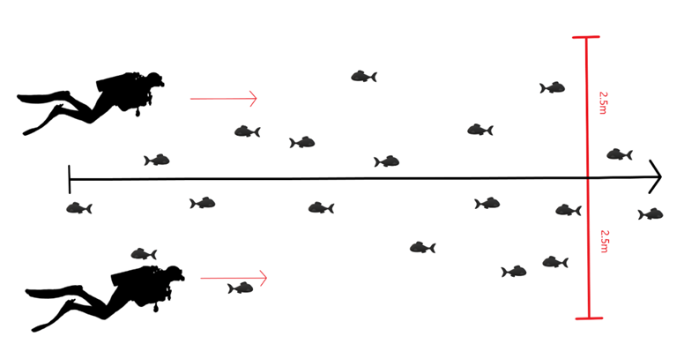

This diagram shows the layout of the fish diversity survey, each transect was 50m in length and had a belt of 2.5m
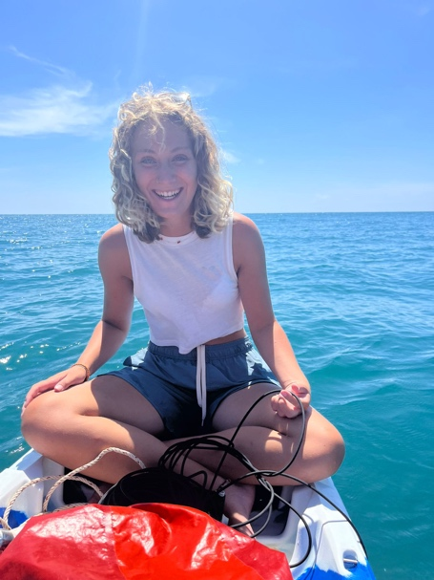
After each dive, the diversity of each transect was calculated using the Shannon Weiner Index which gives a value between 0-5, where 0 represents lowest diversity and 5 is the highest diversity. This resulted in a total of 9 diversity indices per site, these values were plotted in a box plot using RStudio.
Sound recordings
At each site, a total of three 10 minute recordings were taken using a and a hydrophone.
Due to diurnal patterns of marine noise were reached via kayak and mooring buoys were used to keep in place.
Recordings were then analysed in R Studio using the acoustic diversity index (ADI) explained by pikanowski et al (2011b), Pekin et al (2012) and Villanueva-Rivera et al (2011). Only sounds above 50 dB were analysed to exclude background noise such as boats. This resulted in three ADI values per site, these values were plotted in a box plot using RStudio.

2.3.4 Preliminary Findings/Preliminary Results?
In total, three sound recordings were taken at each site giving three ADI values per site. While three dives were completed at Mae Haad and Haad Salad, only two dives were completed at Koh Ma due to time constraints. This dive was completed by COREsea after our departure, but we are still waiting on the data. As the SW value was worked out per transect, a total of 9 values exist for both Mae Haad and Haad Salad but only 6 exist for Koh Ma.

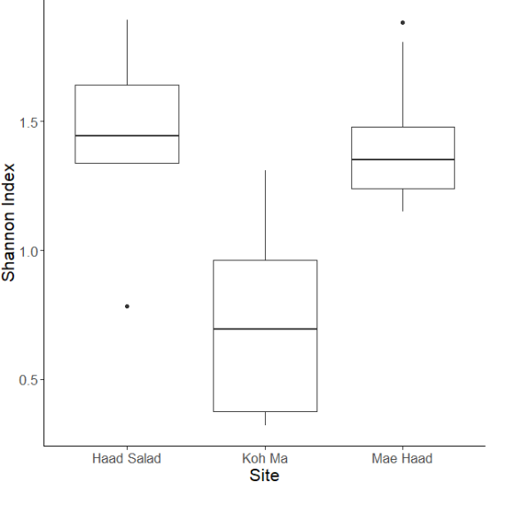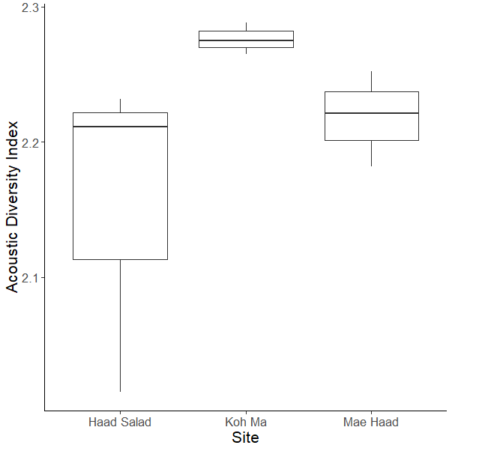
The plot on the left shows the biodiversity of all three sites represented by shannon weiner values and the plot on the right shows the soundscape diversity of all three sites represented by the acoustic diversity values
Statistical tests still need to be carried out to understand the significance of these results but just by comparing the sites visually using the box plots, it can be seen that the soundscape diversity represented by the ADI value for Mae Haad and Haad Salad are similar to that of the biodiversity represented by the shannon weiner value. However, looking at Koh Ma it is clear to see that while the soundscape diversity is higher than that of the other sites, the biodiversity was found to be lower.
This may be due to inaccurate results due to incorrect fish identification, as previous data from COREsea shows that Koh Ma is one of the more bidiverse reefs. However, more will be known when the rest of the data is collected, and statistical tests are completed.

3.Logistics and Finances
The expedition was undertaken from July 31st 2023 to June 18th 2023 on Koh Phangan with the team staying on site at COREsea in Chaloklum on the north coast of the island as planned. Despite the team not raising as much money as predicted, budget adjustments were made to ensure the success of the expedition and team members were consulted continuously to ensure the expedition could remain inclusive and feasible. Our full budget including income and expenditure can be seen below.

3.1 Logistics
The team stayed in dormitory accommodation at COREsea for the duration of the expedition with three team members per bedroom and three bathrooms. The accommodation included a kitchen, living room, WIFI, and drinking water as well as lab and classroom facilities. The team stayed one night on Koh Samui before getting the ferry over to Koh Phangan the next morning. Due to the diversity of post-expedition travel plans among the team, accommodation for the return journey was not needed.

3.2 Budget
The expedition faced two main sources of expenditure, travel and COREsea. Travel included flights, boats, and taxis and the COREsea fee included accommodation, drinking water, WIFI, diving equipment, scientific advisement, and boat hire. We had a total income of £18,144.45 and a total expenditure of £18,682.38. The £1,000 generously granted to us by the Neil Mackenzie Trust went to cover our fee to COREsea, ensuring the team had safe accommodation and areas to work. A total of £1,927.05 was left over at the end of the expedition and will go towards repaying in part personal contributions made by team members. A full income and expenditure breakdown can be found below.

3.2.1 Income

Source | Notes | Amount
Personal Contributions | £919 x 8 team members | £7352
Personal Contributions Subtotal |  | £7352
Fundraising | Bake Sale | £239.45
Fundraising | Underwater party & Pub quiz | £551.62
Fundraising | Pub quiz | £55.50
Fundraising | Ceilidh | £270.00
Fundraising | Raffle | £116.00
Fundraising | Club night | £247
Fundraising Subtotal |  | £1479.57
Individual Fundraising | GoFundMe | £916.00
Individual Fundraising Subtotal |  | £916.00
Grants | Neil Mackenzie Trust Education Expedition grant | £1,000.00
Grants | Glasgow Natural History Society | £1,000.00
Grants | Chancellor’s Fund | £1,000.00
Grants | Turing Fund | £4396.88
Grants | Gilchrist | £1,000.00
Grants Subtotal |  | £8396.88
Total |  | £18,144.45

3.2.2 Expenditure

Source | Notes | Amount
Logistics
Flights | Return London-Bangkok | £5,287.92
Flights | Return Bangkok-Koh Samui | £855.00
Hostel on Koh Samui | 1 night stay | £96.00
Ferry | Return Koh Samui-Koh Phangan | £64.00
COREsea | 504,000.00THB  Accommodation, SCUBA equipment, dive boat, water, WIFI, laboratory facilities, training and lecture series. | £11,344.58
Visas | 8 team members | £240.00
Logistics Subtotal |  | £17,887.40
Fundraising
Hall hire | Underwater themed party event space | £120.00
Decorations | Underwater themed party decorations | £30.00
Photo booth | Underwater themed party photos | £69.98
Ceilidh band hire |  | £350.00
Club hire |  | £225.00
Fundraising Subtotal |  | £794.98
Total |  | £18,682.38

6. Acknowledgements
This expedition was made possible by grant funding from the Neil Mackenzie Trust, Glasgow Natural History Society, University of Glasgow Chancellor’s Fund, Turing Fund, and the Giltrust Educational Trust. Without this funding, the expedition would not have been able to go ahead, and we are extremely grateful.
The expedition was sponsored by The Little Soap Company, SHO, and EcoSOAP PEOPLE who generously donated products to expedition team members that not only reduced personal costs for team members but allowed everyone on the team to travel sustainably, reducing the plastic waste created by team members.
We would like to thank everyone who donated money to our GoFundMe and attended our fundraising events, another invaluable source of funding for the expedition. And finally, we extend our thanks to University of Glasgow staff and all at COREsea who provided support throughout the planning and the expedition itself.

