Report from World Scout Jamboree
Alistair Ogilvie

Our jamboree journey was not only the wonderful three weeks that we spent in South Korea – it was also the two-year period leading up to the jamboree where we joined together as unit for many training camps and fund-raising activities. We forged strong friendships internally within our own unit and then with many others during the jamboree events in South Korea. There were units from over one hundred countries, and it was very interesting meeting different people with different cultural backgrounds and experiences. Meeting so many different people and learning to overcome the language barriers and find new ways to communicate and share our experiences was my favourite part of the experience.

I have gained in confidence from my experience as well as gained life skills such as improving my communications skills, organisational skills for being independent and responsible for myself when travelling. Within Scouting you always learn to work as part of a team and be responsible for keeping a clean and tidy living space and how to cook and clean for yourself and the wider unit. I feel I have matured a person from being a part of this life changing journey.

We had the opportunity to see many interesting things in the city of Seoul before the Jamboree experience.

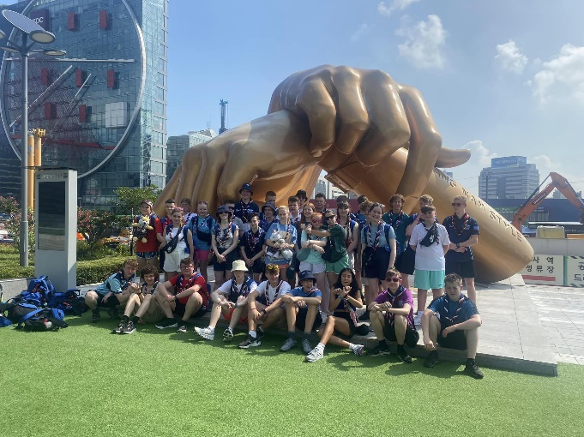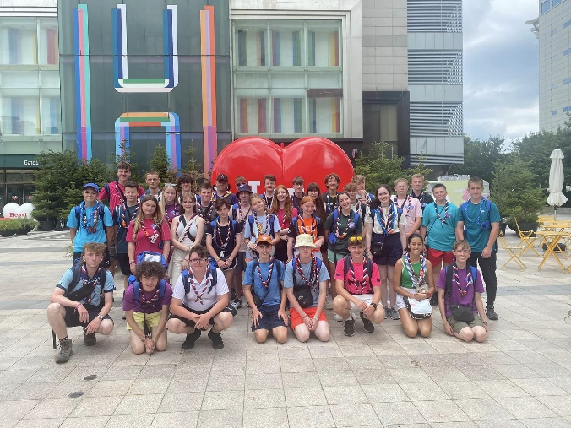

As well as sight-seeing and much fun had during the trip there were many educational experiences as well. One of my favourite days was a day spent at the Korean War Museum. I found it interesting to learn about the history of the Korean War, war tactics and equipment of the time.

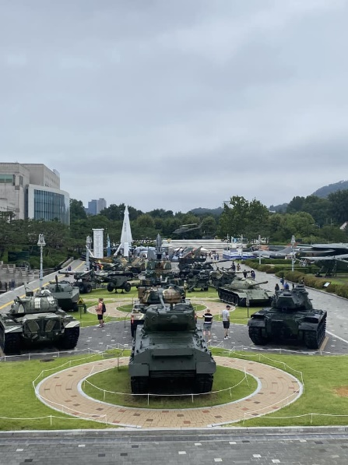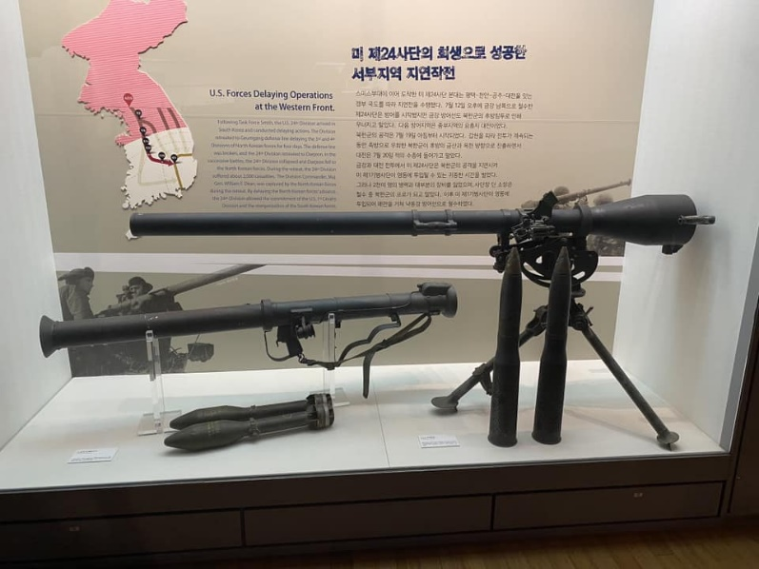

We also had the opportunity to visit the demilitarised zone at the border to North Korea which felt like an important glimpse into the reality of the relationship between North and South Korea. It made me thankful to live somewhere without these tensions.

I felt a sense of pride representing my country at a major world event – we held a ceilidh night to showcase Scottish dancing and music.

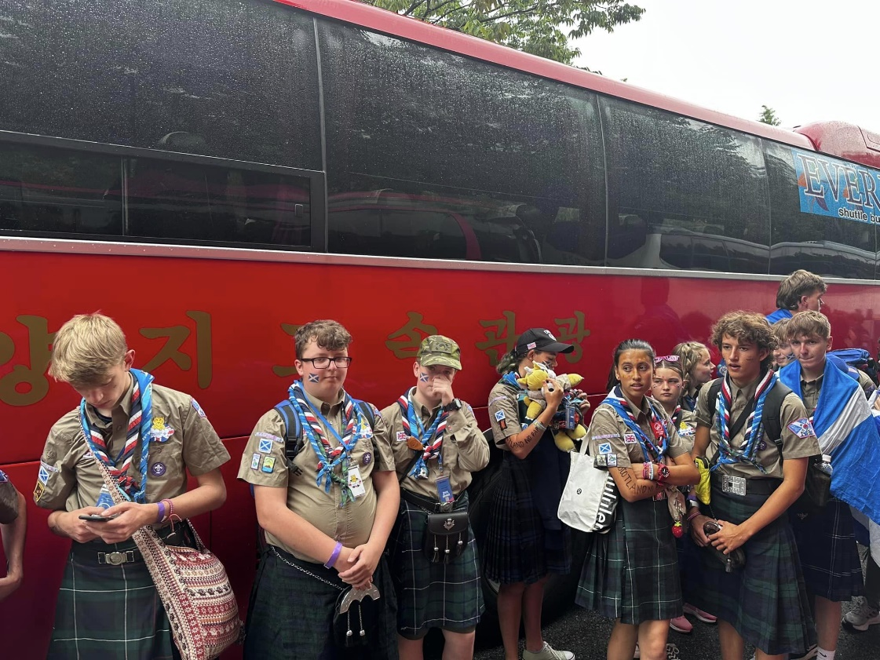

I feel that I came back from the Jamboree with a passion for exploring the world and visiting other countries to experience other cultures and ways of living. I have a greater appreciation for trying new things including a wide range of foods. There was a huge variety of street food in South Korea which was amazing to try and experience. Given that the actual jamboree experienced issues with the camp site and weather forcing early closure of the jamboree, I feel we learned how to be resilient when things do not go to plan. We adapted to the changing conditions and embraced the new plans and experiences – so although it wasn’t the experience, we had originally anticipated, it was an important life lesson in making the most of every opportunity presented. I am very thankful for the opportunity to have been involved in this ‘once in a lifetime’ event and the memories and friendships made will be with me forever.

