Madagascar August 2023

After traveling for 2 full days, taking 3 flights, a bus and a couple of jeeps we had finally made it to our camp in Sainte Luce in the south east corner of Madagascar. We dropped our rucksacks carrying everything we would need for the next 16 days outside the long house and made our way inside. We were greeted by the lovely researchers who were international staff and volunteers helping collect and record data for the charity SEED who would be our hosts throughout the trip. We quickly got to learning everything we needed to know for our time around camp such as health and safety, what research and surveys we would be assisting with and the general dos and don’ts of the culture which are known as Fady. The things we were told not to do were no pointing, feeding animals, talking about money or politics, talking about food from the UK, asking a lot of questions we were also told to be very respectful around burial sites. We then had a tour around the camp including tents spots, the showers, the long drop toilets, water pumps, the service points, research centre and the palm nurseries.

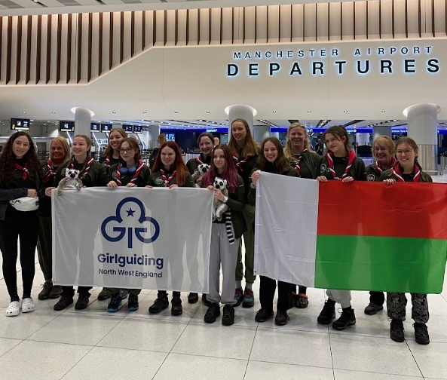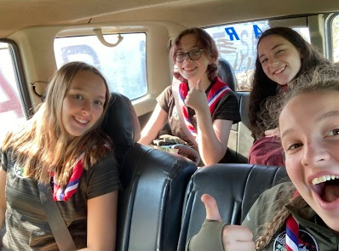

Once we had settled into camp, we made our way to the long house for dinner which was rice and beans (A staple in the Malagash diet and was what we ate for lunch and dinner every day). We also met our favourite resident spider who we called Vivian and lived right above our table for the entirety of our stay. We then prepared for our introductory night walk and got kitted out in our longs and head nets with our torches and set off down a path near camp. This is where we caught our first look at the local wildlife, we came to see such as Chameleons in all sizes, snakes, moths, lemurs, frogs and some very impressive spiders including a species that are bright purple.

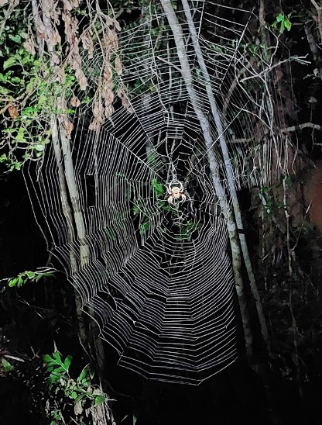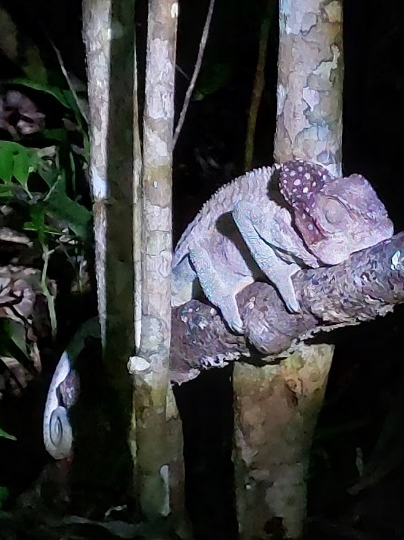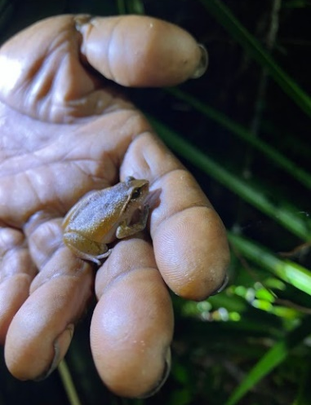
Day 3 was our first full day on camp which we took to acclimatise to our new routine and climate. Our typical schedule looked like this 6AM - wake you to get ready and packed for the day and be at the long house by 7AM for breakfast. We would then head off for a morning survey and be back around 11AM where we would unwind and spend time in the long house playing card games or learning more about what we had seen on survey. 12PM was lunch and you would have the afternoon of which could be spent visiting the local villages and shops as well or playing football with the local children. Dinner would be at 6PM and you would then prepare to leave for an evening survey looking at nocturnal wildlife such as the woolly lemurs. We would get back to camp around 9:30PM and head straight to bed and catch up with your tent partner briefly before falling straight asleep.
The Researchers had planned for us to take a walk through the villages and to the beach which was a very exciting walk. Going through the villages was surreal as the locals would shout “Vazaha” at us which means foreigner as they were used to seeing foreigners around. This excited a lot of the children who would shout hello at us and we would shout “Salama” back which is a Malagash greeting. They would also run up to us and wave or give us fist bumps and it was always a highlight of our day. This is also where we encountered the ‘puddle’ for the first time which was practically the size of a lake that we would walk through which was about thigh deep and the locals would find it hilarious watching us walk through it with our trousers rolled up and crocs on. The beaches were lovely and we climbed up onto the rocks to go whale watching as they often see humpbacks at that time of year but it also allowed us to see a lot of fishermen in pirogues which are canoes dug out of tree trunks which we would later be riding in.

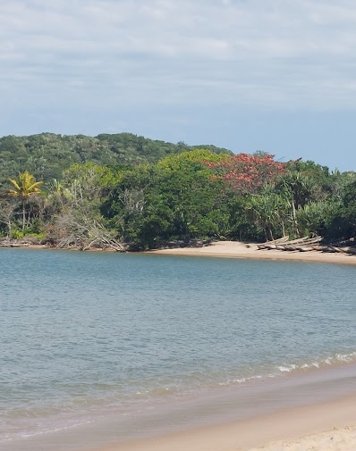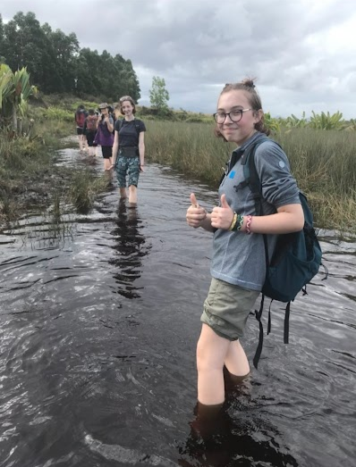

Day 4 was a Sunday which is a day off for everyone working at SEED. the researchers took us down to the beach taking a walk-through villages we hadn’t seen yet and to see some of the forest that we wouldn’t have chance to survey which grew a lot of the palms. We took a 20-minute pirogue ride across a lake which was very different to the canoeing I’ve done before and Solo one of the guides said we would not make great fishermen. We got to explore the cove we had been taken to and go swimming and play volleyball in the water with the researches. Solo then took us up on the rocks to go whale watching as he had spotted some humpbacks earlier which we got to see breaching the water with binoculars. We finished our beach day with a game of rounders which some of the local children enjoyed watching and thought it was funny to see us skidding around on the sand. Going back to camp I chose to go a different route which involved an hour’s pirogue ride through a lake with lots of traveller’s palms which were beautiful. It was then time for our first attempt at bucket showers which were interrupted by the red collared brown lemurs that sat on the trees above us and we discovered that they oink like pigs which was a surprise. We then settled down into a games evening in the long house where we were taught a popular game out in the bush called Cambio which is a mix between a memory game and snap in a race to get rid of as many points as possible. Least to say we were all very competitive and some games got quite noisy.

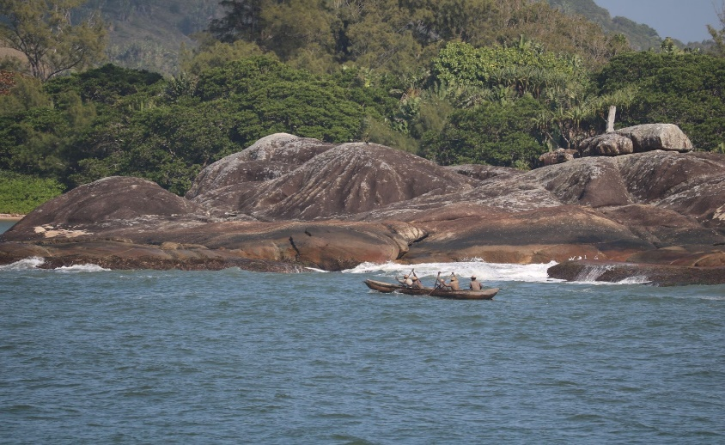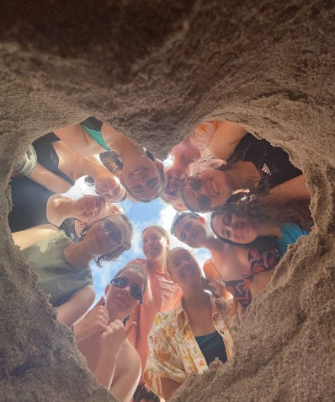

Day 5 brought our first morning survey for my group so we were all up at 5.30 so we were ready for breakfast at 6. Our breakfast consisted of bananas, banana bread, Mofos (fried donuts) and rice pudding which was nearly everyone’s favourite meal of the day. That morning my group were doing a Herpetofauna long term monitoring survey which involved walking along a transect and counting and recording different reptiles and amphibians we saw. We would record information such as species, age, location, hight of ground, distance from transact, weather and canopy cover for each animal we found so it’s quite time consuming. On this particular survey I worked with the GPS which recorded the coordinates that each animal was found that I would then enter into the survey data base. This was a very successful survey as we saw many species of frogs such as Guibemantis annulatus and Guibemantis Wattersoni which are typically found on the Pandanus plants. We also found a lot of chameleons and skinks. By the time we made it back to camp it was time for our QMS prep (Quarterly morning session) which is where they go to the schools in local villages and deliver a presentation and an activity about a particular animal to the children. For this session I was helping deliver the presentation on why snakes are not dangerous and are actually beneficial to the community as they are not venomous, can’t bite and help get rid of diseases by killing rats. I learnt the information I needed for my slide before going to help the other group who were cutting out colouring sheets of snakes for the younger children to colour. We the talked about potential games and songs we could play and sing for the children and practiced those while teaching them to the international staff and Malagash guides. That evening my group also had a night herpetofauna survey which we set off for around 7pm. To get to the transact we were surveying was an adventure as we had to go on a ferry which was actually just 2 pirogues tied together with a plank of wood in a crocodile infested river which we had to jump on and off of but it was good fun. On our walk we also saw juvenile pineapple plants which look fake as it looks like a bush with a tiny inable placed on top. This survey meant we got to see a lot of the nocturnal life and as it was raining more of the animals were out so we got to see plenty of warty chameleons and 2 polonaise chameleons which are only 3cm big. On the walk back to the ferry we heard many horror stories of times the ferry had been broken or stolen and they had to get Babs, solo and Hubi to come and give them a hand getting back to camp so we were all very grateful to see the ferry still their which meant we didn’t have to camp on the river bank for the night.

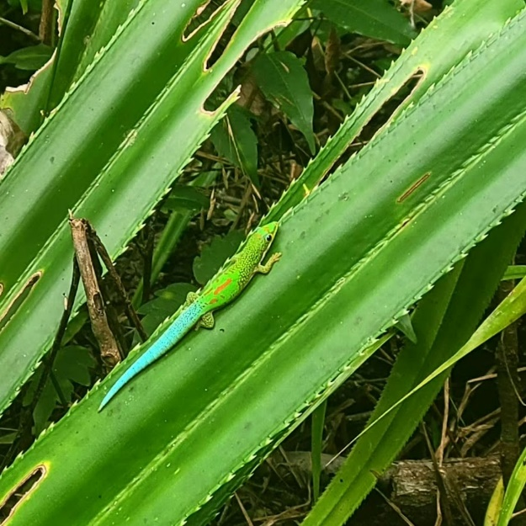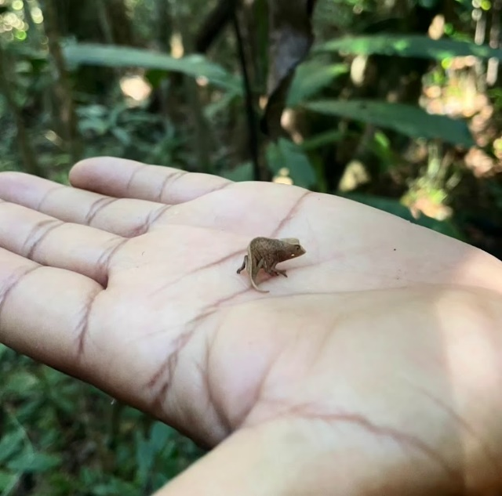

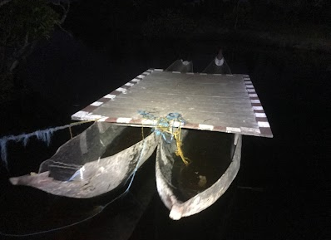

We woke up to torrential rain on day 6 and nearly missed our alarm over the sound of it hitting our 2-man tent. We were all still in high sprites and very excited however as it was our first school session at the school in Manafyafy. The school was only a 10-minute walk away and we were greeted by the children who all neatly lined up outside of the building waiting to go in. The room was packed even though it was their winter holidays. They first welcomed us to the school by singing their school song “Club Atastsaky” meaning club green gecko which is about protecting the forest.

Club atastsaky izahay e
Mijoro eto Sainte Luce
Milsangan mifohaza
Na rangahy na rakemba
Andao isika
Andao hiaro gn’ala
Ala misy hazo
Andao hiaro gn’ala
Misy biby maro
Andao hiaro gn’ala
Ala fianantisika
Andao hiaro gn’ala
Mba ho lovantsika

They then welcomed us individually by chanting our names so Hubi would go along and say our names and the children were so loud and enthusiastic it was quite emotional. We then sang our song for them called Ram Sam Sam which is a Moroccan guiding camp song which has actions that go along which all the children loved and copied from us and as we would walk through the villages after this, they would do the actions of the song for us. The children were then split into 2 groups the older children stayed in one classroom for the presentation on snakes which the younger children went next door to colour. I helped deliver the presentation and talked about all the different species of snakes found in Sainte Luce such as the cat eyed snake, the tree boa and the ground boa as well as what to do to move them away from their homes rather than hurting them such as picked them up with a stick and putting them back in the forest. Hubi translated all of this into Malagash for the children. After the presentation we asked questions which the students would answer to show what they learnt and we would give bracelets which we had made out to those with correct answers which became very converted gifts. We then met up with the younger children outside to play their game of duck duck goose called voalavo voalavo bibilava (rat rat snake) which all the children enjoyed especially when they would pick us to chase them and then laugh at how slow we were. After the game was over, we took a group picture with them all and handed out a bracelet to everyone while letting the younger children show off their colouring. That afternoon we had a crash course in Malagash such as leaning how to introduce ourselves how to say please and thank you as well as a few other conversational topics which was very fun but difficult. Megan, Hannah and I then put these skills to the test as we saw a few of the guides children playing football and catch outside so we went to join them. We came to learn that they were called paneer, buttress and Ursula and they like showing us their football skills and tried to teach us some. This is when we witnessed firsthand Ursula sass when she would pretend, she was going to throw a ball at you but change her mind last second and then stick her tongue out at you which she found hilarious.

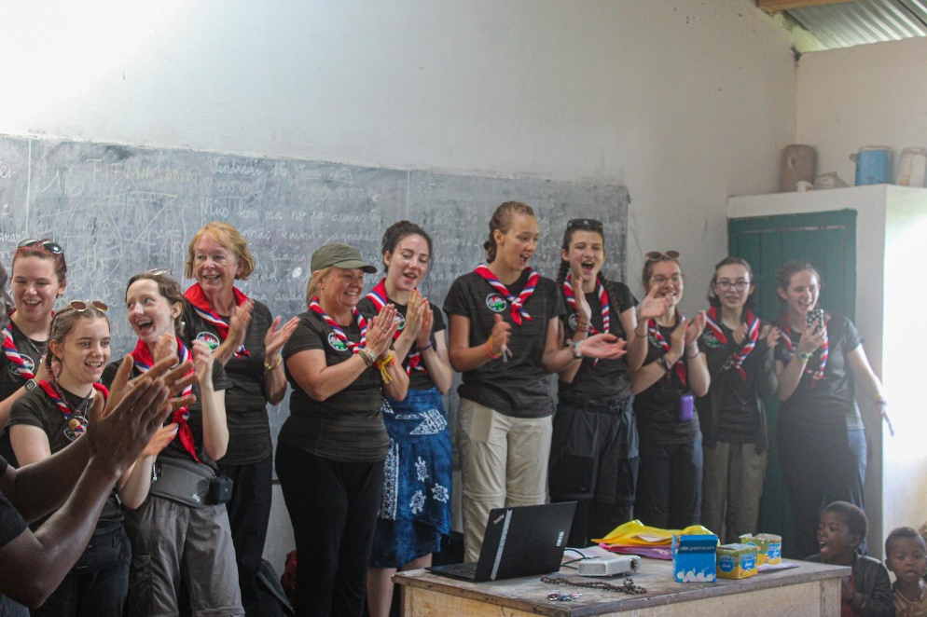

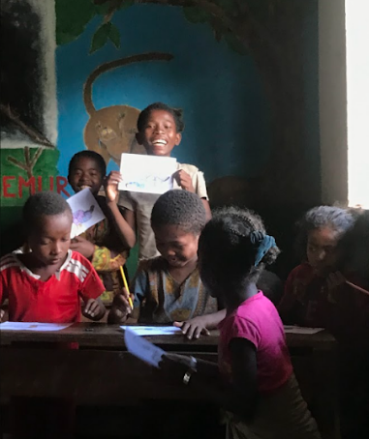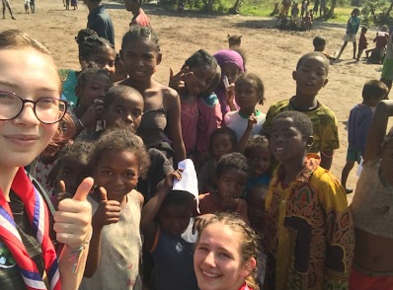

On Day 7 we had our first lemur survey which meant we were looking for Varika. It was the same process recording data as it was for the herpetofauna surveys however we had slightly less success with this one as we didn’t see any Varika and only spotted a family of woolly lemurs which as quite rare in the day time as they are nocturnal lemurs. We reached the end of the transact in about 2 hours and turned off our surveying equipment to start walking back to camp. About 5 minutes into this walk we spotted about 7 Varika which was exciting but disappointing as we could not record them as part of the survey but we were less discouraged after spotting them. Once getting back from our survey we decided to visit the local community projects such as stitch which is now fully ran by the women in Sainte Luce. It’s a shop where everything is hand embroidered such as pillowcases, purses, glasses cases, bracelets, bookmarks and tapestries. We also went to Mahampy where they sell things made out of the Mahampy reeds they harvest dry and dye themselves and then weave into baskets, rugs, bags, snakes, bowls, plates, hats and coasters. We got back to camp just before dinner and did some clothes washing in what we had dubbed as washing city where we hung our clothes to dry. We found loads of chameleons hanging in the trees above my tent so we just sat and watched them for a while. After dinner we caused bit of havoc as the washing up stand finally gave in and broke which sent the whole thing flying which baffled the guides and researchers as it had never happened before but it turns out on of the branches sued as legs had snapped and they found it hilarious at how shocked we were when we heard everything fall. That night we discover a new toilet spider who liked to block off the path leading to the long drops by building his web right in the centre he was an owl spider who fondly came know as Felix.

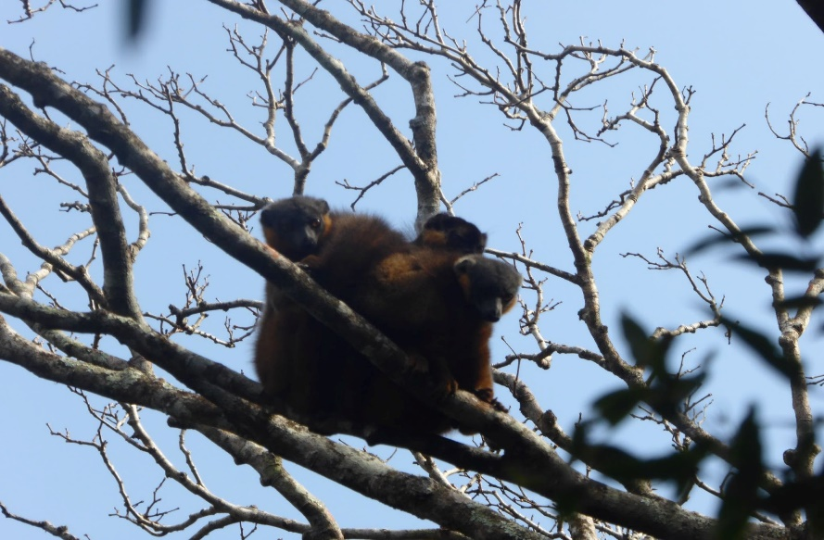

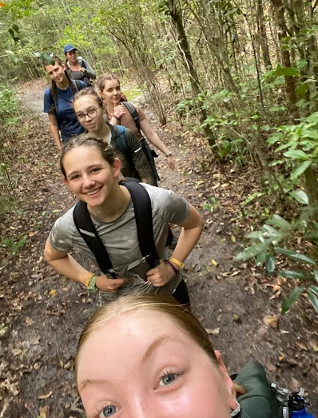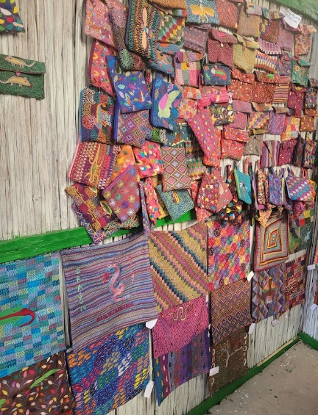
on day 8 we learnt the school song so we could sing along with the children in the next school we were visiting which was challenging but great fun. On our way to the 2nd school, we walked through the giant puddle while a heard of zebu (large, horned Malagash cow) were also going through it so we got splashed a lot. As we reach the school which was further out then the other school, we had a parade of children following us who had tagged along on our way there. The school was even more full than the last school and the kids were just as enthusiastic but the younger children seemed very confused when us vazahas started singing their song but the older children thought our terrible pronunciation was hilarious. We carried out the same kind of activities however I was groped with the younger children which was more of a challenge for me but it was fun trying to figure out how to understand and communicate with the children such as asking them which coloured pencils they would like, which we had learnt in our crash course in the Malagash language. After the children had left with their bracelet gifts the chief of the village wanted to meet with us so we were introduced to him and we had to explain why we were there and hand over the donations we had brought such as coloured pencils for the school. That evening my group had a survey which we had prepared with by being very fashionable such as tucking our trousers into our socks to avoid bites and wearing face nets. We were surveying woolly lemurs which are a nocturnal species of lemur however they were not know to be seen in the forest fragment we were surveying so we didn’t spot any. On the walk back through the transact we were climbing over some large fallen trees when we started being attacked by a large dragon flies which Babs our guide mange to snatch out of the air and started chasing us through the forest with shouting “my friend my friend” until we were out of the forest and he put it down on a plant. We carried on our way home laughing about the whole encounter and how sweet Babs was because he was happy, we had found him funny until we actually spotted a woolly lemur in a tree on the way back. It was safe to say my group did not have great luck with lemur surveys.

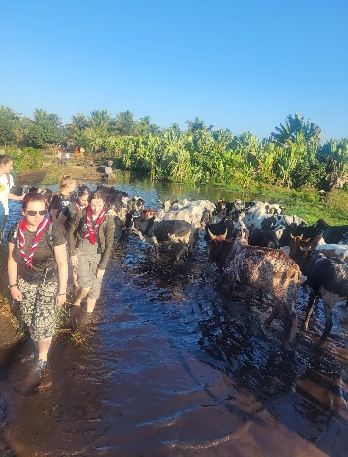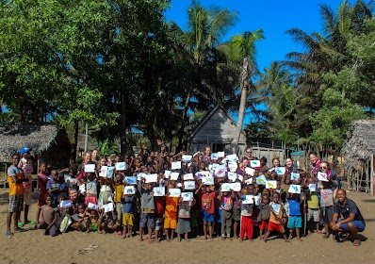

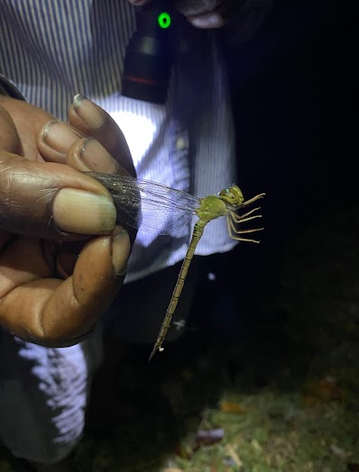

On day 9 we had planned to go on a hike up a mountain so we could watch the sunrise so we woke up at 4.45. The sunrise was beautiful and we got some amazing photos of the scenery and waved at all the fishermen starting work in the lake that morning. We stayed up there for a couple of hours chatting before making our way down back to camp for breakfast. That morning my group had a mahampy weaving class scheduled where the women from the local village came to teech us how to weave bracelets which was tricky at first but as soon as I got the hang of it, it was very peaceful. Madam Jaqueline was one of the women who was teaching us and was proudly showing off her very good English skills and it is a big deal if someone is learning English as it means they are very intelligent. This is when we also got to try more of the local cuisine such as the homemade pizza type things, they made which had ingredients such as carrot, shrimp, onion and chilli on them and were delicious that we ordered 15 from the local woman. Later that day a group of red collared brown lemurs was very close to camp so we spent some time watching them as there were about 12 of them outside the long house. We had also made plans that evening to go to the fire clearing to watch the sunset which was also very beautiful with the mountain range in the background. We also got to learn more about the projects seed run such as how they build and manage the fire cleanings that protect the forest and biodiversity is there were wild fires. On the walk back we managed to do some star gazing as the night sky is breath taking with the lack of light pollution there.

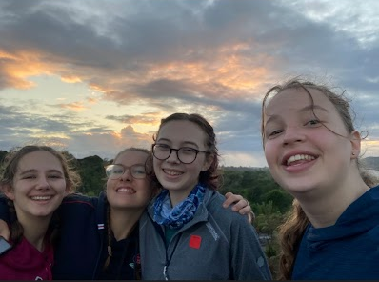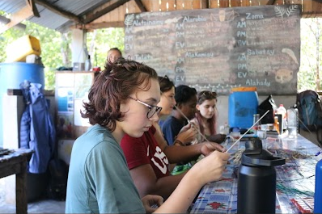

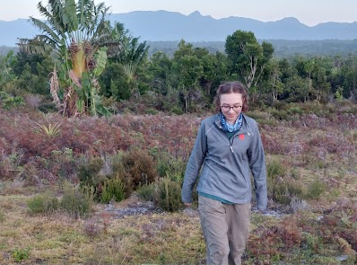

Day 10 was a day we’d all be looking forward to as it was the day of the bush party so we had some bon bon cocos delivered to camp which were the best snacks we had while we were there and they were caramelised shredded coconut pieces. After lunch Hudy took us out on an excursion of his own to the mahampy wet lets which is basically a giant bog where the reeds grow. He taught us how they were experimented with methods of harvesting them such as pulling vs cutting and we helped him measure the new growth which showed the pulling method was more effective in helping the plant grow back faster. He also showed us a special kind of tree they have which they call the vizahah tree as its white and peels easily like when we get sun burn. He also said he had magic feet as when we exited the bog our legs were coved in mud but his were perfectly clean. When we got back, we had a dance warm up and did dances such as the cha cha slide, YMCA and Saturday night which solo joined in with while all the other guides laughed at the lack of rhythm. We set off for the party at the research centre where the whole village was and sat down. The local band was there with their instruments such as whistles drums and guitars and we watched as 3 traditional Malagash performed and they were amazing and they had beautiful matching lambas on. They then started pulling us up and teaching us to dance which some of us were better than others that but the locals had great fun laughing at us. We had an amazing time and danced for hours and Frankie and I taught some of the children funny dance moves such as the DJ, the Sprinkler and the suba which they found funny. Some of us even had marriage proposals and were offered 6 zebus by a mother.
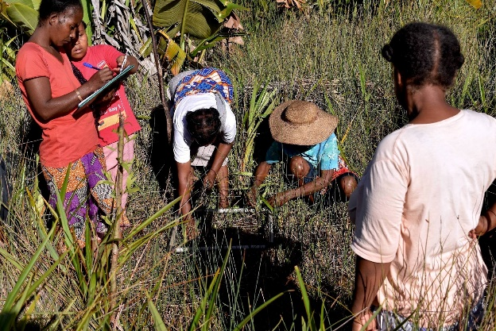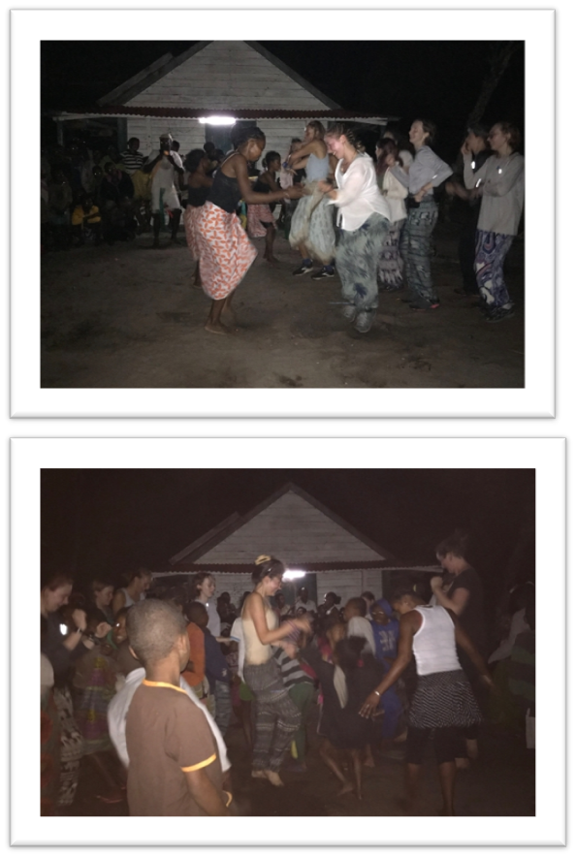

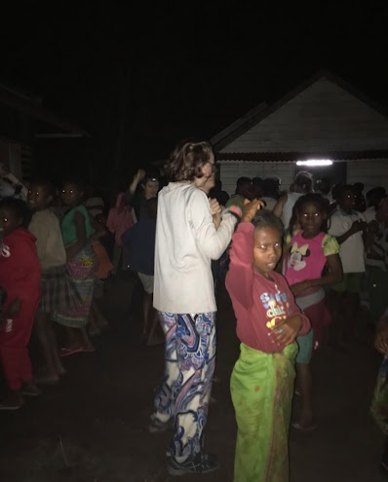

On day 11 we had a rest day from our busy week and planned to go to another beach. We went swimming in the cove and played rounders and made sure to eat our lunch of spaghetti from zip lock bags. Some of the local children were interested in the books and looking at the pictures on the covers and then showed us some of their dance and gymnastics moves. Were then planned to go to jerry’s beach bar so we climbed up and over the rocks and made sure to look in all of the rock pools to see how many crabs we could spot. We reached the beach bar which has a swimming pool, pool tables and chips which were delicious and very much appreciated. We walked back through Manafyaffy and had an evening full of competitive card games and back gammon.

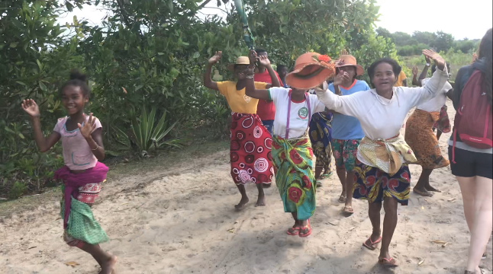

Day 12
After breakfast we wanted to go back to the mahampy and stitch shops to say hello to everyone again and see what knew items they were working on as they are all so beautiful. We also got to learn more about how the businesses are ran such as how literacy lessons are provided to the woman who work there so they are able to complete all of their orders independently as well as how they run their Esty shop, StitchSainteLuce. We then did a survey that was quite a bit different to the surveys we had been doing as we were collecting camera traps from the corridors which are planted forests that help connect forest fragments and redistribute biodiversity. They are monitored with the camera traps we were collecting as they capture the wildlife that uses them. The walk and the views from the corridors were stunning and we had great weather for it however a few crocs were nearly lost in our trek through the bogs. We also spotted a pair of cat eyed snakes which were a type that we had not seen before which was very exciting for me. We had some delicious carrot and potato soup before getting ready for my group’s night herpetofauna survey. We knew this survey was going to be long but it was more challenging than anticipated. We managed a few injuries throughout the survey with even our guide Babs sustaining one. However, we persevered through as it was the most biodiverse were vay we had done so far. Winding through the fallen tree, pandanus plants and across very steep terrain we all managed to spot more wildlife on our own then we had before which we were ecstatic about as finding a brown frog on a brown leaf in the dark feels like quite an accomplishment. We managed to spot a very large warty chameleon as well as more cat eyed snakes and a species of lemur we hadn’t seen called mouse lemurs which are the size of mice and move extremely quickly. We recorded an astonishing variety of animals and species that we hadn’t seen before such as mantidactylus frogs and Malagash skinks despite the difficulty of the survey. We made it back to camp at 10.30PM over 5 hours after we left which is the longest survey we had completed.

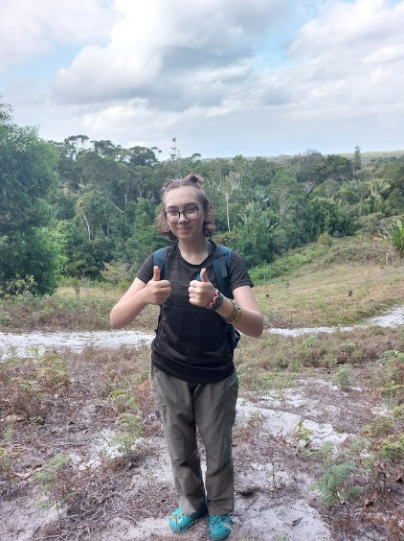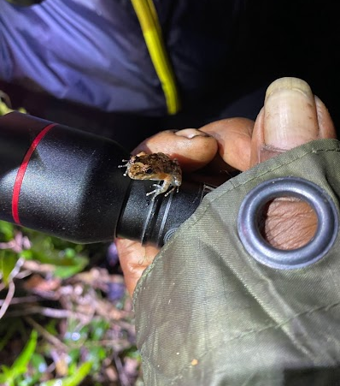

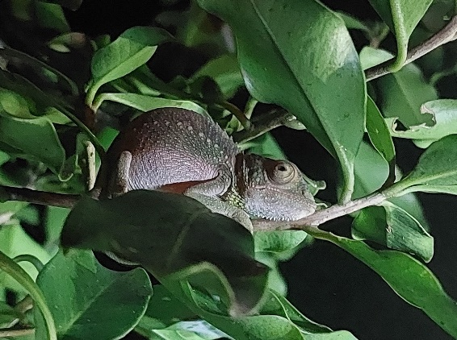

Day 13 was our penultimate day on camp so we began packing up what we could and after our exhausting survey and injuries we decided it was best that my group took it easy that morning. We said hello to our favourite lemur who is blind in one eye as he was a frequent guest at the camp bins as he likes to steel our banana peels before settling into a presentation given to us about what was going to happen to the data we had collected and how it was going to be used in their research. We also got to hear about some of the researchers’ roles such as how Bex was working toward defining more species of animals and collecting data on them with some of the guides. We also took this time to write out a thank you card for all the researchers and guides to thank them for hosting us and to show them how much we enjoyed spending our time there. We spent our final night on camp having a dance party out in the rain to songs like footloose and the eclectic slide which was all good fun for everyone. We then settled down into our tents for the final time.

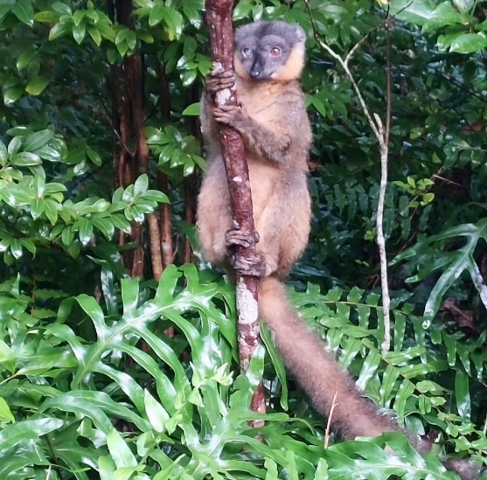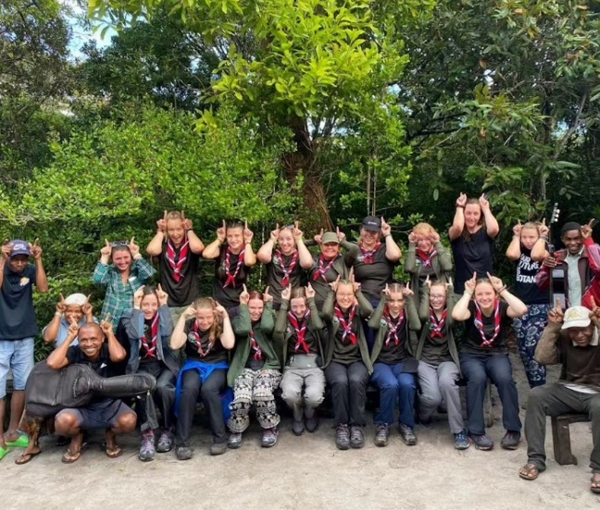

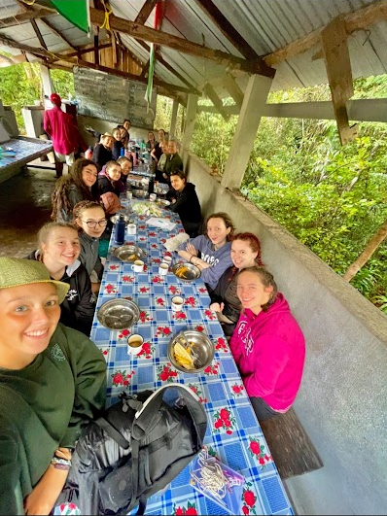

The next morning on day 14 we woke up to torrential rain again at 5AM, packed up the rest of our things such as our camp mats and sleeping bags praying the rain would calm down as it is not ideal tent-putting-down weather and took our bags to the long house. Putting down the tent was a bit of a struggle as it was soaked through and covered in sand from the camp site but we managed it just in time for breakfast and gave a few of the other pairs a hand with putting their tent down as well. We had our last breakfast on camp and handed out all of our cards which included a thank you badge and our team’s favourite anecdote from each person. We helped with the clean up as everyone from camp was traveling back to fort dauphin that day so we had to make sure everything was stored correctly. By that time our cars had arrived so we pilled our bags on the top and set off. We drove through the mountains and rice fields which had glorious views and apart from one mishap with one of the cars briefly setting on fire we made it to fort dauphin safely. We had checked into a hotel for the night which had a swimming pool and real showers which we were all very glad to see. We went for a lovely meal in the hotel’s restaurant where we all talked about our favourite things that we did wile on camp and how excited we were for the tour of the capital the next day.

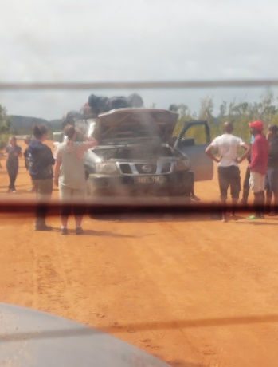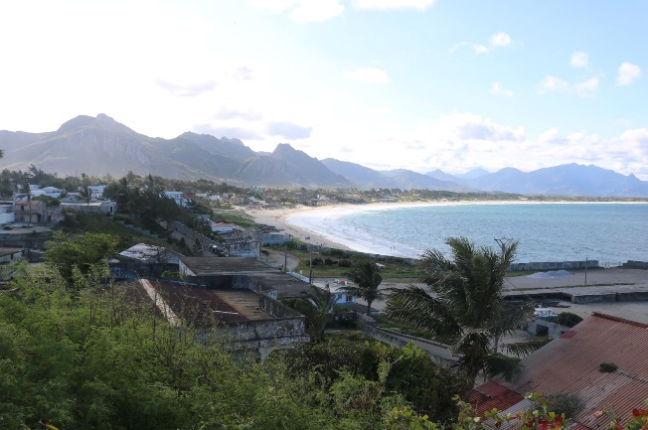

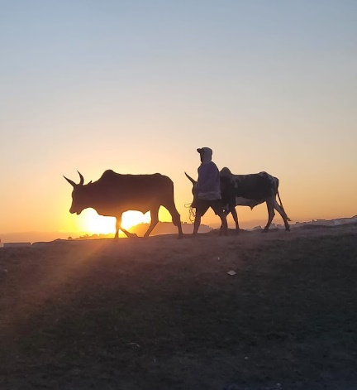

To start day 15, we had a flight from fort dauphin to the capital Antananarivo and we landed we were met with a tour bus and a tour guide called Mr 50/50 lemur. We were very charismatic and vowed to give us the best tour of the city. We first went to the king’s palace which was up the top of a mountain and taught us about some of the history like the zebu sacrifices and egg taxes. We went into some of the preserved rooms such as his bedroom and tight us about the proper etiquette such as entering with your left foot. We then got a tour of the baths that were used traditionally ever new year. We then went to see the queens place which was a lot grander as Madagascar tends to lean for towards a matriarchy. We saw the tombs the past kings and queens are buried in and learnt about how the pray rooms above them were only open one day a year and are very popular to go pray in. the inside of the queen’s place was a museum and we learnt about Madagascar’s relationships with the UK as well as the wars they have been a part of and the traditions the royal family had. We then also bumped into a lot of Madascan scouts who would stand to salute us and we would salute back. Antananarivo were also hosting the Indian ocean island games so we saw a lot of the teams who were competing who we would wave and they would wave back. Finally, we took a tour around the markets and got to see all the vendors and the kind of things they were selling before driving back to the airport in the sunset for our flight which was at midnight.
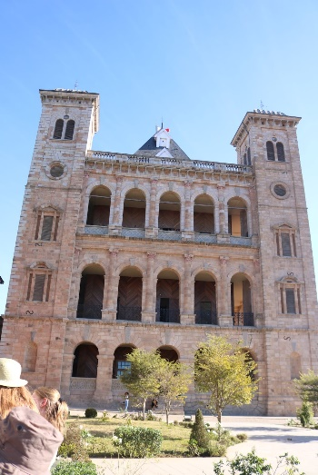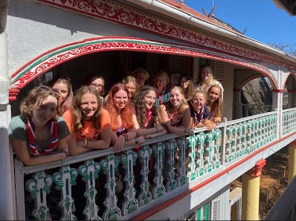

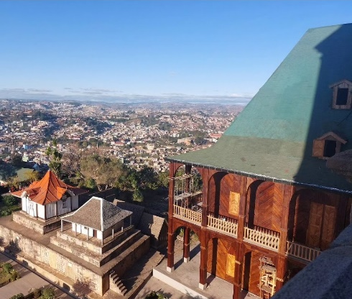

Day 16 was the final day as we had our 11-hour flight to Paris. When we landed, we grabbed some lunch and spent some time talking about all of our favourite bits of the trip and what we learned which got teary very quickly as all 14 of us had gone from strangers to practically family in a short period of time. We had a good laugh as well telling our favourite story and reliving all the embarrassing moments. As we landed in Manchester there was a sense of accomplishment as we collected our bags and were greeted by all the families and we all cheered as we had had a great time and made it back in one piece.

