The Neil Mackenzie Trust

The Neil Mackenzie Trust

The Neil Mackenzie Trust

The Neil Mackenzie Trust

The Neil Mackenzie Trust

The Neil Mackenzie Trust

vvThe Neil Mackenzie Trust

!
  - Newsletter, april 2026

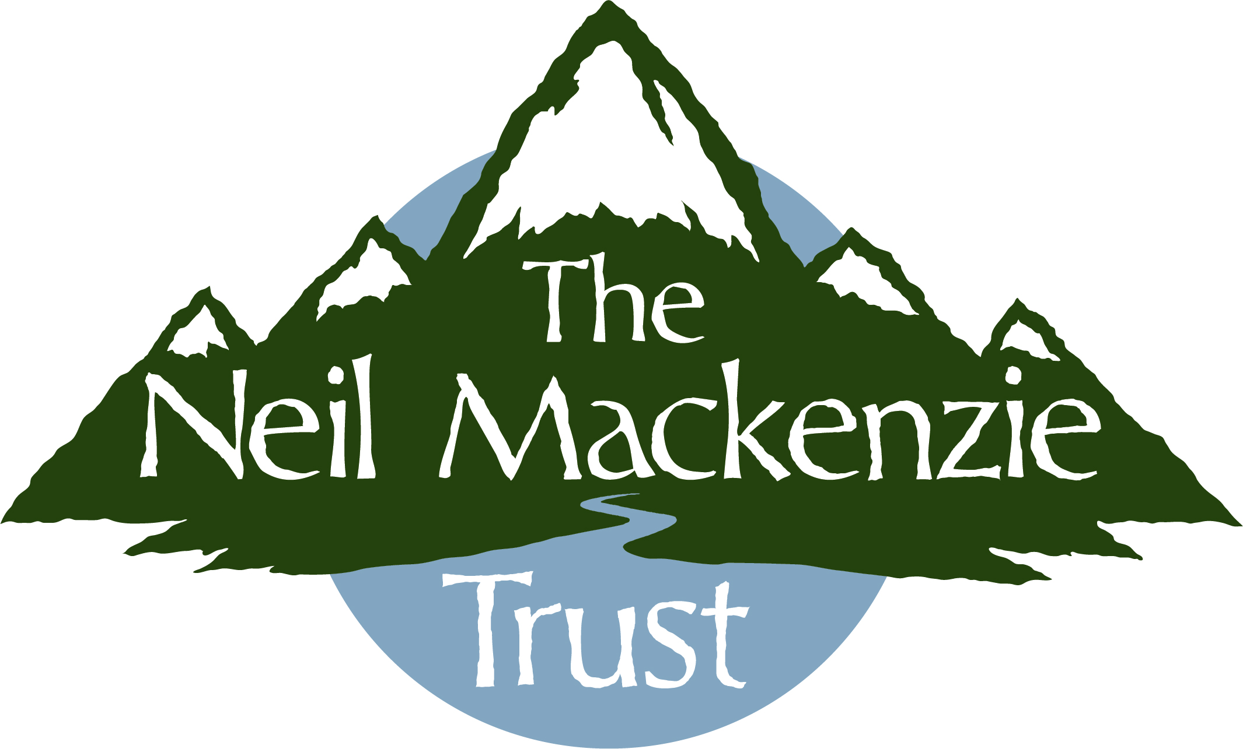

Expedition Grants for small groups, families or individuals to go anywhere in the world

────

Outdoor skills training grants, including enhanced grants for training at Glenmore Lodge, for anyone resident in Scotland over the age of 14

────

Visit our website for further information or to donate: www.theneilmackenzietrust.com
────

Visit us on Facebook:

www.facebook.com/theneilmackenzietrust

────

Or contact us by email: theneilmackenzietrust@dr.com

Donate:


An Amazing Donation!
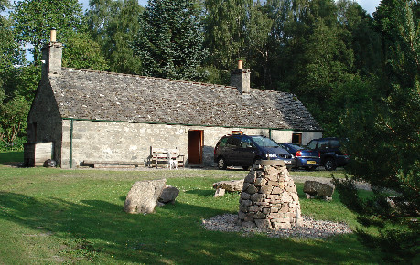
We had a fantastic surprise in March, receiving a donation of £10,000 from The Mill Cottage Fund (charity no. SC020138) especially to assist with training in outdoor skills. It’s difficult to put into words our gratitude for this amazing support.
Mill Cottage, near Feshiebridge, is available for the use of Mountaineering Scotland and British Mountaineering Council affiliated clubs, and individual members. The Trustees are always looking to maximise its use. So if you are looking for somewhere to stay in the Cairngorm National Park, why not give it a go! https://www.mountaineering.scot/clubs/huts/national-huts/mill-cottage
Expedition Grant News
The first few months of the year have been busy with grant applications. We've recently had our spring deadline for grants, and once again we had an excellent selection to choose from. We awarded two Educational Expedition grants: £800 to Glen Dickson, to climb the Durrance route on the Devils Tower in Wyoming, USA, for his Professional Adventure Project as part of his 4th year Hons. course at the University of the Highlands & Islands, and £700 to Lena Gerhardt to do fieldwork investigating hydrotherapy fluid flow, based in Nerva, Spain, as part of her Geology course at St Andrews.
We have awarded an Expedition grant of £800 to assist the 2026 British Universities Kayak Expedition to kayak rarely, or never, paddled rivers in Sumatra, and a Small Expedition grant of £200 towards a group planning a ski touring expedition to the Northern Patagonian Andes.
Also....... each year we fund the Neil Mackenzie Adventure Grant jointly with the Varsity Outdoor Club (VOC) at the University of British Columbia (UBC). Neil was an active member of the VOC at the time of his death in 2015. This year’s grant of CAD$2,500 (approx. £1,400) has been awarded to a group planning to kayak 300km down the lower Stikine River to Wrangell, Alaska.

Skills Training
This year we plan to encourage more skills training applications. As part of that, and in the light of the increasing costs of training, we are raising the maximum level of the skills training grant from £300 to £400, and our support for subsequent assessments will increase to up to £350. A maximum of £500 will be available under our enhanced grant scheme with Glenmore Lodge for individuals who can demonstrate particular need. Under this, Glenmore Lodge match the grant we offer by discounting the cost of the course. We will also be reinstating our support for intermediate and advance level courses, as well as leader courses, particularly relating to mountain skills, for 2026 and possibly beyond.
Jessica Douglas, who is studying at Glasgow Kelvin College, attended a weeks snow sports training residential in France last month; this was her first time on skis and she had an “incredible experience”! We look forward to hearing all about it.
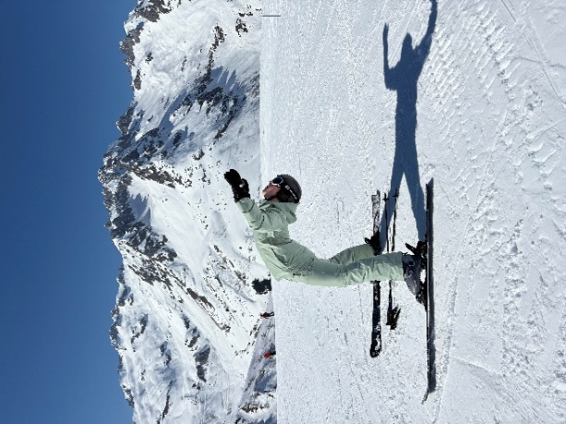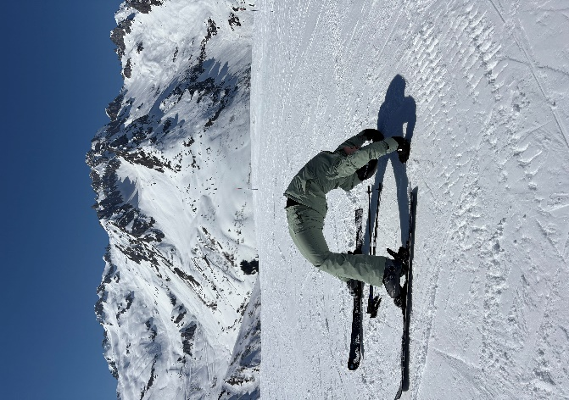
We have awarded a skills training grant to Cerys Bowie, a teenager from the West of Scotland towards the costs of a PADI Advanced Open Water Diving course, and a related First Aid course. Her goal is to advance to diving expeditions and become involved in marine conservation. She is also keen to be qualified to help train new divers, enabling her to pass on her skills to others.
We’re delighted to be assisting Ava Warner Brown with her Rider Training Programme, level 1-2, through the Association of British Riding Schools. Ava is the second person we have helped enhance their riding skills through programmes delivered by Eat, Sleep, Ride (charity no. SC053818), a charity which aims to empower young people, families and communities to overcome challenges and thrive, through harnessing the power of horses. Read more at www.eatsleeprides.org
Supporters Day 2026
This year our Supporters’ Open Day will be on 22nd August and again based at Farr Hall. IV2 6AX, and we look forward to another active, interesting and social occasion. There will be activities for all ages in the morning – we’re very open for suggestions of different activities, within reason, so please let us have your suggestions if you are able to lead them, or know someone who can! In the afternoon there will be talks and videos from some of our recent grant recipients and plenty of tea, coffee and cakes! If you have recently received a grant, we very much hope you will come along and talk about your experience and how it has benefitted you. If you received one before 2025, perhaps you would like to come and tell us about the effect the training/experience has had on you.
As always we will be looking for your help! If you are available on the day will you be able to lead a morning activity? We will be looking for bakers, and kitchen helpers on the day. An IT guru is always helpful, and general helpers for selling raffle tickets, managing the door, etc. would be appreciated. Please let us know what you can do to help.
The day will end with a barbeque and there will be lots of opportunities to meet recipients, chat and share stories! It’s a very informal day.
Footnote: We are always on the lookout for funds to support our applicants – How can you help!?

