The Neil Mackenzie Trust

The Neil Mackenzie Trust

The Neil Mackenzie Trust

The Neil Mackenzie Trust

The Neil Mackenzie Trust

The Neil Mackenzie Trust

vvThe Neil Mackenzie Trust

!
  - Newsletter, august 2026



Expedition Grants for small groups, families or individuals to go anywhere in the world

────

Outdoor skills training grants, including enhanced grants for training at Glenmore Lodge, for anyone resident in Scotland over the age of 14

────

Visit our website for further information or to donate: www.theneilmackenzietrust.com
────

Visit us on Facebook:

www.facebook.com/theneilmackenzietrust

────

Or contact us by email: theneilmackenzietrust@dr.com

Donate:


Supporters’ Day August 22nd 2026
Our 4th Supporters’ Open Day, kindly sponsored by Matheson Builders Ltd., will be on 22nd August and again will be based at Farr Hall. IV2 6AX with morning activities starting from School Wood, Farr IV2 6XB from 10am. We look forward to another active, interesting and social occasion. It is open to everyone and there will be new activities for all ages in the morning. In the afternoon there will be talks and videos from grant recipients from mountaineering expeditions to paddling and there will be plenty of tea, coffee, cakes and squash! Please bring your own picnic lunch and some food for the BBQ (and any other drink you would like.) There will also be an opportunity to talk to recipients and supporters, to spend money on our cards, tea towels etc, and a raffle, and there will be a bouncy castle for the little ones.
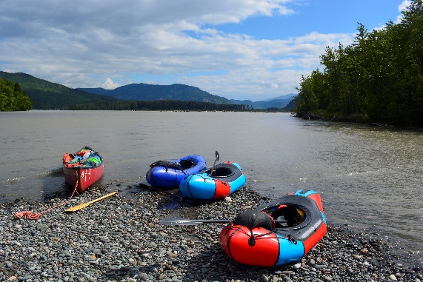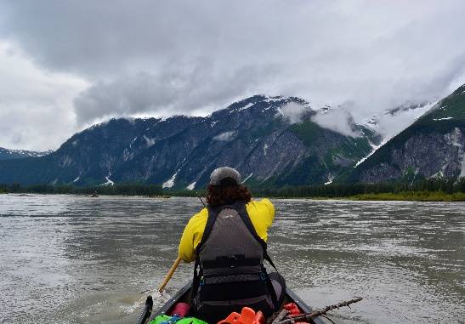
As always we will be looking for helpers! If you are available on the day will you be able to lend a hand? We are looking for bakers, and kitchen helpers, an IT guru and general helpers will be needed for selling raffle tickets, managing the door, etc. Please let us know what you can do to help. The day will end with a barbeque. It’s a very informal day and everyone is welcome, for the whole day, or just part of it!
Venue: Farr Hall IV2 6AX and School Wood IV2 6XB
Cost: entrance by donation. Please bring cash and give generously!
10am – registration for activities at School Wood.
Activities: Hill walking, running, cycling and low level walk - all leave immediately after registration.
10.30 - School Wood Cabin: Children’s yoga, for ages 3 – 10 (All children must be accompanied by an adult).
NOT TO BE MISSED! From 12 noon at the Hall (Smith Field if dry): Herd dynamics – suitable for EVERYONE. An introduction to how horses or other herd animals interact with each other to move together in a group – a fun and informative exercise for EVERYONE as long as you can walk.
Bouncy castle during the day. Tea and talks from 2pm & BBQ 5pm (see below).
Please return registration form attached (P3 & 4) or contact us if you require more information. theneilmackenzietrust@dr.com

Tea & Talks, coffee & Cakes from 2pm in the hall – Entry by donation – please bring cash and give generously!
We have a selection of live speakers and videos. Join us to hear about some amazing climbing, ski touring and paddling expeditions we have assisted all over the world, and some smaller grants we have awarded closer to home. We also have some amazing photos from a VOC (Varsity Outdoor Club of the University of British Columbia) expedition we assisted which took place earlier this summer, paddling down the lower Stikine river from Canada through Alaska to the sea.
The barbeque will be lit when the talks finish and we anticipate food will be ready soon after 5pm. If you are staying for it, please bring contributions for the BBQ (burgers, sausages, skewers etc.) to the kitchen from 12.30pm. They will be stored in the fridge until required. If you have special dietary needs/requirements please wrap and label your food, and we will store it separately. Any donations of cakes, sandwiches & other items for the BBQ (rolls, salad, etc.) will also be appreciated! Also please BYOB and glasses
Grant News
New: group mountain and hillwalking training grant
For a limited time, as a result of the generosity of Mill Cottage SCIO, we are offering grants for groups of students to attend courses in basic mountain skills. These will be cordinated by the University/College clubs and are designed to encourage students, new to the mountain environment, to enjoy the outdoors and be safe in the mountains. If you are a member of a university outdoor club and think there would be an interest please let us know (theneilmackenzietrust@dr.com) We will be contacting university clubs over the next few weeks, but we will not find them all!
We are looking forward to a video at the Supporters’ Day from the girls at Eat, Sleep, Ride (ESR) who we have assisted over the last year, including from Ava, who attended the ABRS (Association of British Riding Schools) – Rider Training Programme at ESR. Dani, founder and organiser of ESR has sent us guidance to run the Herd Dynamics earlier in the day.
Glen Dickson, was awarded an Educational Expedition Grant to climb the Durrance route on the Devils Tower in Wyoming, USA, for his Professional Adventure Project as part of his 4th year Hons. course at the University of the Highlands & Islands. He will be doing a presentation of his trip on Supporters’ Day, but for those of you who can’t make it, here is a link to his report: https://theneilmackenzietrust.com/glen-dickson-may-2026/ We also look forward to meeting Lena Gerhardt who is doing fieldwork investigating hydrotherapy fluid flow, based in Nerva, Spain, as part of her Geology course at St Andrews.
Each year we fund the Neil Mackenzie Adventure Grant jointly with the Varsity Outdoor Club (VOC) at the University of British Columbia (UBC). Neil was an active member of the VOC at the time of his death in 2015. This year’s grant was awarded to a group planning to kayak 300km down the lower Stikine River to Wrangell, Alaska. All the photos on this newsletter were from that trip, and we will be showing about 800 of them in a background loop on Supporters’ Day!!
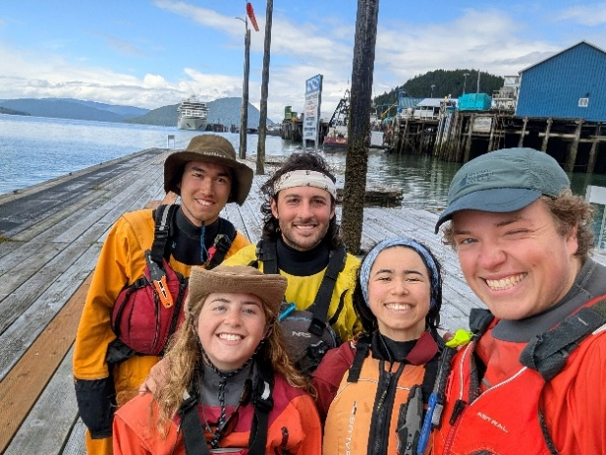

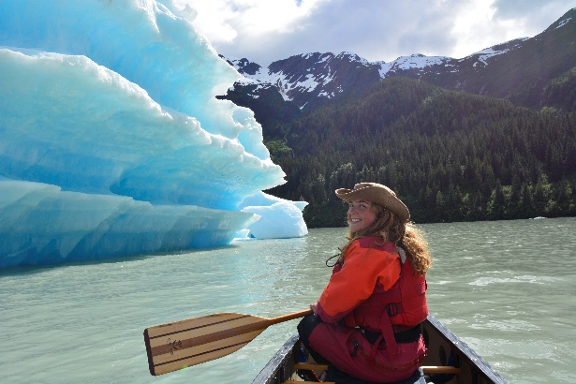
Dates for your diary:
Ceilidh - 6th March 2027 – Farr Hall
The Deadline for applications for our 2026/7 winter expedition grant is 23rd August. Applications for grants for summer 2027 expeditions will need to be in in March 2027. Small expedition grants (up to £200) and skills training grants can be applied for at any time but will take 4-6 weeks to process. Please contact us through www.theneilmackenietrust.com and tell us of your plans!

Supporters’ Day Activity Booking Form 2026

Thank you for your interest in joining us for one of our activities for our Supporters’ Day on Saturday 22nd August. The activities on offer are below.
Please select your preferred option and let us know the name and age (if under 18) of each participant (and where applicable, fitness level), sign and return your completed form to theneilmackenzietrust@dr.com

Activities:

Hill walking/ running/ cycling
Join us for a hill walk, hill cycle or hill run! A low level walk is also available.
Using some of our local hill tracks, come and explore the local environment. There is an option for all abilities, but please let us know your preference so that we can allocate groups accordingly. All children must be accompanied by an adult.

Meeting point - The Pagoda, School Woods
Start time - please register at 10am for 10.10am start
Entry by donation (please give generously!).

Participant 1:
Name, and age, if under 18 …………………………………………………………………………..……………………
Preferred activity (please circle) – Hill walk/ Hill cycle/ Hill run.
Please indicate your fitness level (please circle) - low/ average/ above average/ superfit
Please state your preferred distance - 2-5km, 5–7km or 7km+

Participant 2:
Name, and age, if under 18 …………………………………………………………………………..……………………
Preferred activity (please circle) – Hill walk/ Hill cycle/ Hill run.
Please indicate your fitness level (please circle) - low/ average/ above average/ superfit
Please state your preferred distance - 2-5km, 5–7km or 7km+

Participant 3:
Name, and age, if under 18 …………………………………………………………………………..……………………
Preferred activity (please circle) – Hill walk/ Hill cycle/ Hill run.
Please indicate your fitness level (please circle) - low/ average/ above average/ superfit
Please state your preferred distance - 2-5km, 5–7km or 7km+

Participant 4:
Name, and age, if under 18 …………………………………………………………………………..……………………
Preferred activity (please circle) – Hill walk/ Hill cycle/ Hill run.
Please indicate your fitness level (please circle) - low/ average/ above average/ superfit
Please state your preferred distance - 2-5km, 5–7km or 7km+

Participant 5:
Name, and age, if under 18 …………………………………………………………………………..……………………
Preferred activity (please circle) – Hill walk/ Hill cycle/ Hill run.
Please indicate your fitness level (please circle) - low/ average/ above average/ superfit
Please state your preferred distance - 2-5km, 5–7km or 7km+

All attendees/parents will be required to fill in a disclaimer form for the hill walk/ cycle or run.
Some activities will be dependent on weather and/or availability of leaders/instructors, and numbers may be limited.
The Neil Mackenzie Trust cannot be held responsible for any loss or injury as a result of activities in the woods or hill tracks.

Children’s Yoga at The Cabin (suitable for ages 3 – 10)
Join us for a mix of fun & playful movement, yoga poses, breathing techniques and time for quiet meditation, reflection and relaxation. Please note that parents will need to accompany their children for this session.

Venue – The Cabin, School Woods
Start time – 10.30am. Please register at The Pagoda in School Woods from 10.15am
Entry fee – minimum £2 suggested donation per child.

Participant 1 (please state name, and age, if under 18) …………………………………………………….….
…………………………………………………………………………………………………………………………………...
Participant 2 (please state name, and age, if under 18) ………………………………………………………..
……………………………………………………………………………………………………………………………….…..
Participant 3 (please state name, and age, if under 18) ……………………………………………………….
..…………………………………………………………………………………………………………………..……………..
Participant 4 (please state name, and age, if under 18) ………………………………………………………..
………………………………………………………………………………………………………………………………..…..

Please fill in, sign and return to theneilmackenzietrust@dr.com :
I/We would like to attend the Supporters Day activities on the morning of 22nd August.
Registration for all morning activities will be at The Pagoda in School Wood, Farr from 10am. Once you have completed your activity, please join us at Farr Hall from 12noon for the next part of the day.

Signed: ……………………………………………………………………………………………………….…………….
Printed: …………………………………………………………………………………………………………………….
Email: ………………………………………………………………………………………………………..……………..
Telephone No: ……………………………………………………………………………………………………………

Please bring your own lunch. Tea, coffee, squash and light refreshments will be available at the hall.

